ASK A LIBRARIAN
Get support from the Library

In-person | Chat | Phone | Email
https://library.concordia.ca/help/questions/

RELI 409

METHODOLOGY AND THE STUDY OF RELIGION
Library Workshop

GET TING STARTED
Online resources to explore
- Developing Your Search Strategy by Concordia University Library, YouTube video, 7min22, https://youtu.be/6mLjkgkXWAc
- Search Smarter, Search Faster by the University of Sydney, YouTube video, 6min53, https://youtu.be/Oa66AxTbjxA

ACCESSING INFORMATION
The world is at your fingertips! The Library offers multiple sources of information. If you have any difficulty finding or accessing a document, contact us. https://library.concordia.ca/help/questions/

Library website
You can connect your Google Scholar account to the Concordia Library, via “Settings”. This will allow access to more full-text documents.
ÉTHEL GAMACHE | REFERENCE & SUBJECT LIBRARIAN | ETHEL.GAMACHE@CONCORDIA .CA | 514-848-2424 EXT 7742
https://library.concordia.ca/

Religions and Cultures Subject Guide
https://www.concordia.ca/library/guides/religion.html

Sofia Discovery tool https://concordiauniversity.on.worldcat.org/ advancedsearch?queryString=&databaseList=

Print books are organized in the Library by call numbers, an alphanumerical identification.
- Using a Call Number to Find a Book by the University Libraries at Virginia Tech, YouTube video, 2min24, https:// youtu.be/duemCqRqMKA

Databases by subject
https://library.concordia.ca/find/databases/
Databases explored during the workshop: Academic Search Complete and Canadian Newsstream.

Google scholar
https://scholar.google.ca/
Courses reserve
https://reserves.concordia.ca/ares/

Interlibrary loans
https://library.concordia.ca/find/interlibrary-loans/

Article\ Chapter Scan & delivery
https://library.concordia.ca/find/delivery/login.php?target=articleForm.php

Finding
https://library.concordia.ca/help/guides.php?guid=finding

Evaluating
https://library.concordia.ca/help/guides.php?guid=evaluating

Citing
https://library.concordia.ca/help/citing/

Ask a Librarian
https://library.concordia.ca/help/questions/

Support for undergraduate students
https://library.concordia.ca/help/users/undergraduates/index.php

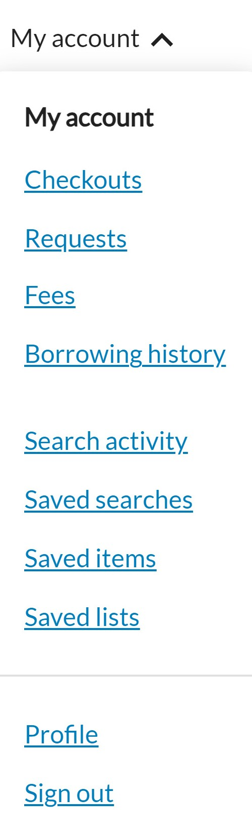
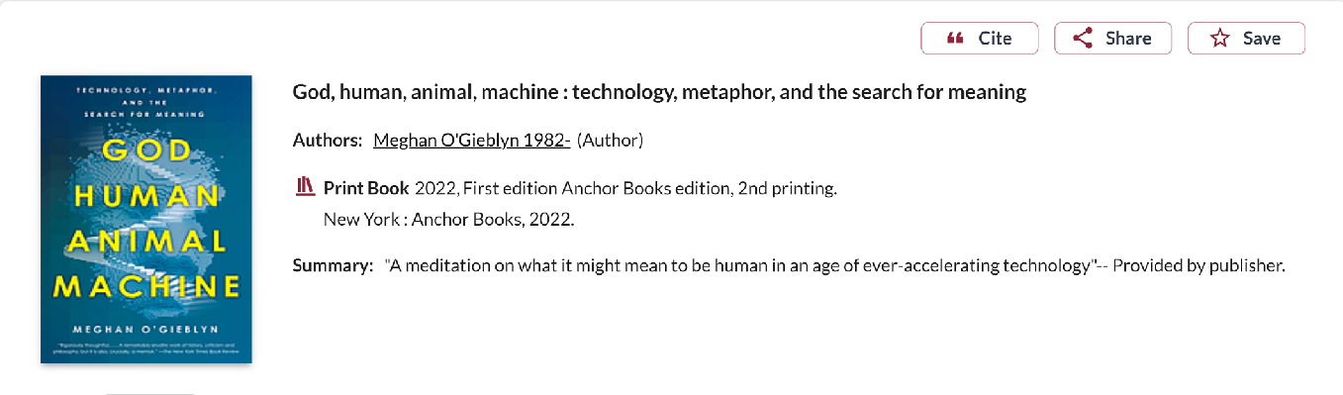
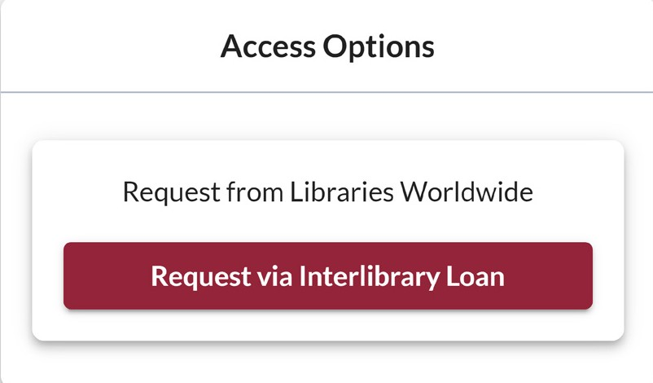
INTERLIBRARY LOANS SERVICE
The Interlibrary loans service (ILL) is embedded within the Discovery tool Sofia. ILL requests
are made directly in the Sofia Discovery tool, using the “Request via Interlibrary Loan” button or using the form available under the “Requests” tab in your Sofia “My Account”.
If you visit another university library in Québec, your Concordia ID card will be your
library card. You can also get a PBUQ (Partenariat des bibliothèques universitaires du Québec) card.
card

For more information on how to place ILL requests for books, articles and chapter scans, please visit the User guide for the Sofia Discovery tool.

This service is available to Concordia undergraduate and graduate students, faculty members and staff.
QUESTIONS
The Ask a Librarian service (https://library.concordia.ca/help/questions/) will connect you via chat, phone and email to a reference assistant or librarian who can help you with most questions.
Éthel Gamache Reference & Subject Librarian
ethel.gamache@concordia.ca

GO FURTHER
The Library also offers a selection of workshops open to the Concordia community (https://library.concordia.ca/help/workshops/). The Library Research Skills tutorial is
also worth exploring if you prefer a self-paced tutorial (https://library.concordia.ca/learn/).

This resources handout is available in a digital format on the Religions and Cultures subject guide https://www.concordia.ca/
library/guides/religion/
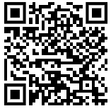
courseguide.html

