Centre for Innovation in Construction and Infrastructure Engineering and Management (CICIEM)
Quarterly Newsletter - Winter 2026
Message from the Director

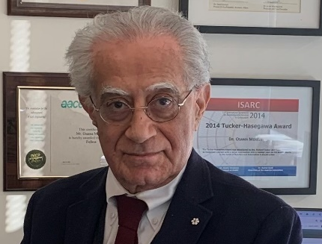
Dr. Osama Moselhi
Driven by society’s need to address sustainability and carbon reduction in construction, a team of three professors initiated a collaborative research program with Canam (a major Canadian company specialises in designing and manufacturing metal components for the North American construction industry), focusing on the application of circular economy principles in construction. Other members of the CentRE have continued their collaboration with the National Research Council of Canada (NRC), advancing research initiatives in carbon reduction, digitalization, and automation to support the transformation of the construction industry.
The Centre is also undergoing a leadership transition, as I will be retiring at the end of May 2026. We are working in tandem with the Offices of the Vice-President, Research, Innovation and Impact, and the Dean of the Gina Cody School of Engineering and Computer Science, together we are shaping the Centre’s next phase of growth and impact. We extend our sincere appreciation to the Advisory Board members for their strategic guidance and active contributions to the successful search and appointment of two new Co-Directors who will lead the Centre into its next chapter.
CICIEM members continue to expand their national and international research networks, securing competitive funding and contributing to global knowledge through a strong and growing body of high-impact publications, a representative sample of which is highlighted. We proudly celebrated the recent graduation of several PhD students, the appointment of Dr. Mazdak Nik-Bakht as Associate Dean for Research and Innovation, and the engagement of new industry professionals to advance collaborative research initiatives in circular construction.
Looking ahead, the Centre is committed to expanding its membership base, deepening its industry and community engagement, and strengthening its leadership role in driving innovation, sustainability, and digital transformation across the construction sector.

Osama Moselhi, Ph.D., P.Eng., FCSCE, F. ASCE, F. AACE, F.CAE, C.M.
Professor and Director

Newsletter Winter 2026
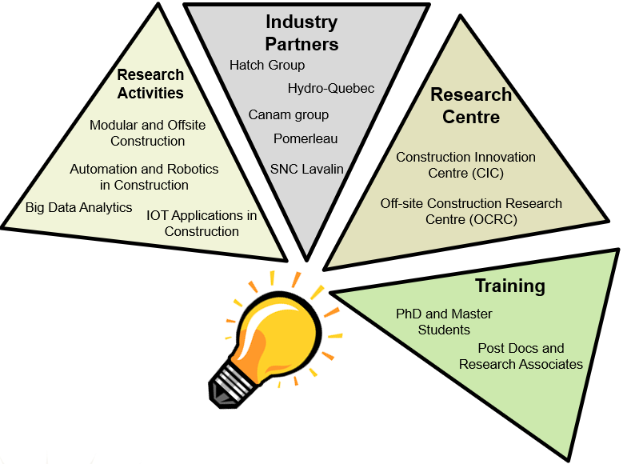  Research Highlights  The CICIEM supports large-scale interdisciplinary research, the training of highly skilled professionals (HQP), promotes technology transfer, and maintains strong collaboration with industry. Its primary research focus areas include:  - Structural steel reuse within a circular economy framework  - Sensing technologies and IoT applications in construction  - Big data analytics in the context of smart cities  - Eco-friendly smart construction systems for Decarbonization of construction industry  The CICIEM has also purchased new equipment: (i) LiDAR (Matterport), (ii) UWB (Ubisense) and (iii) Time-lapse camera in order to enhance its research capabilities with regard to data capturing, real-time localization and autonomous construction site monitoring. |  |  | Collaborations  CICIEM members collaborated with Canam, Hatch, and the National Research Council of Canada (NRC) to drive industry-oriented research. Notable projects include: (i) working with Canam on circular economy principles in construction; (ii) partnering with Hatch to identify and analyze indirect cost factors in mining projects; and (iii) collaborating with the NRC on eco-friendly smart systems to decarbonize the construction industry.        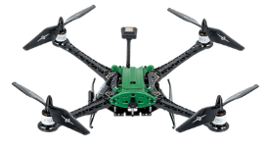
 | Spotlight  CICIEM is proud to collaborate with Canam Group, a major North American company specializing in the design and fabrication of steel products and construction solutions. These collaborations not only advance innovation in sustainable construction but also play a crucial role in training highly qualified PhD students. The partnership with Canam provide our researchers and students with valuable industry exposure, real-world challenges, and the opportunity to contribute to impactful, cutting-edge solutions.

Newsletter Winter 2026

Seminars and Visitors
- On December 1st and 3rd, 2025, CAL hosted a special industry-focused seminar in collaboration with Canam Group. Daniel Barbeau, M. Eng. (Growth and Market Development Manager), and Julie Gravel, ing. M.Sc.A., P.Eng., ENV SP (Business Development Engineer) of Canam Group, provides a first-hand exposure to Canam’s detailing, modelling, and design coordination workflows.

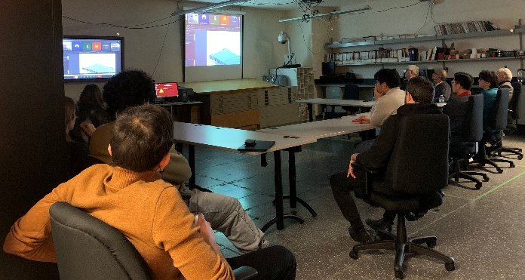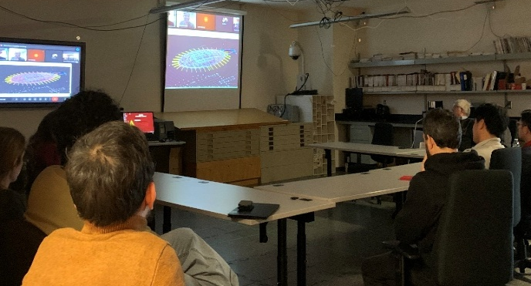

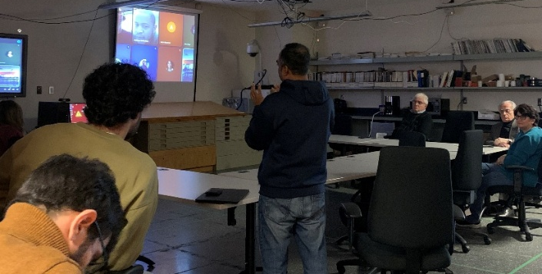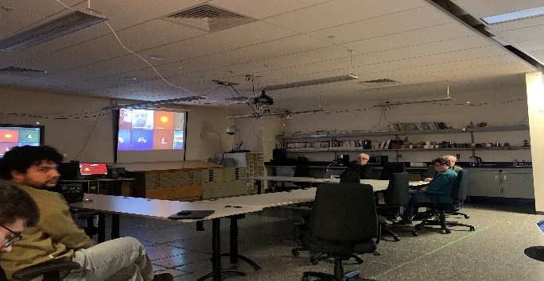

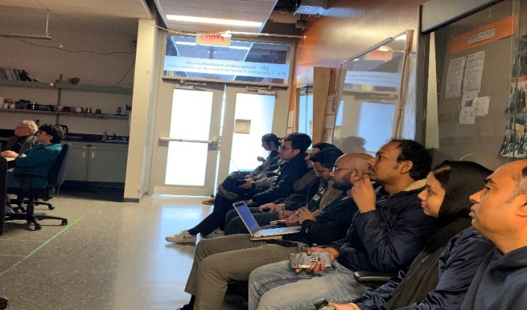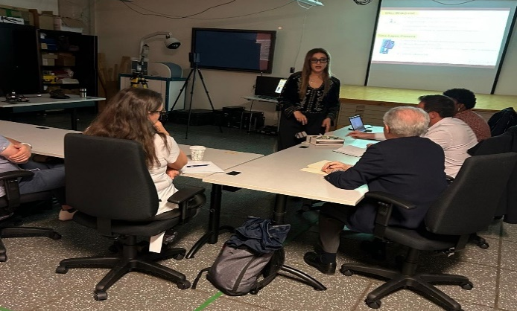
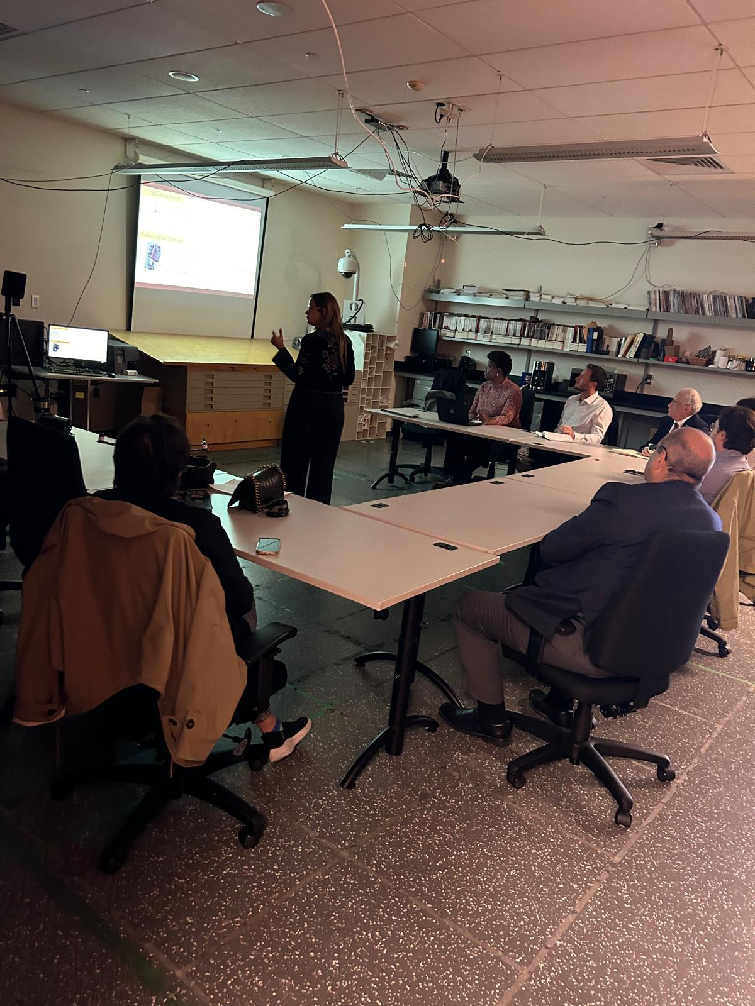

Newsletter Winter 2026

- Seminar Series: During the Fall 2025 semester, several biweekly seminars were organized in the Construction Automation Lab (CAL) to showcase student research. These seminars support one of the key objectives of CICIEM: the training of highly qualified personnel (HQP).

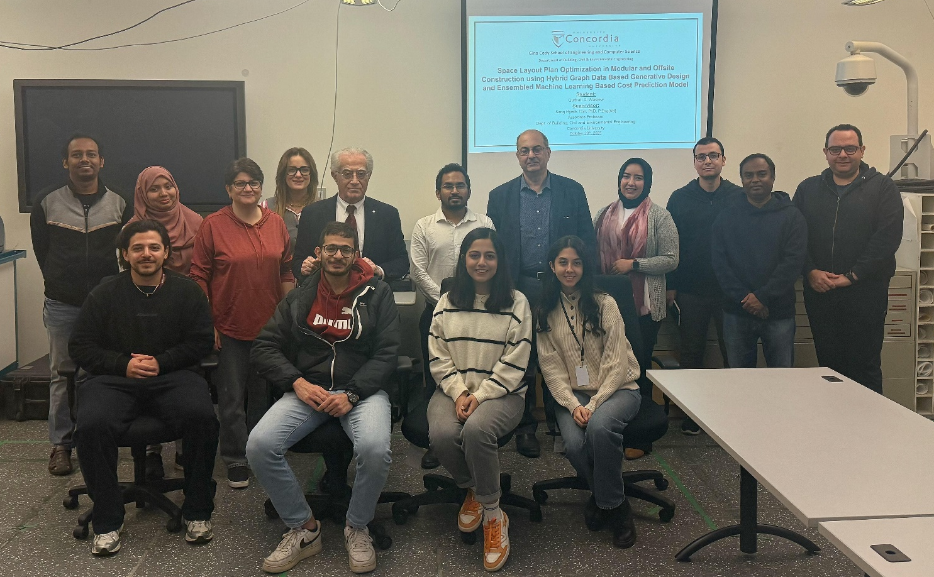
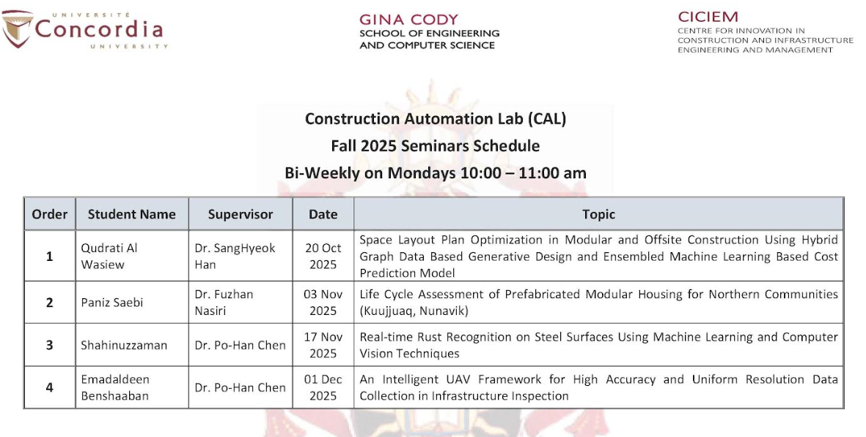
Newsletter Winter 2026

Recent Publications
A selection of publications is listed below:
Automation and Digitization in Construction
Omar, A. and Moselhi, O. 2026. Automated standardization of bridge inspection data using generative AI. Engineering Structures, 350, 121904.
Ghelmani, A. and Hammad, A. 2026. DIGERv2: Anchor-Free Multiscale Construction Activity Recognition and Localization Using Cross-Backbone Attention and Adaptive Sample Selection. Journal of Computing in Civil Engineering, 40 (2).
Rostami, G., Chen, P.H. and Hosseini, M. 2026. Segment Any Crack: Deep Semantic Segmentation Adaptation for Crack Detection. Journal of Computing in Civil Engineering, Vol 40 (3).
Huang, I.F., Shih, K.C., Chan, Y.C., Chen, P.H. and Chang, L.M. 2026. Optimizing deep learning models for fast and effective rust identification. Journal of Asian Architecture and Building Engineering.
Zaman, S., Chen, P.H. and Chang, L.M. 2025. Real-Time Rust Segmentation on Steel Surface Using a Lightweight Transformer Deep Learning Model. Journal of Infrastructure Systems, 31(4), 04025033.
Khazen, M., Nik‐Bakht, M., Moselhi, O. and Dungen, J. 2025. A Deployable Solution for Indoor Tracking of Workers in Construction Sites through Bluetooth Low Energy Technology . Journal of Information Technology in Construction, 30, 1377-1397
Bahreini, F., Nik-Bakht, M. and Hammad, A. 2025. Developing Computer Vision-Based Digital Twin for Vegetation Management near Power Distribution Networks. Remote Sensing, 17 (21), 3565.
Dunson-Todd, M., Nik-Bakht, M. and Hammad, A. 2025. Proposed Standard Test to Evaluate Back-Support Exoskeleton Efficacy for Rebar Workers: Test Design and Initial Implementation. Journal of Computing in Civil Engineering, 39 (5).
Chang, W.C., Lu, H.K. and Chen, P.H. 2025. Application of Mixed Reality and Infrared Inspection to Examine External Wall Tiles. Journal of Performance of Constructed Facilities, 39 (6).
Civil Infrastructure/Asset Management
Omar, A. and Moselhi, O. 2026. Multi-objective optimization model for automated risk-based inspection planning for concrete bridges. Automation in Construction, 181, 106608.
Khashei, M., Dziedzic, R. and Roshani, E. 2025. Comparative Review of Water Main Failure Prediction Models: Physical and Data-Driven Approaches. Journal of Water Resources Planning and Management, 151(11), 03125003.
El Naggar, A., Soliman, A., Youssef, M.A. and El Naggar, H., 2025. Novel Methodological Approach to Developing Scaled-Down Concrete Material for Structural Applications: Experimental Validation Using Froude Scaling – DOAJ. Buildings, 15(17), 3234.
Alaghbandrad, A. and Hammad, A., 2025. Framework of smart multi-purpose utility tunnel information modeling for lifecycle management. Canadian Journal of Civil Engineering, 52 (4), 531-551.
Chen, J.H., Su, M.C., Chen, C.H., Lin, W.J., Chen, P.H. and Chien, K.Y. 2025. U-Net Enhanced Depth Sensing Detection on Earthwork Management. Journal of Infrastructure Systems, 31 (4).

Newsletter Winter 2026
Zarei, F. and Nik-Bakht, M. 2025. Enhancing Road Asset Management with CityGML Enriched by Public Inputs: A Comprehensive Approach to Pothole Repair Prioritization. Journal of Infrastructure Systems, 31(4).
Khalili, K., Ahrabi, R.R., Chen, P.H. and Nasiri, F. 2025. Optimal Allocation of Electric Vehicles Charging Stations in Commercial Parking Lots: A Mixed-Integer Nonlinear Programming Approach. Sustainability, 17.
Yan, S., Chen, J.H., Nguyen, P.V.A., Chen, P.H. and Lee, T.H. 2025. Minimizing personnel assignment costs in the layout phase of steel component construction. Engineering, Construction and Architectural Management.
Osorto Carrasco, M.D. and Chen, P.H. 2025. Feasibility Study for a New Mixed-Reality Enhanced Construction Inspection Workflow. Journal of Performance of Constructed Facilities, 39(6).
Modular and Off-site Construction
Gharib, S. and Moselhi, O., 2025. A Conceptual Framework for Enabling Structural Steel Reuse Utilizing Circular Economy in Modular Construction. Sustainability, 17(19).
Sokhangoo, L.R., Mehdipoor, A., Hojjati, A., Hwang, J.H., Han, S.H. and Nik-Bakht, M. 2025. Integrating life cycle assessment in space layout planning for minimizing the embodied carbon emission of modular buildings – identification of influencing factors. Architecture, Structures and Construction, Springer Nature Link.
Zaalouk, A., Altaf, S., M. and Han, S.H. 2025. Operations-Oriented Supply Chain Master Planning in Panelized Construction Using Hybrid Multiagent Simulation. Journal of Construction Engineering and Management, 151(10).
Bhatia, A., Moselhi, O. and Han, S.H. 2025. Hybrid Optimization Approach for Scheduling in Panelized Construction Manufacturing. Journal of Construction Engineering and Management, 151(8).
Risk Management
Elhosary, E. and Moselhi, O. 2025. Intelligent Countermeasures Analysis in Oil and Gas Projects Utilizing Topic Modeling. Journal of Loss Prevention in the Process Industries, 105751.
Predictive Models
Bezyan, Y., Nasiri, F. and Nik-Bakht, M. 2026. Feature Selection and Fault Detection Under Dynamic Conditions of Chiller Systems. Electronics, 15(1), 208.
Huang, I.F., Shih, K.C., Chan, Y.C., Chen, P.H. and Chang, L.M. 2026. Optimizing Deep Learning Models for Fast and Effective Rust Identification. Journal of Asian Architecture and Building Engineering.
Allam, A. and Nik-Bakht, M. 2025. Integrating industry foundation classes and knowledge graphs for automated deconstruction planning. Journal of Building Engineering,106, 112564.
Panizza, R., Jalaei, F. and Nik-Bakht, M. 2025. Towards Circular Construction: Material and Component Stock Assessment in Montréal’s Residential Buildings. Journal of Designs, Special Issue: Sustainable Construction: Innovations in Design, Engineering, and the Circular Economy, 9 (6), 129.
Ahmed, U., Mahmood, A., Khan, AR., Kuhlmann, K., Alimgeer, KS., Razzaq, S. and Hammad, A. 2025. Parallel boosting neural network with mutual information for day-ahead solar irradiance forecasting. Scientific Reports, 15 (1), 11642.

Newsletter Winter 2026
Collaboration with Industry on Sustainability and Circular Construction
The research team led by Dr. Osama Moselhi, Dr. Amin Hammad, and Dr. Mazdak Nik-Bakht held a meeting on September 24, 2025, to explore collaboration opportunities with the Canam Group. The proposed research projects focus on several areas, including structural steel reuse within a circular economy framework, among other related topics.

Dr. Osama Moselhi, Professor Dr. Mazdak Nik-Bakht, Associate Professor Dr. Amin Hammad, Professor
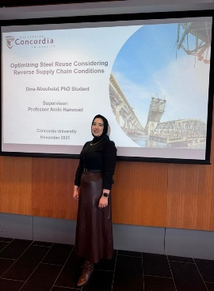
Shrouk Gharib Azadeh Soffypour Dina Abouhelal Golnaz Mirzaei
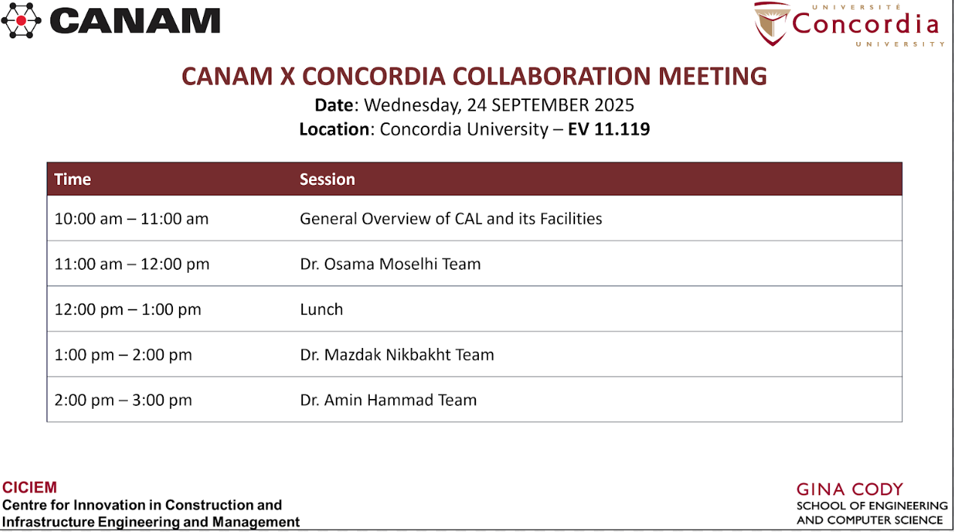

Newsletter Winter 2026
Collaboration with National Research Council (NRC)
The research team at CICIEM is working in collaboration with the National Research Council (NRC) on several projects. This partnership provides our researchers and students with valuable exposure to real-world challenges and opportunities to contribute to impactful, cutting-edge solutions, while also playing a crucial role in the training of highly qualified PhD students.
A selection of research projects with NRC is listed below:
- Transformation from Conventional to Industrialized Construction. Dr. Osama Moselhi (Supervisor), Dr. Vafa Rostamiasl (Postdoctoral Fellow), and Aida Azarain (PhD student).

- Optimum Design Layout for Modular and off-site Construction (MOC) Projects to minimize Life Cycle Environmental Impact and Life Cycle Cost (LCA/ LCC). Dr. SangHyeok Han (Supervisor), Dr. Mazdak Nik-Bakht (Supervisor), Leila Rafati (PhD Student), and Qudrati Al Wasiew (PhD student).

- Eco-Friendly Smart Construction Systems for Decarbonization of Construction Industry. Dr. SangHyeok Han (Supervisor), Dr. Mazdak Nik-Bakht (Supervisor), Azadeh Soffypour (PhD Student), and Etsub Tadesse (PhD student).

- Digital Twins for Smart Decarbonization of the Built Environment Meeting Circular Economy Criteria. Dr. Mazdak Nik-Bakht (Supervisor), Azadeh Soffypour (PhD Student), Amr Allam (PhD Student).

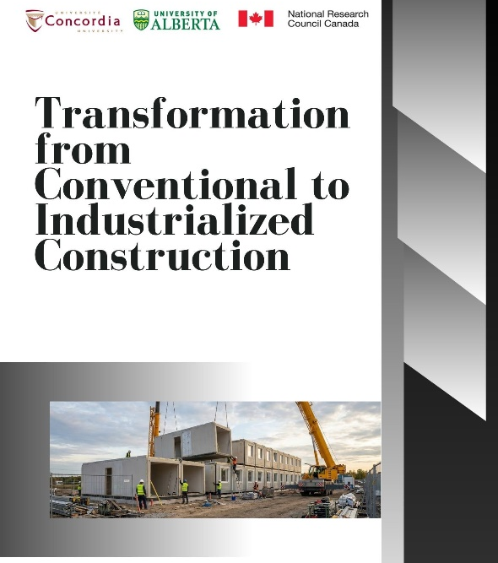

Newsletter Winter 2026
Featured Highlights

Dr. Po-Han Chen, Member of CICIEM, and Professor in the Department of Building, Civil, and Environmental Engineering at Concordia University, is currently leading and collaborating on various industry and international research projects, including:

(i) AI-Powered Analysis of Steel Shop Drawings, Mitacs Accelerate Grant and Groupe ADF.
(ii) Enhancing Construction Safety Inspection through Spatial-Temporal Analysis and Regulation Mapping, funded, Mitacs Globalink Research Award (Intern: Phuong Linh Le).

(iii) Human-Centered Smart Safety Intelligence for Urban Rail Construction: Integrating Generative AI, IoT, and Machine Learning toward Society 5.0, Mitacs Globalink Research Award (Interns: Thi Thuy Duong Tran, Minh Hieu Nguyen, Quang Vu Phung, Duc Toan Nguyen).

Recent News
Dr. Mazdak Nik-Bakht was appointed Associate Dean, Research & Innovation in 2025. In this role, Dr. Nik-Bakht is responsible for promoting, advancing, and facilitating research and innovation at the Gina Cody School and across its academic programs.


Dr. Vafa Rostamiasl, a graduate of the University of Ottawa, was hired in September 2025 by Dr. Osama Moselhi as a Postdoctoral Fellow at Concordia University. Dr. Rostamiasl is working on several projects, including the transformation from conventional to industrialized construction, in collaboration with the National Research Council (NRC).

Recent PhD Graduates
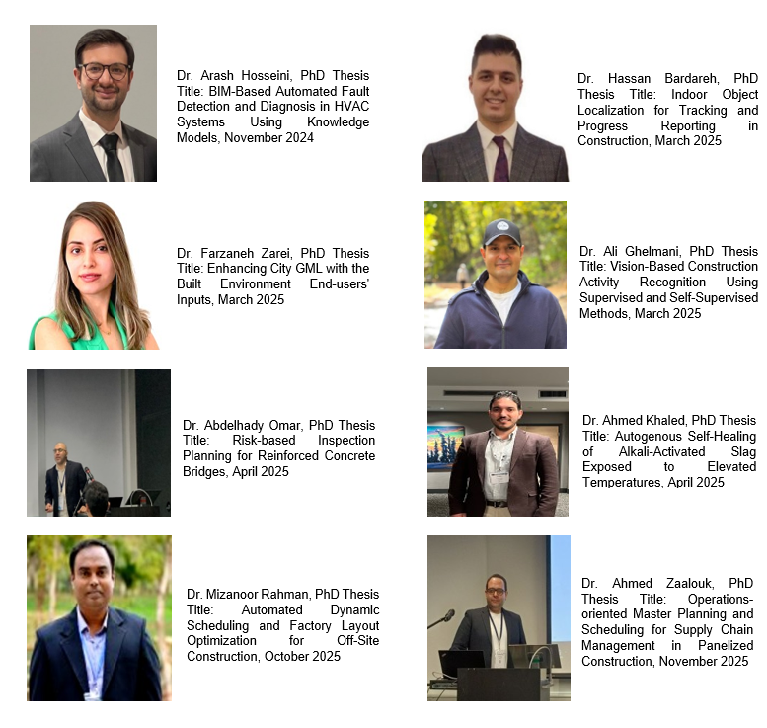
Newsletter Winter 2026
Join CICIEM
The Centre for Innovation in Construction and Infrastructure Engineering and Management (CICIEM) promotes and initiates innovative research and knowledge-based solutions for improving quality, productivity, safety and competitiveness of the Canadian construction industry through a wide range of advanced methods and technologies Please contact us If you’re interested in joining the Centre, forward your request to the Director, Dr. Osama Moselhi, along with your updated CV at moselhi@encs.concordia.ca and (CC) amin.hammad@concordia.ca.
Share your Feedback Subscribe to CICIEM Newsletter

