Centre for Innovation in Construction and Infrastructure Engineering and Management (CICIEM)
Quarterly Newsletter- Fall 2025
Message from the Director


Dr. Osama Moselhi
In recent months, CICIEM has witnessed a series of impactful events and strategic management decisions. These milestones were made possible through the dedication of its members, who have actively contributed to numerous collaborative initiatives within CICIEM, as well as with other research centres and industry partners.
In July 2025, the Centre successfully organized and hosted three major international conferences—ISARC, CSCE/CRC, and MOC. In addition, several seminars and workshops were held, featuring distinguished guests such as Mayor Simon Yu and leading industry executives.
CICIEM also secured significant external research funding, along with substantial internal grants, to enhance and upgrade its research infrastructure. This investment enabled the acquisition of new equipment and a broad range of advanced sensing technologies. With this institutional support and access to resources, the Centre has strengthened its commitment to research excellence, producing numerous scholarly contributions, including 60 articles in peer-reviewed scientific journals.
Further achievements include the graduation of several PhD students, the hiring of a research associate to support the Centre’s administrative, outreach, and research activities, and the recruitment of postdoctoral fellows. As part of its drive for excellence, the Centre undertook a comprehensive review of its vision and organizational structure in April 2025.The Centre also organized and hosted its annual international student competition (AACEi 3+1), generously sponsored and supported by industry partners.
These initiatives have reinforced CICIEM’s position as a hub for innovation, knowledge exchange, and interdisciplinary research.


Osama Moselhi, Ph.D., P.Eng., FCSCE, F. ASCE, F. AACE, F.CAE, C.M.
Professor and Director

Newsletter Fall 2025
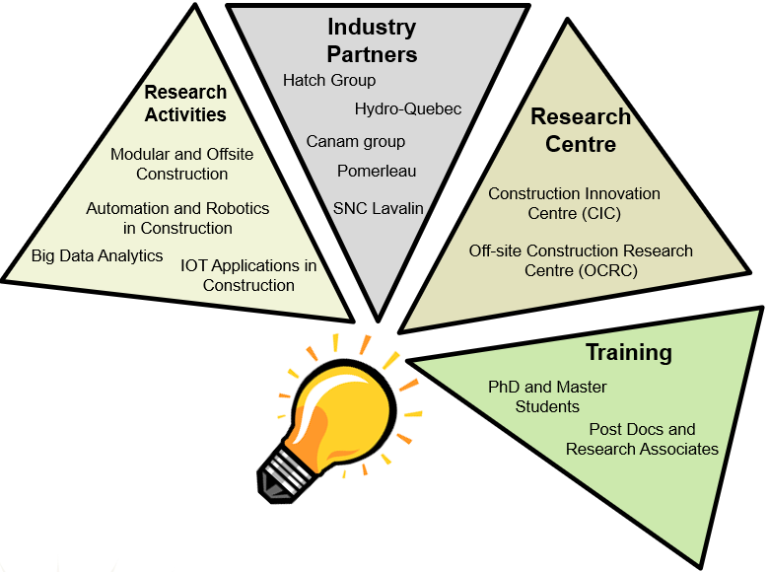  Research Highlights  The CICIEM promotes large-scale interdisciplinary research, training of highly qualified personnel, technology transfer and strong engagement with industry. Key research areas include:  - Conducting HAZOP studies in the process industries utilizing AI  - Automation and robotics in construction  - Sensing technologies and IoT applications in construction  - Industrialization of construction  - Big data analytics in the context of smart cities  The centre published a significant number of scholarly outputs including 60 peer-reviewed journal articles in the research areas highlighted above. Additionally, the CICIEM purchased new equipment: (i) LiDAR (Matterport), (ii) UWB (Ubisense) and (iii) Timelapse camera in order to enhance its research capabilities with regards to data capturing, real time localization and autonomous construction site monitoring, while also supporting the training of highly qualified personnel in cutting-edge construction technologies.  Upcoming workshop: Crafting Together the Future of Construction in Canada (November 26, 2025) |  |  | Collaborations  The CICIEM collaborated with the national research Council Canada (NRC) and Hydro Quebec as well with a number of industrial partners including Hatch, Canam, and Pomerleau to promote industry-oriented research. For example, various joint projects with NRC focus on: (i) Transformation from Conventional to Industrialized construction; (ii) Digital Twins for Smart Decarbonization of the Built Environment Meeting Circular Economy Criteria; (iii) Eco-Friendly Smart Construction Systems for Decarbonization of Construction Industry.          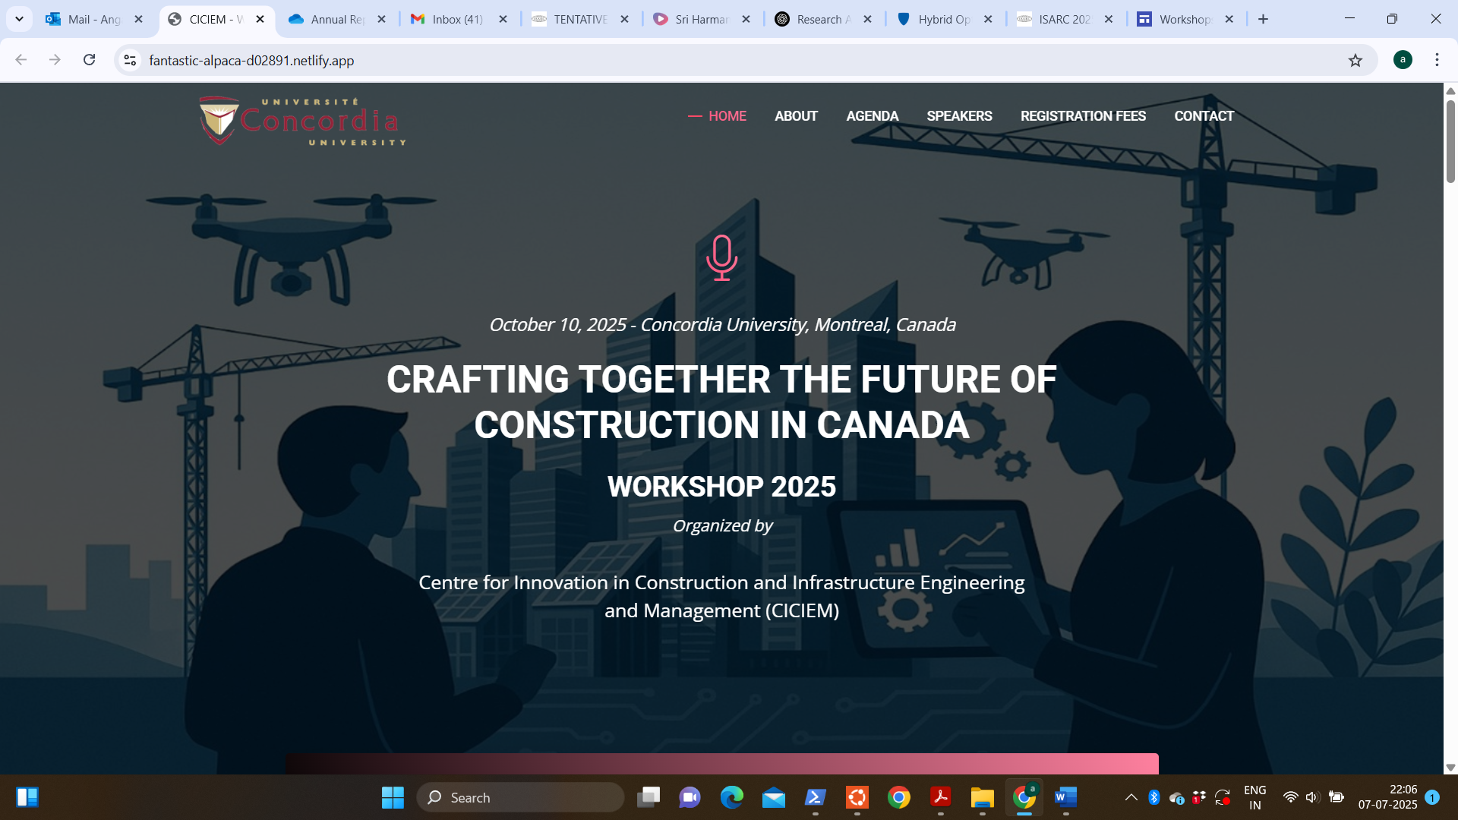
 | Spotlight  CICIEM is proud to collaborate with Hatch, a globally recognized engineering and professional services firm, through several MITACS-funded projects. These collaborations not only advance innovation in sustainable construction but also play a crucial role in training highly qualified PhD students. The partnership with Hatch provides our researchers and students with valuable industry exposure, real-world challenges, and the opportunity to contribute to impactful, cutting-edge solutions.

Newsletter Fall 2025

Visitors
- On August 07, 2025, Dr. Farnaz Sadeghpour, Associate Professor at University of Calgary and President elect, CSCE (Canadian Society for Civil Engineering) gave a seminar on ‘Rethinking Safety in Construction: A Dynamic Digital Twin for Smart Site Operations’.
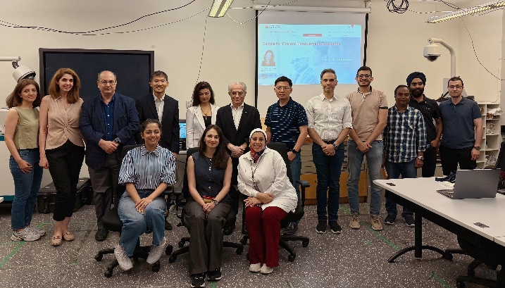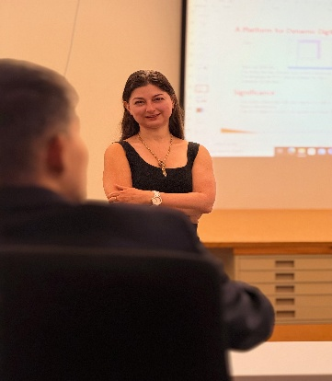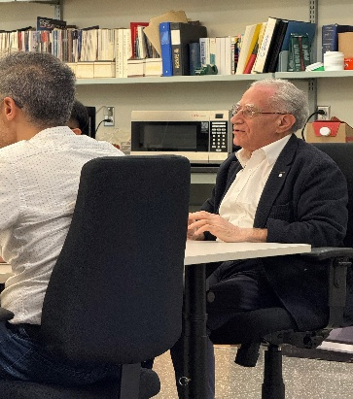
- On August 01, 2025, Dr. Kenneth Park, Reader in Construction Management & Engineering at Aston University, United Kingdom gave a seminar on ‘Lessons learned from Korean Construction Industry & Offsite Construction’.
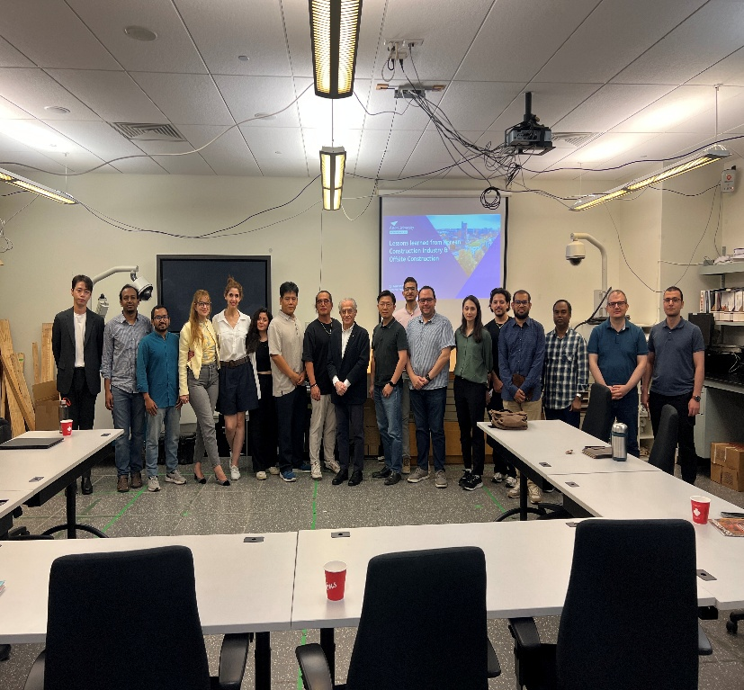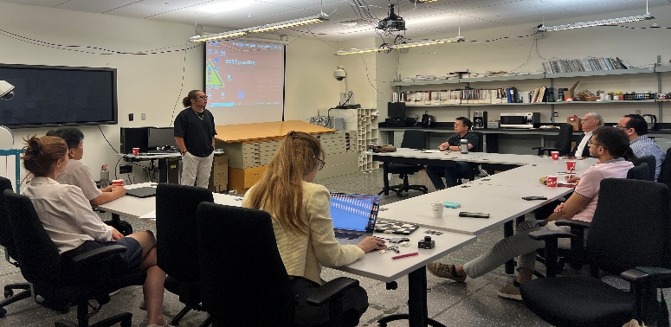
- On July 30th, Lise Bouchard, Managing Director of PM&C Excellence at Hatch, along with Dr. Moe Roghabadi, Global Director at Hatch, visited CICIEM. The purpose of this visit is to explore potential avenues for research collaboration between Hatch and Concordia University in the project management domain.
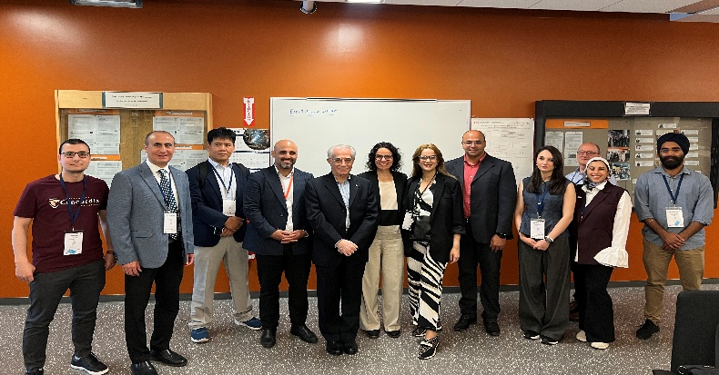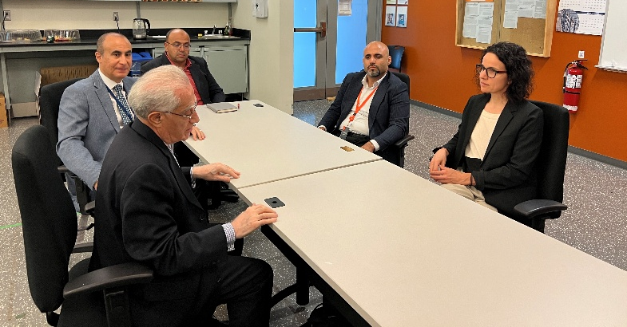
- On June 05, 2025, Mayor Simon Yu, the Mayor of Prince George, British Columbia visited CICIEM. The visit was organized by Dr. Dena Shamsollahi, and it focuses primarily on the overview of the recent research activities by CICIEM in modular construction.

- On March 13, 2025, Dr. Tim Evans, Vice-President of Research, Innovation, and Impact at Concordia University, visited the Construction and Automation Lab (CAL) to engage with ongoing research initiatives. 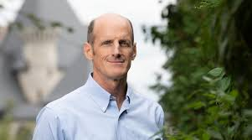

- On April 15, 2025, Dr. Quan Nguyen, Associate Professor at Hanoi University of Civil Engineering (Vietnam), visited the Construction and Automation Lab (CAL) and delivered an insightful presentation titled: ‘Transforming the Construction Industry in Vietnam Towards Society 5.0: Leveraging Digital Technologies, Circular Economy, and Stakeholder Management.’ Dr. Nguyen shared his research on the evolving role of digital transformation, sustainability, and collaborative governance in shaping the future of Vietnam’s construction sector.
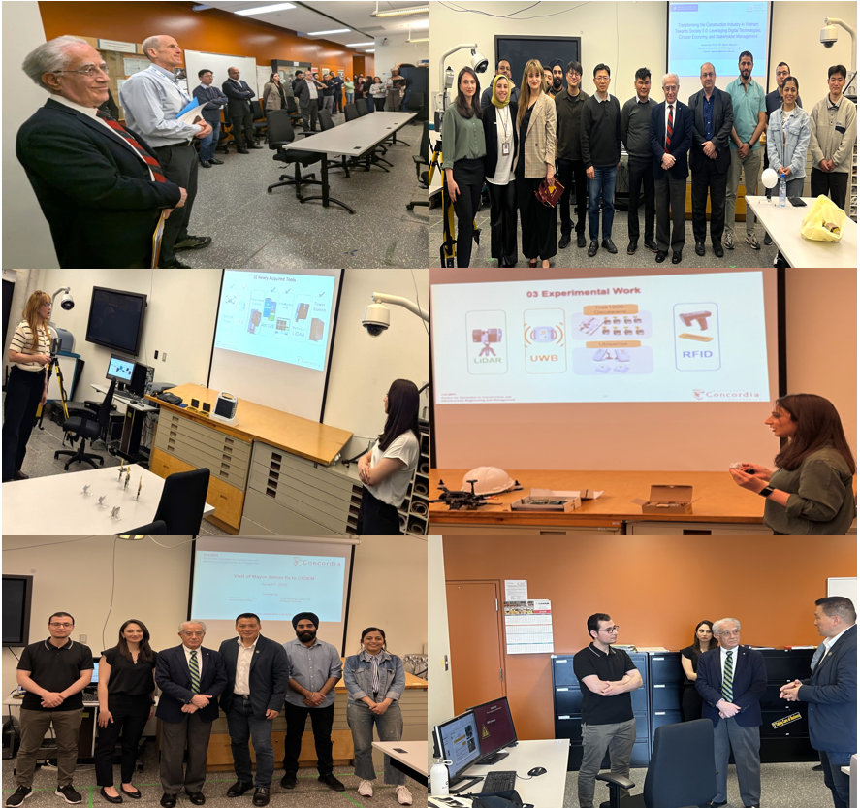

Events and Presentations at International Conferences
CICIEM hosted multiple conferences in Summer 2025, bringing together leading experts, researchers, and industry professionals to explore emerging topics and techniques in ‘Decarbonizing the Construction Industry.’
- International Symposium on Automation and Robotics in Construction (ISARC).

- CSCE Construction Specialty Conference jointly with Construction Research Congress (CRC).

- Modular and Offsite Construction (MOC) Summit.

- 7th Annual AACEI 3+1MT Construction Elevator Pitch Competition
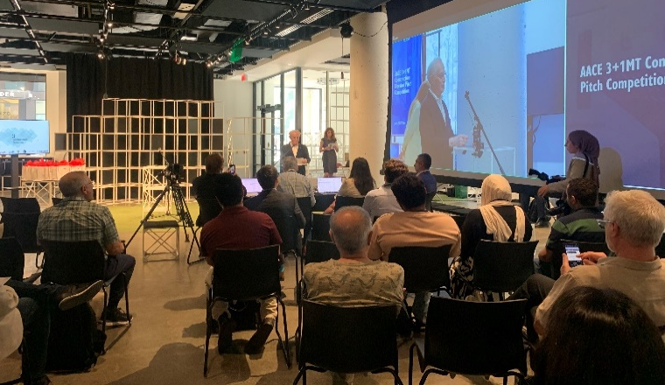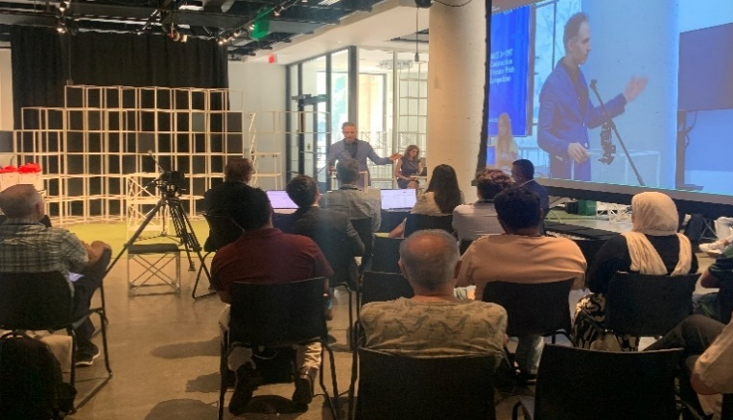
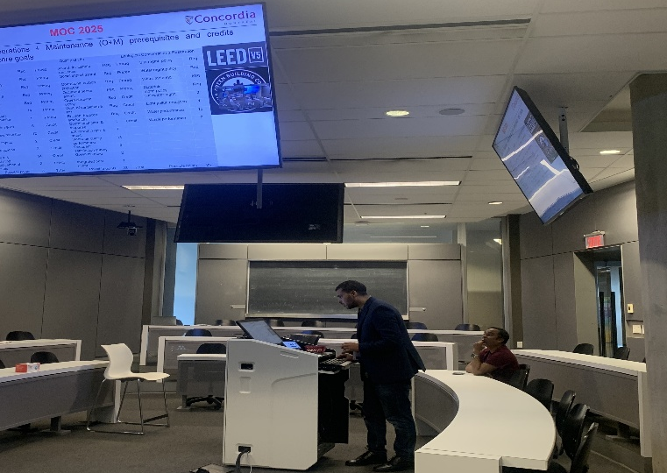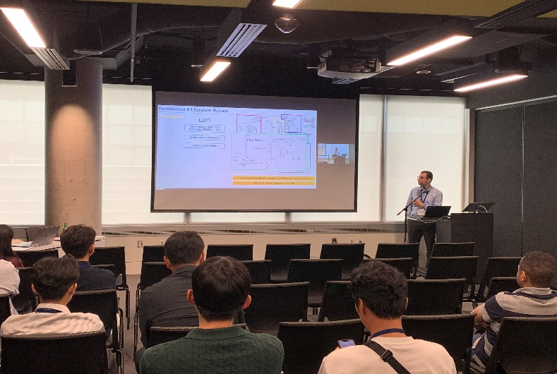
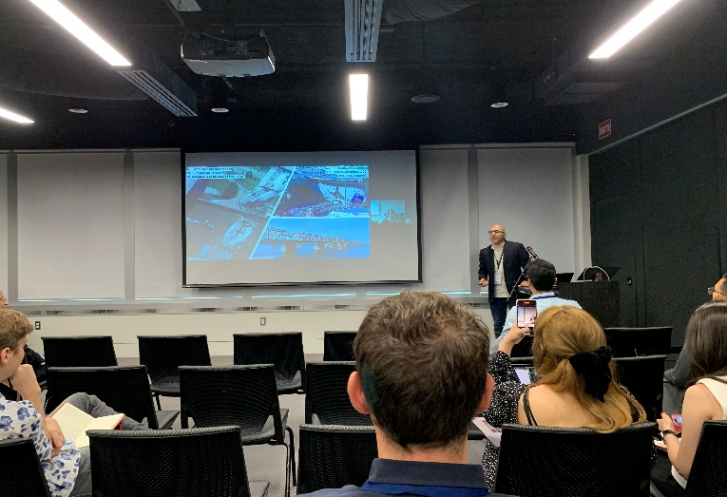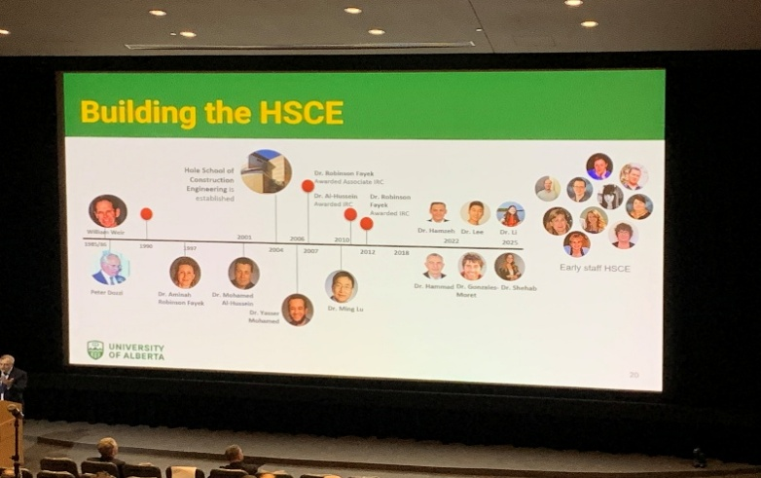
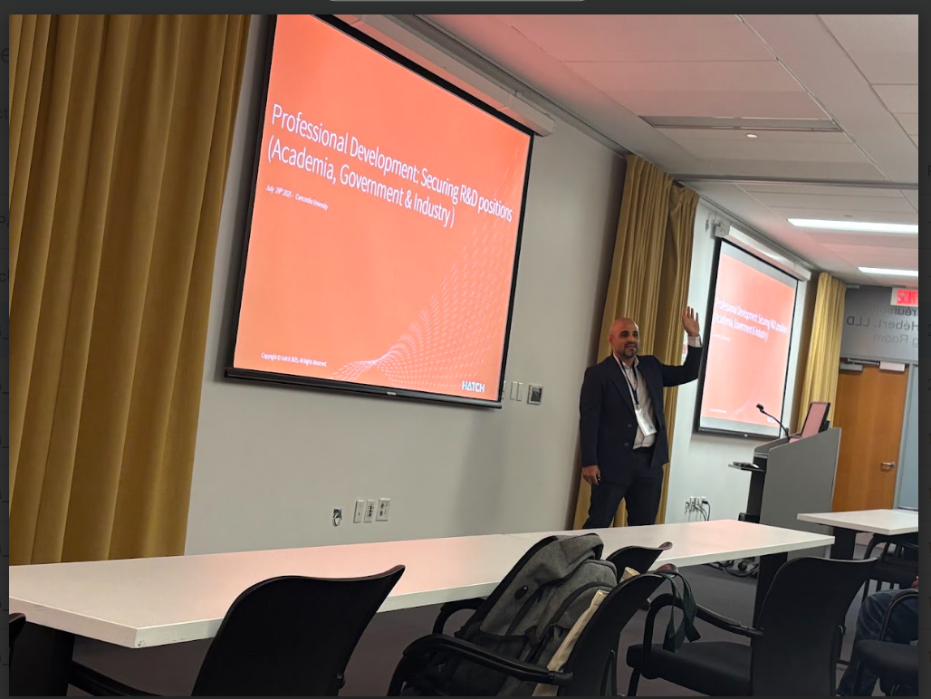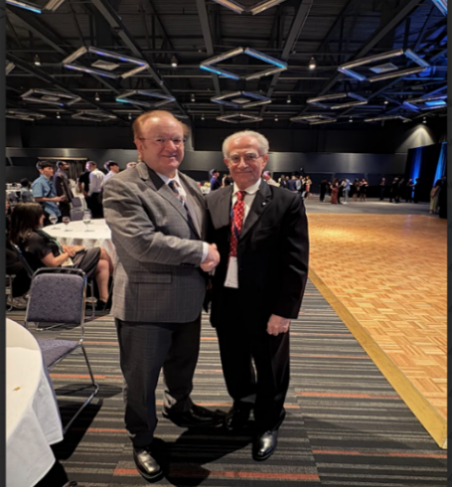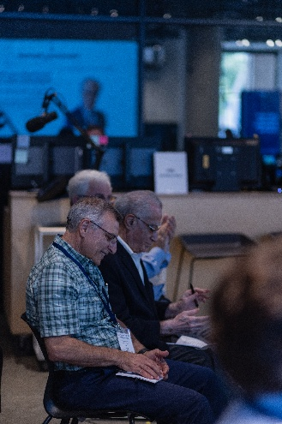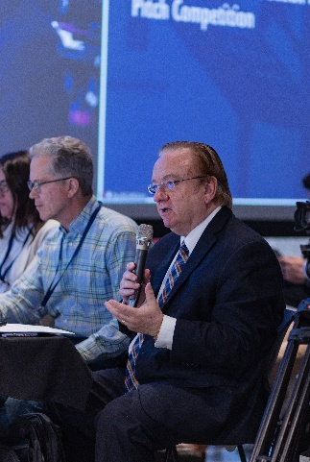
Newsletter Fall 2025

Recent Publications
A selection of publications from conferences hosted by CICIEM are listed below:
Automation and Digitization in Construction
Gharib, S. and Moselhi, O. 2025. Automated Image Dataset Generation Using Web Scraping and Large Multimodal Models for Construction Applications. Proceedings of the International Symposium on Automation and Robotics in Construction, Montreal, Canada.
Mirzaei, G., Hammad, A. and Homayounfard. F. 2025. Design Optimization of Stell Structures with Reused Components Using Generative Design. Proceedings of the International Symposium on Automation and Robotics in Construction, Montreal, Canada.
Bardareh, H., and Moselhi, O. 2025. Automated generation of inspection reports for construction operations. Proceedings of the International Symposium on Automation and Robotics in Construction, Montreal, Canada.
Huang, H. and Hammad, A., 2025. Generative Adversarial Imitation Learning to Train Rebar-Tying Agents for Agent-Based Simulation. Proceedings of the International Symposium on Automation and Robotics in Construction, Montreal, Canada.
Kim. D., Kosseim. L., Kim. H. and Ma, J.W. 2025. Paraphrasing-Based Data Augmentation for Responsible Personnel Classification in Carne Accidents. Proceedings of the International Symposium on Automation and Robotics in Construction, Montreal, Canada.
Rostami. G., Chen. P.H, and Hosseini. M. 2025. Deep Learning for Automated Crack Recognition: Insights, Challenges, and Future Directions. Proceedings of the International Symposium on Automation and Robotics in Construction, Montreal, Canada.
Civil Infrastructure/Asset Management
Khashei, M., Boloukasli F., Marzouny, N. and Dziedzic, R. 2025. Risk-Based Prioritization of Water Main Replacememnts Under Climate Change Scenarios. Proceedings of CSCE/CRC, Montreal, Canada.
Omar, A. and Moselhi, O., 2025. Improved Information Extraction from Bridge Inspection Reports using Fine-tuned Generative Pretrained Transformers. Proceedings of the International Symposium on Automation and Robotics in Construction, Montreal, Canada
Modular and Off-site Construction
Azarian, A., Bouferguene, A., Al-Hussein, M., Razavi Alavi, S. R., Ahn, J., Mehdipoor, A., Hojjati, A., Hwang, J. H., Shamsollahi, D., & Moselhi, O. 2025. Barriers and potential solutions to modular and offsite construction: A review. Modular Offsite Construction Summit, Montreal, Canada.
Zallouk, A., Altaf. S and Han, S.H. 2025. Simulated-based Integrated Transportation Planning in Panelized Construction. Proceedings of the International Symposium on Automation and Robotics in Construction, Montreal, Canada.
Rahman, M., Choudhury. R., Wasiew, Q., Moon, S. and Han, S.H. 2025. Optimizing Production Scheduling for Decarbonization in Off-Site Construction, Proceedings of CSCE/CRC, Montreal, Canada.
Bhatia, A., Moselhi, O. and Han, S.H. 2025. SVR and GA Aided Lean Six Sigma Method for Planning in Modular Construction. Proceedings of the International Symposium on Automation and Robotics in Construction, Montreal, Canada.
Risk Management
Elhosary, E. and Moselhi, O., 2025. Utilization of Artificial Intelligence in HAZOP studies and Reports. Proceedings of the International Symposium on Automation and Robotics in Construction, Montreal, Canada.
Hammam, M., Moselhi, O. and Alkass, S., 2025. Risk-Based Comparison of Collaborative Delivery Methods in Canadian Construction: Progressive Design Build, Integrated Project Delivery and Project Alliancing. Proceedings of CSCE/CRC, Montreal, Canada
Predictive Models
Gourabpasi, A., Jalaei, F., and Nik-Bakht, M. 2025. Feature Sensitivity Analysis for Enhanced HVAC Fault Detection and Diagnosis. Proceedings of the International Symposium on Automation and Robotics in Construction, Montreal, Canada.
Social Activities, Awards and Recognitions
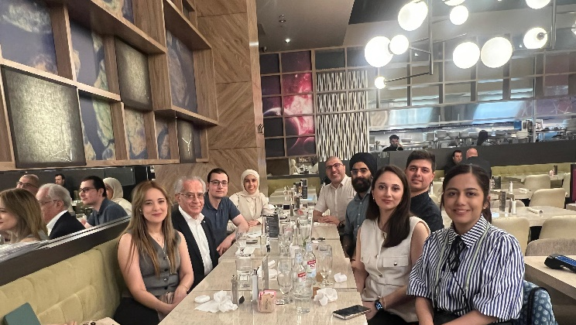
Lunch Gathering with Dr. Osama Moselhi in Celebration of PhD Graduates
Deans Excellence Research Award 2025 First Place at AACE 3MT+1 Pitch Competition 2025


Dr. Mazdak Nik-Bakht, Associate Professor Golnaz Mirzaei, MASc. Student

Recent PhD Graduates and Recent Hiring
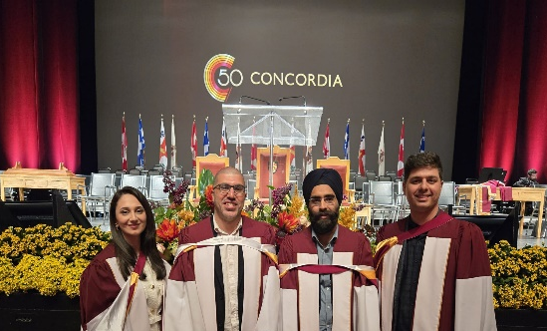     Dena Shamsollahi, Abdelday Omar, Angat Bhatia, Hassan Bardareh Arash Hosseini Farzaneh Zarei Ali Ghelmani Ahmed Nawar

Dena Shamsollahi (Postdoctoral Fellow) Angat Bhatia (Research Associate) Farzaneh Zarei (Postdoctoral Fellow)
Join CICIEM
The Centre for Innovation in Construction and Infrastructure Engineering and Management (CICIEM) promotes and initiates innovative research and knowledge-based solutions for improving quality, productivity, safety and competitiveness of the Canadian construction industry through a wide range of advanced methods and technologies Please contact us If you’re interested in joining the Center, forward your request to the Director, Dr. Osama Moselhi, along with your updated CV at moselhi@encs.concordia.ca and (in CC) amin.hammad@concordia.ca.
Share your Feedbacks Subscribe to CICIEM Newsletter

