

CICIEM
Centre for Innovation in Construction and Infrastructure Engineering and Management

Annual Report June 2024 - June 2025

EXECUTIVE SUMMARY
The period from June 2024 to June 2025 witnessed the successful acquisition of substantial external and internal research funding, alongside a wide range of impactful research and training activities.

While the Center was originally established in 2019, it was formally recognized as a University Research Center on November 3, 2023. And it was not until May 14, 2024, that the Center received its operating budget. This critical milestone was made possible through the dedication of its members, who have actively contributed to diverse research initiatives and collaborative efforts—both within CICIEM and in partnership with other research centers and industry collaborators.

This formal recognition, coupled with institutional support and resources, has catalyzed a renewed and focused drive for research excellence.

This report highlights the Center’s key achievements during the funding period, including:

• The training of highly qualified personnel (HQP)

• The dissemination of research findings through a significant number of scholarly outputs
including 60 peer-reviewed journal articles.

In addition, the Center organized and hosted numerous seminars, workshops, and international conferences-, many in collaboration with Canadian research centers and industry stakeholders. These activities have further solidified CICIEM’s role as a dynamic and impactful hub for innovation, interdisciplinary research, and knowledge exchange in construction engineering and management.


Osama Moselhi, Ph.D., P.Eng., FCSCE, F. ASCE, F. AACE, F.CAE, C.M.
Professor and Director



  `




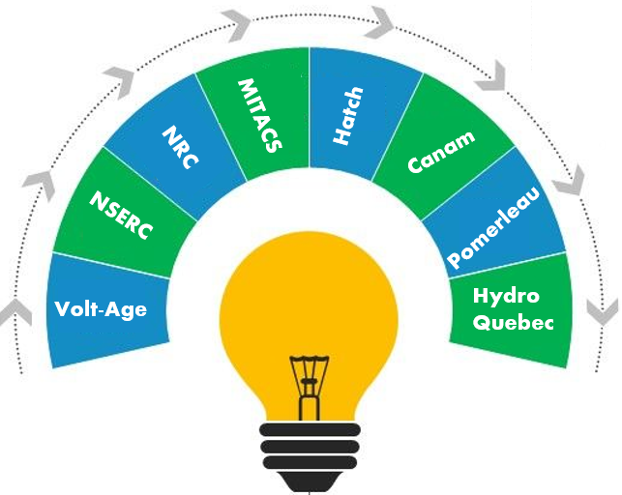

external funding Received
Liaising with the greatest and most active industry players in the areas of construction and infrastructure, the Centre has several successful research team grants. This includes: (i) Eco-Friendly Smart Construction Systems for Decarbonization of Construction Industry; (ii) Digital Twins for Smart Decarbonization of the Built Environment Meeting Circular Economy Criteria; (iii) Comparing Hardening Options for Power Distribution Networks Considering Climate Change. The CICIEM was able to secure a total fund for the three projects of about
$ 1.5 million.

Additionally, CICIEM secured funding of $330,000 from the NRC for a project titled: Transformation from Conventional to Industrialized Construction.

CICIEM has also secured additional grants through Mitacs and international research collaborations. For example, Mitacs-funded projects, such as the simulation-based risk allocation and HAZOP related studies in collaborative projects conducted with Hatch, received a total of $60,000 in funding.

Total funding secured by CICIEM: $2.3114 million
Grant Agency | Project Name | PI | Funds
Volt- Age | Comparing Hardening Options for Power Distribution Networks Considering Climate Change | Dr. Amin Hammad | $ 460,000
Volt- Age | Digital Twins for Smart Decarbonization of the Built Environment Meeting Circular Economy Criteria | Dr. Mazdak Nik-Bakht | $ 400,000
Volt- Age | Eco-Friendly Smart Construction Systems for Decarbonization of Construction Industry | Dr. SangHyeok Han | $ 426,000
NRC | Transformation from Conventional to Industrialized Construction | Dr. Osama Moselhi | $ 330,000
NRC | Open BIM for Retrofit Digital Twin Models Under a Circular Economy Criteria | Dr. Mazdak Nik-Bakht | $199,000
Mitacs | Fast Estimation of Building Stocks in the GTA for Deconstruction Assessment | Dr. Mazdak Nik-Bakht | $ 60,000
Mitacs/NSERC | Structural Digital Twins of Bridge Infrastructure with Physics-Informed Neural Network | Dr. Mazdak Nik-Bakht | $ 140,000
Mitacs | Exploring Methods of Intelligent Development of P& IDs and Generation of HAZOP Notes | Dr. Osama Moselhi | $ 30,000
Mitacs | Evaluation of AI-assisted HAZOP Tools and their Potential Applications | Dr. Osama Moselhi | $ 15,000
Mitacs | Simulation-Based Risk Allocation in Collaborative-Based Projects | Dr. Osama Moselhi | $ 15,000
NSERC-City of Montreal | Reliable Optimization Approaches for Energy Efficient Water Distribution Networks | Dr. Rebecca Dziedzic | $150,000
Mitacs | Developing Sustainable Housing for the Net Zero Transition Leveraging Green Materials and Digital Technologies: Advancing Research and Practice in Vietnam and Canada | Dr. Po-Han Chen | $ 18,000
Concordia -Vietnam Seed | Conception of Sustainable Planning and Implementation for Infrastructure and Construction | Dr. Po-Han Chen | $ 12,000
Canada - ASEAN Seed | BIM- Based Carbon Footprints Analysis in Toll Road Projects: Usage of Asphalt, Concrete, and Diesel Fuel | Dr. Po-Han Chen | $ 10,200
Canada - ASEAN Seed | Probabilistic Simulation for Predicting Urban Crossroad Traffic Noise Mapping: A comparative Analysis between Canada and Malaysia | Dr. Po-Han Chen | $ 10,200
Mitacs | Finetuning an Embedding Model for RAG in the Construction of Minority Languages | Dr. JongWon Ma | $ 6,000
Mitacs | Digital Twinning Opportunity for Circular Economy in Construction | Dr. JongWon Ma | $ 30,000

CICIEM NEW EQUIPMENT
The CICIEM has invested heavily in new research equipment, with a focus on innovation and sustainability. This year, CICIEM allocated $ 80,000 (equipment grant) towards buying cutting-edge equipment that has set new construction industry standards.

Ultra-wideband (UWB) TRACKING SYSTEM
Ultra-Wideband (UWB) is a wireless communication technology that transmits data over a wide frequency spectrum. It is used for precise object location tracking.

MATTERPORT LIDAR
Matterport LiDAR refers to the use of LiDAR (light detection and ranging) technology in Matterport devices to create highly accurate 3D models of real-world spaces.

MODAL AI DRONE
Modal AI drone (VOLX series) is a cutting edge unmanned aerial system built around the VOLX autonomy platform by Modal AI. These US- made drones are capable of real-time obstacle avoidance and onboard AI interference.

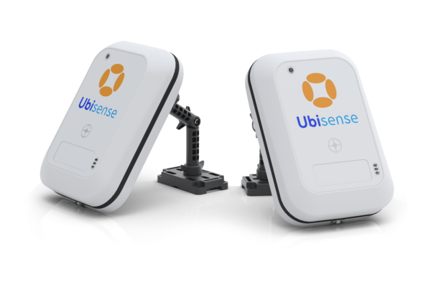  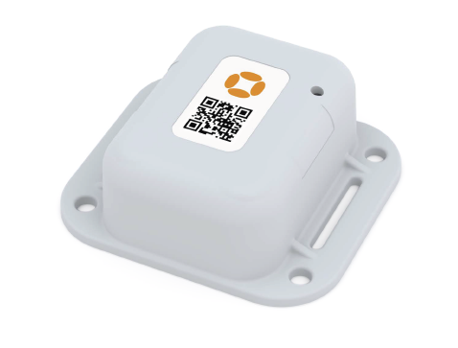 |  |  |  |  | 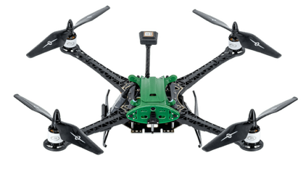
UWB  $ 24, 304 |  | MATTERPORT LIDAR  $ 12,615 |  |  | MODAL AI DRONE  $ 9,129

No | Tool | Cost (CAD) | Main Features & Capabilities | Research Applications
1 | UWB Tracking System – Ubisense | $ 24,304.13 | - Real-time 3D tracking with high precision (centimeter-level accuracy)  - High update rate  - Robust performance in complex environments  - Seamless IoT integration | - Asset tracking on construction sites  - Site monitoring and safety enhancement  - Workflow optimization studies
2 | 3D Laser Scanner FARO 3D X | $ 7,520.89 | - High-resolution 3D scans  - Long-range capabilities (up to 350m)  - Fast data capture  - Compact and portable design | - As-built modeling  - Structural analysis  - Progress tracking  - BIM integration for construction projects
3 | Timelapse Camera – Brinno | $ 984.78 | - HDR & FHD video  - Long battery life  - Real-time monitoring  - Weather-resistant design  - Automated imaging | - Construction progress documentation  - Timeline and delay analysis  - Project lifecycle visualization
4 | Aerial Data Drone  Model AI | $ 9,129.42 | - 4K camera  - GPS-enabled navigation  - Remote connectivity  - Real-time data processing  - AI-based navigation | - Aerial mapping of construction sites  - Activity monitoring  - Digital twin creation  - Site inspections
5 | GIS Software Platform – Esri | $ 3,530.00 | - Spatial data analysis  - Visualization dashboards  - Mobile data collection  - 3D GIS mapping | - Geospatial analysis for infrastructure planning  - Risk assessment  - Construction project site analysis
6 | RFID-GIS Integration Tool - Bernsten | $ 4,052.97 | - Real-time asset tracking  - Mobile/web access  - Continuous data updates  - GIS software integration | - Material tracking and management  - Supply chain optimization  - Asset lifecycle monitoring in projects
7 | LiDAR Imaging System – Matterport | $ 12, 615 .68 | - Combines LiDAR with photogrammetry  - Creates immersive virtual environments  - Cloud-based processing  - Suitable for both indoor and outdoor use | - High-precision 3D modeling  - Virtual inspections  - Data visualization  - Change detection in construction projects
8 | High-Performance Tower Workstation | $ 3,165.77 | - AI processing capabilities  - Big data analytics  - Simulation modeling  - Machine learning optimization | - Advanced computing for large datasets  - AI model development  - Data analysis for construction performance

Projects undertaken
The CICIEM promotes large-scale interdisciplinary research, training of highly qualified personnel, technology transfer and strong engagement with industry.

Automation and Digitization in Construction
Modular and Off-Site Construction
Civil Infrastructure and Asset Management
Risk Management, Smart Materials and Predictive Models

Transformation from Conventional to Industrialized Construction. PI: Dr. Osama Moselhi; Co-PIs: Dr. Al-Hussein, Dr. Ahmed Bouferguène. This project is in collaboration with the University of Alberta and the National Research Council (NRC). Project Duration: March 2024 - March 2026.

Comparing Hardening Options for Power Distribution Networks Considering Climate Change. PI: Dr. Amin Hammad; Co-PIs: Dr. Osama Moselhi, Dr. Mazdak Nik-Bakht, Dr. Rebecca Dziedzic, Collaborators: Hydro-Quebec, UoA, UQAM. Project Duration: 2 Years

Eco-Friendly Smart Construction Systems for Decarbonization of Construction Industry. PI: Dr. SangHyeok Han; Co-PIs: Dr. Ahmed Soliman, Dr. Osama Moselhi, Dr. Mazdak Nik-Bakht, Dr. Rebecca Dziedzic, Dr. Po-Han Chen, Dr. Jong Won Ma, Collaborators: UoA, NRC, Canam, Pomerleau, Hydro-Quebec. Project Duration: 2 Years

Digital Twins for Smart Decarbonization of the Built Environment Meeting Circular Economy Criteria. PI: Dr. Mazdak Nik-Bakht; Co-PIs: Dr. Amin Hammad, Dr. Jong Won Ma; Collaborators: NRC, UoT, ETS, Light House, Adaptis, Aknovia. Project Duration: 2 Years

Simulation-Based Risk Allocation in Collaborative Based Projects. Supervisor: Dr. Osama Moselhi, Intern: Meenatallah Hammam. Project Duration: August – December 2024

Evaluation of AI- Assisted HAZOP Tools and Their Potential Applications. Supervisor: Dr. Osama Moselhi, Intern: Ehab Elhosary. Project Duration: November 2024 – May 2025.

Exploring Methods of Intelligent Development of P& IDs and Generation of HAZOP Notes. Supervisor: Dr. Osama Moselhi, Intern: Ehab Elhosary. Project Duration: October 2023 - November 2024

Developing Sustainable Housing for the Net Zero Transition Leveraging Green Materials and Digital Technologies: Advancing Research and Practice in Vietnam and Canada. Supervisor: Dr. Po-Han Chen, Interns: Minh Quan Pham, Quang Phuong Luu, Duc Trung Nguyen.

Conception of Sustainable Planning and Implementation for Infrastructure and Construction. PI: Dr. Po-Han Chen, Collaborator: Dr. T. Quan Nguyen.

Finetuning an Embedding Model for RAG in the Construction of Minority Languages. Supervisor: Dr. JongWon Ma, Intern: Kichang Choi.

Digital Twinning Opportunity for Circular Economy in Construction. Supervisor: Dr. JongWon Ma, Interns: Hyunuk Jung, Sunjae Kim, Yunji Lee, Hyejin Kim, Heejin Ju.

BIM – Based Carbon Footprint Analysis in Toll Road Projects: Usage of Asphalt, Concrete and Diesel Fuel. PI: Dr. Po- Han Chen.

Probabilistic Simulation for Predicting Urban Crossroad Traffic Noise Mapping: A Comparative Analysis Between Canada and Malaysia. PI: Dr. Po- Han Chen.

Reliable Optimization Approaches for Energy Efficient Water Distribution Networks. PI: Dr. Rebecca Dziedzic.

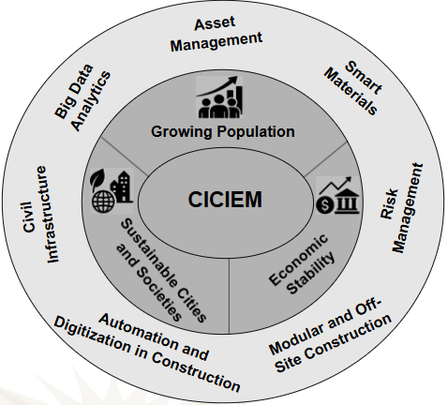

publicationS
A selection of journal publications on relevant topics are listed below:

​​​Automation and Digitization in Construction
- ​Bardareh, H., and Moselhi, O. 2025. Automated Generation of Inspection Reports for Construction Operations. Proceedings of the International Symposium on Automation and Robotics in Construction, Montreal, Canada.
- Oktavianus, A., Chen, P.H., Lin, J.J., and Chang, L.M. 2025. Automating Post-Earthquake Recovery in Construction: Leveraging BIM, Deep Learning, and Web Map Services for Efficient Solutions. Journal of Computing in Civil Engineering, 39(3), 6142.
- Dunson-Todd, M., Nik-Bakht, M., and Hammad, A. 2025. Proposed Standard Test to Evaluate Back-Support Exoskeleton Efficacy for Rebar Workers: Test Design and Initial Implementation. Journal of Computing in Civil Engineering, 39(5), 04025071.
- Allam, A.S., and Nik-Bakht, M. 2025. Integrating Industry Foundation Classes and Knowledge Graphs for Automated Deconstruction Planning. Journal of Building Engineering, 106, 112564.
- ​Shamsollahi, D., Moselhi, O., and Khorasani, K. 2024. Data Integration Using Deep Learning and Real-Time Locating System for Automated Construction Progress Monitoring and Reporting. Automation in Construction, 168, 105778.
- ​Bahreini, F., and Hammad, A. 2024. Dynamic Graph CNN Based Semantic Segmentation of Concrete Defects and As-Inspected Modeling. Automation in Construction, 159, 105282.
- Ma, J.W., Jung, J., and Leite, F. 2024. Deep Learning–Based Scan-to-BIM Automation and Object Scope Expansion Using a Low-Cost 3D Scan Data. Journal of Computing in Civil Engineering, 38(6), 04024040.
- Pham, V.H., Chen, P.H., Nguyen, Q., and Duong, D.T. 2024. BIM-based Automatic Extraction of Daily Concrete and Formwork Requirements for Site Work Planning. Buildings, 14(12), 14124021.
- Oktavianus, A., Chen, P.H., and Lin, J.J. 2024. Intelligent Post-Earthquake Building Recovery System: A Framework Combining BIM and Deep Learning. Journal of Building Engineering, 98, 111366.

​​​Civil Infrastructure and Asset Management​​
- ​Sinaei, A., Dziedzic, R., and Creaco, E. 2025. Holistic Assessment of Social, Environmental and Economic Impacts of Pipe Breaks: The Case Study of Vancouver. Water, 17(2), 252.
- Zarei, F., and Nik-Bakht, M. 2025. Enhancing CityGML with Demographic Information of the Public for Knowledge Management and Interference – The Case of Prioritizing Pothole Repairs in Toronto. Journal of Infrastructure Systems (Accepted, May 2025).
- Panizza, R., and Nik-Bakht, M. 2024. Building Stock as a Future Supply of Second-Use Material – A Review of Urban Mining Methods. Waste Management Bulletin, 2(2), 19-31.
- Zarei, F., and Nik-Bakht, M. 2024. Extending CityGML with Public Input–Social ADE. Built Environment Project and Asset Management, 14(4), 547-561.
- ​Omar, A., and Moselhi, O. 2024. Automated Data-Driven Condition Assessment Method for Concrete Bridges. Automation in Construction, 167, 105706.
- Boloukasli, F., Khashei, M., Nosrati, M., Hedaiaty, N., and Dziedzic, R. 2024. Enhancing Water Demand Forecasting: Leveraging LSTM Networks for Accurate Predictions. Engineering Proceedings, 69(1), 120.

​​Modular and Off-site Construction
- ​Zaalouk, A., Altaf, M.S., and Han, S.H. 2025. Operations-Oriented Supply Chain Master Planning in Panelized Construction Using Hybrid Multiagent Simulation. Journal of Construction Engineering and Management, 151(10), 04025159.
- Bhatia, A., Moselhi, O., and Han, S.H. 2025. Hybrid Optimization Approach for Scheduling in Panelized Construction Manufacturing. Journal of Construction Engineering and Management, 151(8), 04025107.
- ​Rahman, M., and Han, S.H. 2024. Linear Scheduling Method-Based Multi-Objective Optimization for Off-Site Construction Manufacturing. Automation in Construction, 167, 105712.

​Condition Assessment and Predictive Models
- Soultanzadeh, M.B., Nik-Bakht, M., Ouf, M.M., Paquette, P., and Lupien, S. 2025. Unsupervised automated fault detection and diagnosis for light commercial buildings HVAC systems. Building and Environment, 267, 112312.
- Khazen, M., Nik-Bakht, M., and Moselhi, O. 2024. Monitoring Workers on Indoor Construction Sites Using Data Fusion of Real-Time Worker's Location, Body Orientation, and Productivity State. Automation in Construction, 160, 105327.
- ​Martinez, A.J., and Nik-Bakht, M. 2024. Process Mining, Modeling, and Management in Construction: A Critical Review of Three Decades of Research Coupled with a Current Industry Perspective. Journal of Construction Engineering and Management, 150(11), 04024158.
- Hosseini Gourabpasi, A., and Nik-Bakht, M. 2024. An Ontology for Automated Fault Detection & Diagnostics of Hvac Using BIM And Machine Learning Concepts. Science and Technology for the Built Environment, 30(8), 972-988.
- Soultanzadeh, M.B., Ouf, M.M., Nik-Bakht, M., Paquette, P., and Lupien, S. 2024. Fault Detection and Diagnosis in Light Commercial Buildings’ HVAC Systems: A Comprehensive Framework, Application, and Performance Evaluation. Energy and Buildings, 316, 114341.
- Gourabpasi, A.H., and Nik-Bakht, M. 2024. Bim-Based Automated Fault Detection and Diagnostics of HVAC Systems in Commercial Buildings. Journal of Building Engineering, 87, 109022.

​Risk Management
- Elhosary, E., and Moselhi, O. 2025. Evaluating Natural Language Processing Algorithms for Improved Hazard and Operability Analysis. Geodata and AI, 100026.
- Elhosary, E., and Moselhi, O. 2024. Automation for HAZOP study: A State-Of-The-Art Review and Future Research Directions. Journal of Information Technology in Construction, 29(33), 750-777.

​Smart Material and Sustainability
- ​Ali, N., and Soliman, A.M. 2025. Influence of Viscosity Modifier Addition Methods on the Rheological Behavior of Alkali-Activated Slag Systems. Construction and Building Materials, 483, 141714.
- Khaled, A., and Soliman, A.M. 2025. Effect Of Activator Dosage on the Post-Fire Autogenous Self-Healing of Alkali-Activated Slag. Construction and Building Materials, 461, 139908. ​
- Gomes. J., Dziedzic. R., and Nik-Bakht, M. 2025. A Comprehensive and Inclusive Decision -Making Framework for the End-of-Life (EoL) of Built Facilities. Journal of Cleaner Production (Accepted 2025).
- Allam, A., and Nik-Bakht, M. 2024. Supporting Circularity in Construction with Performance-Based Deconstruction. Sustainable Production and Consumption, 45, 1-14.

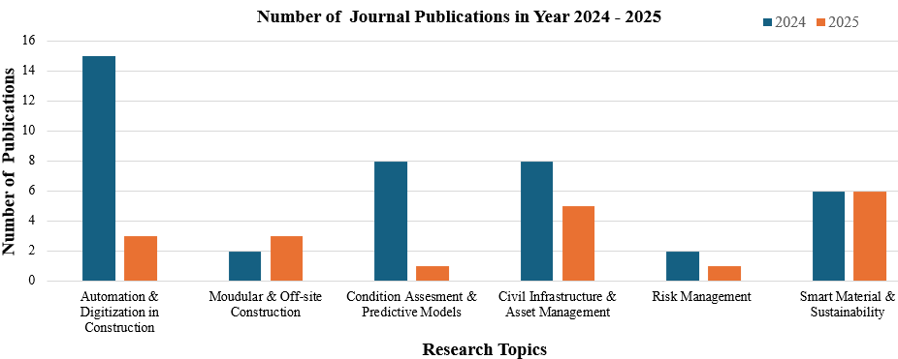

HOSTED EVENTS
On June 05, 2025, Mayor Simon Yu, the Mayor of Prince George, British Columbia visited CICIEM. The visit was organized by Dr. Dena Shamsollahi, and it focuses primarily on the overview of the recent research activities by CICIEM in modular construction.

On April 15, 2025, Dr. Quan Nguyen, Associate Professor at Hanoi University of Civil Engineering (Vietnam), visited the Construction and Automation Lab (CAL) and delivered an insightful presentation titled: ‘Transforming the Construction Industry in Vietnam Towards Society 5.0: Leveraging Digital Technologies, Circular Economy, and Stakeholder Management.’ Dr. Nguyen shared his research on the evolving role of digital transformation, sustainability, and collaborative governance in shaping the future of Vietnam’s construction sector.

On March 13, 2025, Dr. Tim Evans, Vice-President of Research, Innovation, and Impact at Concordia University, visited the Construction and Automation Lab (CAL) to engage with ongoing research initiatives. During the visit, Dr. Dena Shamsollahi (Postdoctoral Fellow) and other CAL team members showcased several of their latest projects. The presentations highlighted the lab's innovative work in construction progress monitoring, with a particular focus on the use of advanced technologies such as LiDAR and Ultra-Wideband (UWB) sensors.

On November 5, 2024, Julie Grave, a representative from Canam, visited CICIEM and CAL. During the visit, Ms. Grave shared insights into Canam’s products, ongoing projects, and expertise in the construction industry.

On November 4, 2024, Professor Luh-Maan Chang, Professor Emeritus at Purdue University and National Taiwan University, visited CICIEM. During his visit, Professor Chang delivered an insightful and engaging presentation on Taiwanese semiconductor chip manufacturing and fabrication facilities.

On June 20, 2024, Dr. Valerie Francis, a Professor at the University of Melbourne, visited CICIEM and Construction and Automation Lab (CAL) to engage with ongoing research initiatives. During her visit, students of Dr. Osama Moselhi and Dr. Rebecca Dziedzic presented their research on Automation and Digitization in Construction, Modular and Off-site Construction, and Civil Infrastructure.

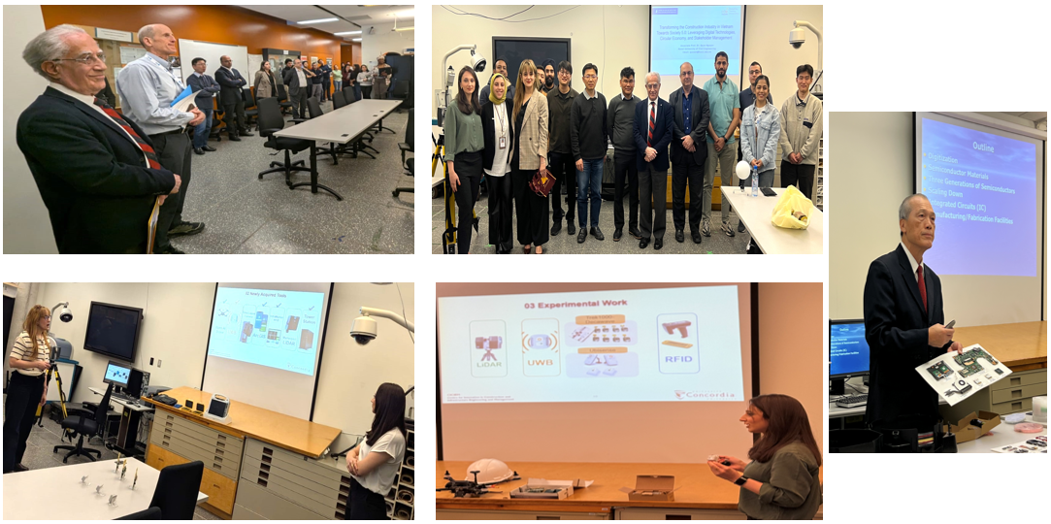

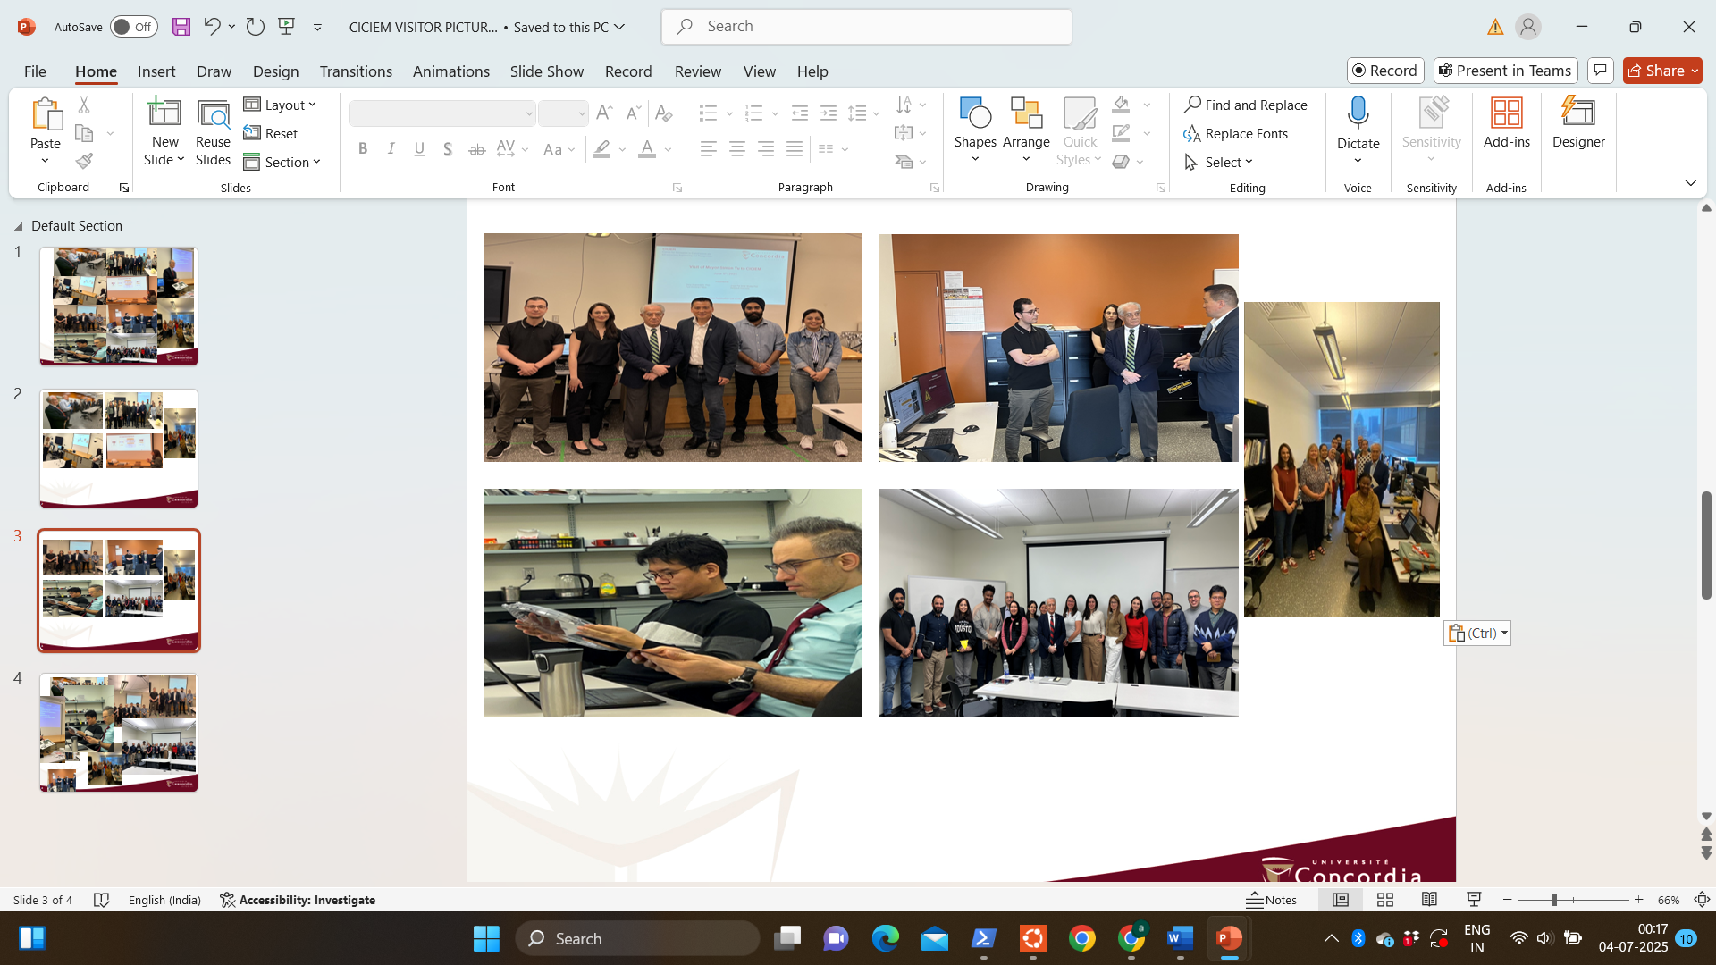

PLANNING/Organization of Conference, SEMINAR, WORKSHOP
Conference
Three major international conferences (ISARC, CSCE/CRC, MOC) were hosted by CICIEM at Concordia University from July 28 – 31, 2025. The event was organized by a local committee led by Dr. Amin Hammad. The CSCE/CRC was chaired by Dr. Mazdak Nik-Bakht, and Dr. Mohamed Al-Hussein chaired MOC. The conference was attended by approximately 500 participants from 30 countries.

International Symposium on Automation and Robotics in Construction (ISARC)
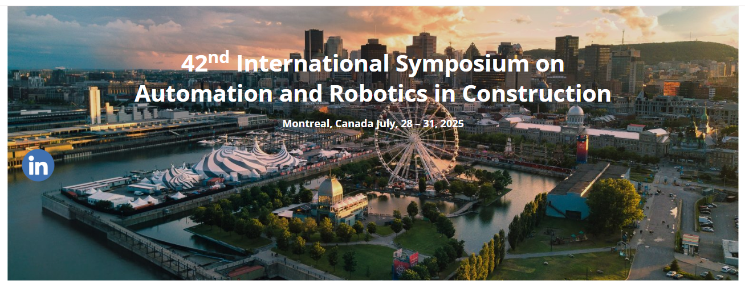

CSCE Construction Specialty Conference / ASCE Construction Research Congress (CRC)
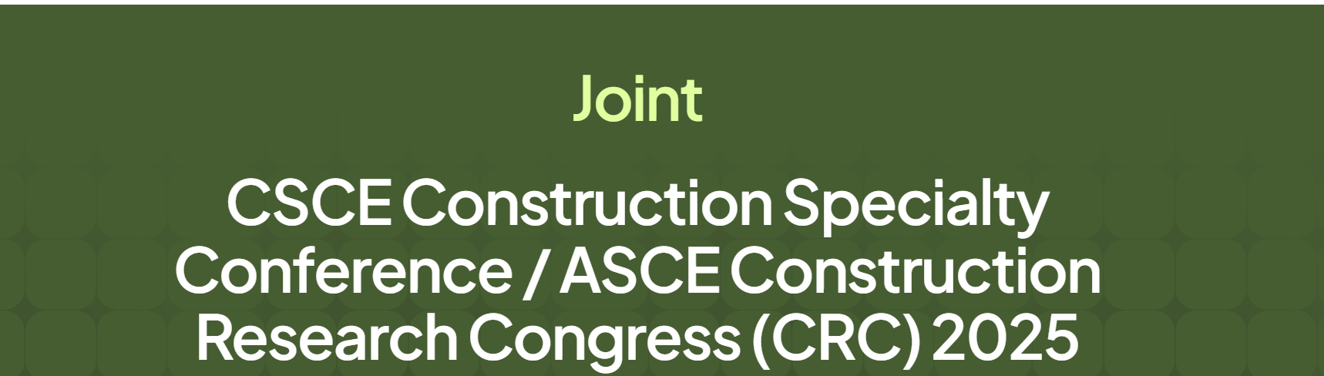

Modular and Offsite Construction Summit (MOC)
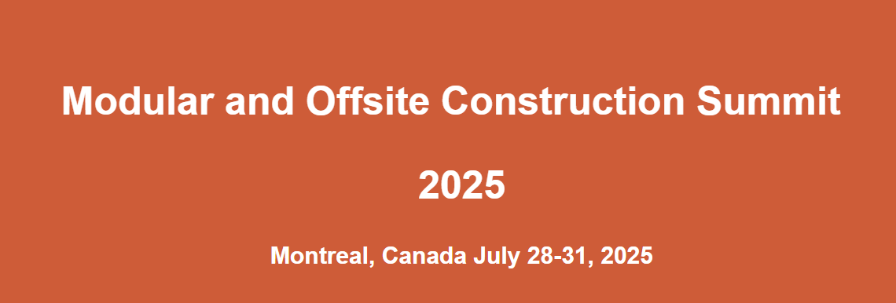

Seminar
During the Fall 2024 and Winter 2025 semesters, several bi-weekly seminars were organized in the Construction Automation Lab (CAL) to showcase student research. These seminars support one of the key objectives of CICIEM: the training of highly qualified personnel (HQP).
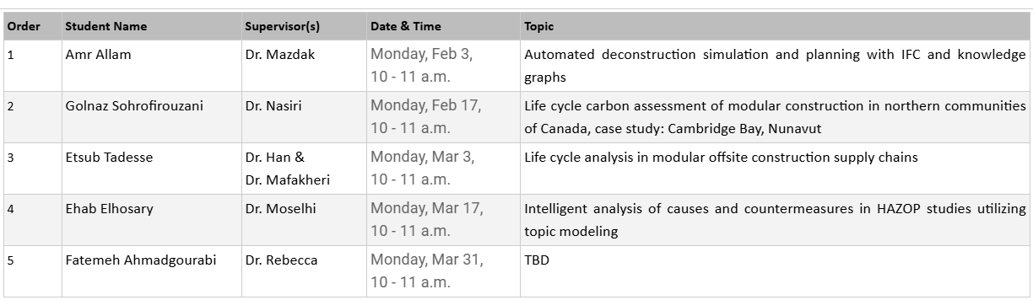

Workshops, July 2025
Six workshops: (i) Digitization, Automation and Robotics in Construction; (ii) BIM-based Automated Code checking and Automated Scan—to-BIM; (iii) The Future of Civil Engineering with Generative AI; (iv) Future Proofing Construction Professionals: Technology in Education and vs. Education for Technology; (v) Bridging Digital Design and Digital Fabrication in Modern Construction; (vi) Architecture, Engineering and Construction at the Forefront of Climate Action and Innovation.
Organized by: Centre for Innovation in Construction and Infrastructure Engineering and Management (CICIEM) in collaboration with ISARC, CSCSE/CRC and MOC.

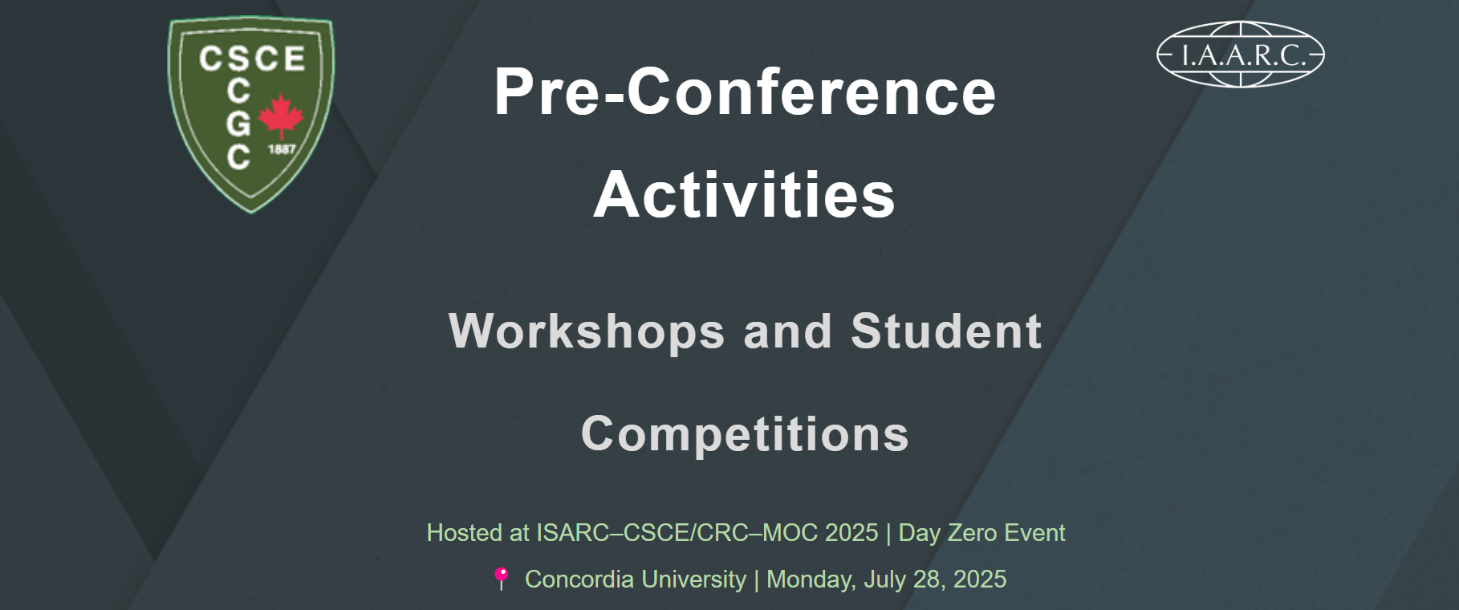

Upcoming EVENTS
The center is planning a workshop on the future of construction industry in Canada to be hosted at Concordia University led by group of experts from the construction industry in Canada.

Workshop Title: Crafting Together the Future of Construction in Canada
Workshop Date: October 10, 2025
Organized by: Centre for Innovation in Construction and Infrastructure Engineering and Management (CICIEM), Concordia University.

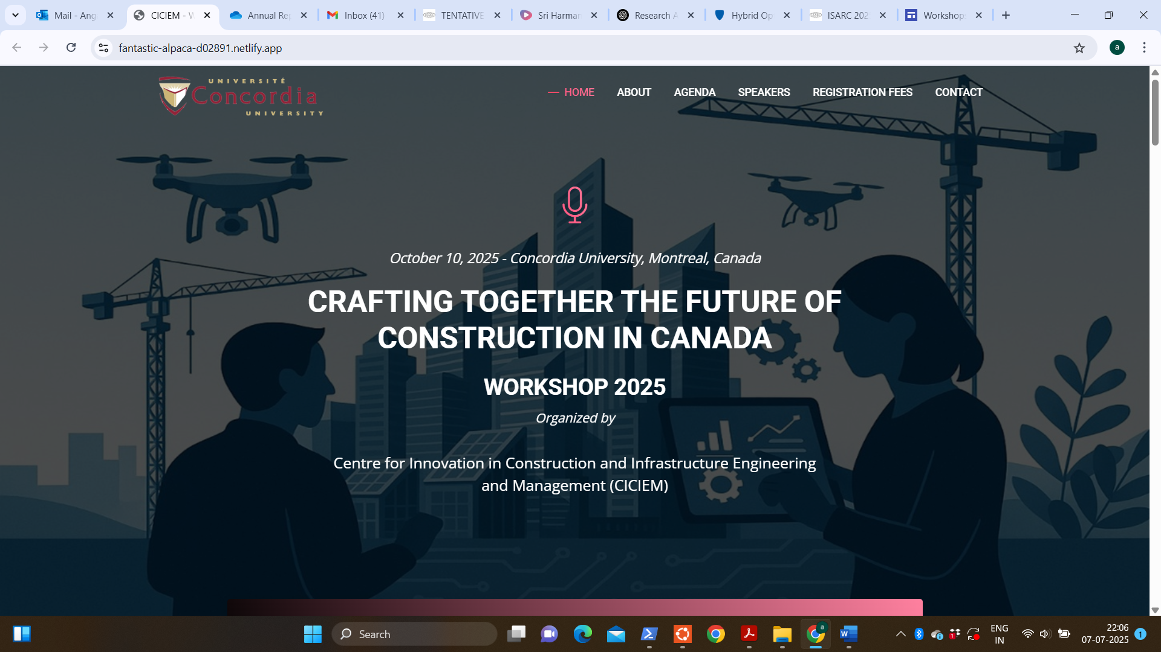

Workshop Agenda (Tentative): (i) Keynote Speech (Maturity of Automation Technologies and its beneficial utilization); (ii) Session 1 (Collaborative Project Delivery Methods and Related Risk Allocation and Selection of Private Partners); (iii) Session 2 (Industrialized Construction and it’s Integration in Project Delivery Methods); (iv) Session 3 (Safety and Sustainability in Construction); (v) Roundtable Discussion (Workforce Transformation- Challenges, Opportunities and Strategic Roadmap).


