THE CONCORDIA DEPARTMENT OF THEATRE PRESENTS

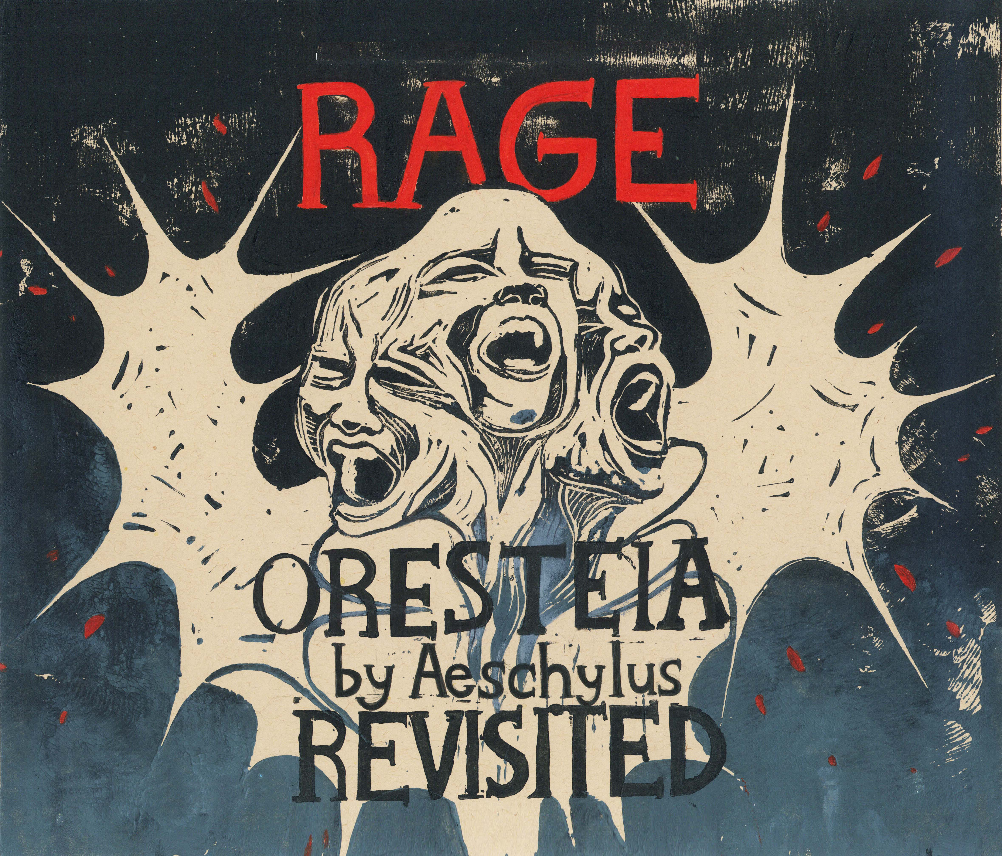

RAGE – ORESTEIA REVISITED
Illustration by Myriam Olivier
March 16 - 19, 2022
D.B. Clarke Theatre

concordia.ca/theatre

By Aeschylus

Note on the creation

A shifting sea of images began the process of working with the words of Aeschlyus' Oresteia, sounded out across airwaves in our homes over zoom as we were introduced to the text. The scope of the Oresteia winds its way around the Trojan war, around the people who didn't fight in it, but fought with it. And we wrestled with the text, together. Naming ourselves after the characters, we read their lines and tried to make sense of them, and as we began to make sense of our ensemble at the same time. We liken the process to tuning into a radio station: listening for the truth of the words ringing through our bodies.

And as we moved forward, and into the space, the radio station became clearer and clearer: ensemble work began to form into moments, landmarks on this strange journey through RAGE across generations. Flashes of clarity that we clambered to, climbing over them, sheltering in them, moving with them. Visual monuments, yes, but also aural ones. Words, screams, gestures, rituals, burps; the Oresteia is visceral and unrelenting; but beyond the initial storm surge in these words, we found expansion; and, driving forward, we found our destination.

Our work was interdisciplinary, our moments like torches lighting the night sky. Our story was one that we came to know in our bodies, reflected through history. The line of plot merely a part of the journey we were taking, the story we are telling. The radio is now clear. The landmarks that dotted our way have followed us on this journey, becoming the story we are now telling. We invite you to take in this world we have found over these past few months; refracted and crystallized though RAGE.

Leslie Baker, Director and

Melissa Titze, Dramaturg

CAST (in alphabetical order)
Joseph Blincoe - Watchman, Pylades, Apollo, Chorus
Jules Gigon - Cilissa, Athena, Chorus
Sean Henderson - Agamemnon, Slave, Chorus
Gill Hurd - Iphigenia, Electra, Chorus
Maria Kammoun - Clytemnestra, Chorus
Noah Kaulbach - Aegisthus, Chorus
Gabriel Lezza - Herald, Orestes, Chorus
Lauren Mendes - Cassandra, Pythia, Chorus
Elliot Pond - Clytemnestra, Chorus
Lisa-Willia Volcy – Clytemnestra, Ghost of Clytemnestra, Chorus

CREATIVE TEAM

Director: Leslie Baker
Dramaturg: Melissa Titze
Stage Manager: Georgia Holland
Assistant Stage Manager: Melissa Pickering-Bourdeau, Lauryn Ivy Andersson

DESIGN TEAM
Design Supervisor: Amy Keith

Set Designer: Sierra Shaw
Assistant Set & Video Designer: Madison Gosselin

Costume Designer: Louise Nicolas
Assistant Costume Designer: Maria-Rachelle D’Amour

Lighting Designer: Emily Tucker
Assistant Lighting Designer: Trinity McQuillan

Sound Design: S. Harris

Video Designer: Madison Gosselin
Assistant Video Designer / Camera Operator: Tianzi Han

Properties Designer: Violette Maréchal
Assistant Properties Designer: Moëv Kurdi
PRODUCTION STAFF

Jen Strahl, Supervisor, Performance Production and Venues
Ted Stafford, Stage Supervisor, D.B. Clarke Theatre
Tristynn Duheme, Technical Coordinator / Lighting
Pietro Cerone, Technical Coordinator / Sound and Multimedia
HeatherEllen Strain, Performance Production Assistant
John Davis and HeatherEllen Strain, Front of House & Box Office Coordinators

PRODUCTION ASSISTANT
Aura Carolina Rodriguez Vasquez
Maria Jose Lujan Rios

COSTUME SHOP
Laura Acosta, Head of Costume Shop
Ana Pablo, Costume Shop assistant
Chantell Clarke, Catalina Holguin, Stefne Vallandigham, Work Study Students, Costume Shop
Melody Chenard, Keegan Edwards, Lindsey Reshef, Grace Simonetti, Aura Carolina Rodriguez Vasquez, Costume Shop Crew & Dressers

SCENE SHOP
Marlène Lucas, Head of Scene Shop
Elisabeth Bureau, Nicole Kritzinger, Gabriella Torchia, Anthonin Garcia, Scene Shop crew

PROPERTIES SHOP
Dominique Coughlin, Head of Properties Shop
Bruno-Pierre Houle, Properties Shop Assistant
Sophia Lopez-Asselin, Claire Keegan, Olivia St-Jean, Properties Shop Crew

LIGHTING & SOUND CREW
Charlotte Alexander, Roxane Bourassa, Catherine Good, Trinity McQuillan

THANK YOU

Special thanks Centaur Theatre, The Bakery, Joseph Shragge, Tim Rodrigues and to our Concordia Shops and Theatre Department encouraging creative reuse and repurposing of previous production goods and tools as well as recyclable materials.

FULL-TIME FACULTY

Raymond Marius Boucher, Senior Lecturer
Ronnie Burkett, Artist in Residence
Ana Cappelluto, Professor
Jessica Carmichael, Assistant Professor
Micheline Chevrier, Artist-in-Residence
Noah Drew, Associate Professor, Chair
Gene Gibbons, Associate Professor
Shauna Janssen, Assistant Professor, Concordia University Chair in Performative Urbanism
Donya Metzger, Artist-in-Residence
Menka Nagrani, Limited Term Appointment
Ursula Neuerburg-Denzer, Associate Professor
Robert Reid, Associate Professor
Luis C. Sotelo Castro, Associate Professor
Mark Sussman, Associate Professor

PART-TIME FACULTY 2021/22
Jean Asselin, Leslie Baker, John Battye, Denise Boulanger, Suzanne Cerreta, Elisabeth Couture, Miriam Cummings, Joe De Paul, Jean-François Gagnon, Erin Flynn, Amy Keith, Stephen Lawson, Corinne Merrell, Cathia Pagotto, Brian Peters, Gabriela Petrov, Rose Plotek, Warona Setshwaelo, Harry Standjofski, Liz Valdez.

ADMINISTRATIVE STAFF
Maud David Lerebours, Department Administrator
Katherine Scribner, Department Assistant
Brooklyn Melnyk, Receptionist & Office Assistant
Nicoletta Pasquino, Department Assistant

COMING SOON

- Cabaret Brouhaha
Led by Stephen Lawson
March 24, 2022

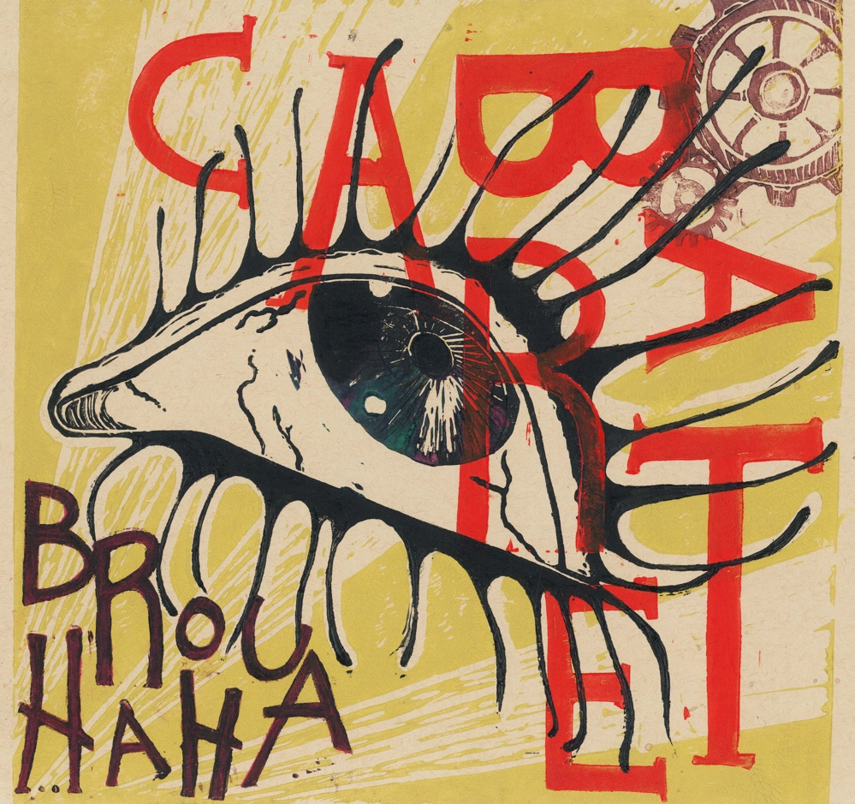
Illustration by Myriam Olivier

Visit: concordia.ca/theatre

