Guide to Creating Workplace Labels
Prior to creating a workplace label, verify if the workplace label already exists. Contact the FAS Central Stores at Loyola campus (lyudmila.anohina@concordia.ca or ext. 3369) or EHS (ehs@concordia.ca or ext. 4877) to inquire if a WHMIS 2015 compliant workplace label is available. Workplace labels in various format for commonly used chemicals are available.
If not available, you will be required to create your own WHMIS 2015-compliant workplace label. This user guide describes how to produce a WHMIS 2015 compliant workplace label. For more information on workplace labels, please consult Workplace Labeling Requirements (EHS-DOC-206).
Step 1: Determine the required format
Determine the label format, based on the size of the container and the information to convey. Currently, three (3) standard formats (1.5×2.5 in, 2.5×4 in, and 4×6 in) of labels are available from the FAS Central Stores for this purpose. These labels will be self-adhesive and resistant to most chemicals. Non-standard label formats with various and adapted dimensions can be created using other resources and may be taped to the container.
Step 2: Determine what to display
There are three (3) mandatory elements to be displayed on the label: product name, safe handling precautions (WHMIS and Personal Protective Equipment pictograms and Hazard and/or Precautionary statements) and a reference to the Safety Data Sheet (See EHS-DOC-206 for more details).
Additional information can also be displayed, including: a signal word, CAS number, net quantity, Molecular Weight, some physical data, a chemical compatibility chart for storage and disposal.
Step 3: Collect the required information from the Safety Data Sheet
The information displayed on a workplace label must match what is indicated on the product’s Safety Data Sheet. If the display of additional information is desired and possible, ChemWatch SDS Database (accessible from the EHS website at concordia.ca/ehs) represents an updated and near-exhaustive resource. For instance, useful compatibility charts for storage and disposal considerations can be easily extracted from the Database documents (Gold SDS, mini-SDS, etc.).
Step 4: Create the label
- Open one of the blank PowerPoint files from http://www.concordia.ca/campus-life/safety/lab-safety/chemical-safety.html, under the WHMIS 2015 and the Globally Harmonised System (GHS) – label requirements section, if a standard format label is desired. In the case of a non-standard format label, the user must ensure that the dimensions fit the space allowed on the container.
- Add the required information collected in Step 3 (name of the product, signal word, H- and P-Phrases, WHMIS 2015 pictograms). For convenience, all Hazard and Precautionary Statements with corresponding codes, along with the WHMIS 2015 pictograms and examples of PPE symbols (high-quality images) are provided below and can be directly copied (copy/paste) from this document.
Some Precautionary Statements (highlighted in yellow in the corresponding section) must be completed with the specific information displayed on the SDS related to the product before being copied.
Step 5: Print the workplace label
Once the label is completed with the desired information, the user can save the PowerPoint slide as a PDF file (“save as PDF”). If one of the three standard formats has been chosen, send it to the FAS Central Stores for printing, indicating the desired dimensions and layout. In the case of a workplace label with non-standard dimensions, print locally and affix to the container.

Questions
If you have questions or need assistance, contact EHS at: ehs@concordia.ca or 514-848-2424 ext. 4877

Hazard Statements (H-Phrases and codes)
Physical Hazards:
H200: Unstable explosive
H201: Explosive; mass explosion hazard
H202: Explosive; severe projection hazard
H203: Explosive; fire, blast or projection hazard
H204: Fire or projection hazard
H205: May mass explode in fire
H220: Extremely flammable gas
H221: Flammable gas
H222: Extremely flammable aerosol
H223: Flammable aerosol
H224: Extremely flammable liquid and vapour
H225: Highly flammable liquid and vapour
H226: Flammable liquid and vapour
H227: Combustible liquid
H228: Flammable solid
H229: Pressurized container: may burst if heated
H230: May react explosively even in the absence of air
H231: May react explosively even in the absence of air at elevated pressure and/or temperature
H240: Heating may cause an explosion
H241: Heating may cause a fire or explosion
H242: Heating may cause a fire
H250: Catches fire spontaneously if exposed to air
H251: Self-heating; may catch fire
H252: Self-heating in large quantities; may catch fire
H260: In contact with water releases flammable gases which may ignite spontaneously
H261: In contact with water releases flammable gas
H270: May cause or intensify fire; oxidizer
H271: May cause fire or explosion; strong oxidizer
H272: May intensify fire; oxidizer
H280: Contains gas under pressure; may explode if heated
H281: Contains refrigerated gas; may cause cryogenic burns or injury
H290: May be corrosive to metals
Health Hazards:
H300: Fatal if swallowed
H301: Toxic if swallowed
H302: Harmful if swallowed
H303: May be harmful if swallowed
H304: May be fatal if swallowed and enters airways
H305: May be harmful if swallowed and enters airways
H310: Fatal in contact with skin
H311: Toxic in contact with skin
H312: Harmful in contact with skin
H313: May be harmful in contact with skin
H314: Causes severe skin burns and eye damage
H315: Causes skin irritation
H316: Causes mild skin irritation
H317: May cause an allergic skin reaction
H318: Causes serious eye damage
H319: Causes serious eye irritation
H320: Causes eye irritation
H330: Fatal if inhaled
H331: Toxic if inhaled
H332: Harmful if inhaled
H333: May be harmful if inhaled
H334: May cause allergy or asthma symptoms or breathing difficulties if inhaled H335: May cause respiratory irritation
H336: May cause drowsiness or dizziness
H340: May cause genetic defects
H341: Suspected of causing genetic defects
H350: May cause cancer
H351: Suspected of causing cancer
H360: May damage fertility or the unborn child
H361: Suspected of damaging fertility or the unborn child
H361d: Suspected of damaging the unborn child
H361f: Suspected of damaging fertility
H362: May cause harm to breast-fed children
H370: Causes damage to organs
H371: May cause damage to organs
H372: Causes damage to organs through prolonged or repeated exposure
H373: May cause damage to organs through prolonged or repeated exposure
H300+H310: Fatal if swallowed or in contact with skin
H300+H330: Fatal if swallowed or if inhaled
H310+H330: Fatal in contact with skin or if inhaled
H300+H310+H330: Fatal if swallowed, in contact with skin or if inhaled
H301+H311: Toxic if swallowed or in contact with skin
H301+H331: Toxic if swallowed or if inhaled
H311+H331: Toxic in contact with skin or if inhaled
H301+H311+H331: Toxic if swallowed, in contact with skin or if inhaled
H302+H312: Harmful if swallowed or in contact with skin
H302+H332: Harmful if swallowed or if inhaled
H312+H332: Harmful in contact with skin or if inhaled
H302+H312+H332: Harmful if swallowed, in contact with skin or if inhaled

Precautionary Statements (P-Phrases and codes)
The highlighted P-Phrases (and combinations) must be completed with the specific information displayed on the SDS related to the product.
General Precautionary Statements:
P101: If medical advice is needed, have product container or label at hand.
P102: Keep out of reach of children.
P103: Read label before use.
Prevention Precautionary Statements:
P201: Obtain special instructions before use.
P202: Do not handle until all safety precautions have been read and understood.
P210: Keep away from heat, hot surfaces, sparks, open flames and other ignition sources. No smoking.
P211: Do not spray on an open flame or other ignition source.
P220: Keep/Store away from clothing/…/combustible materials.
P221: Take any precaution to avoid mixing with combustibles.
P222: Do not allow contact with air.
P223: Do not allow contact with water.
P230: Keep wetted with …
P231: Handle under inert gas.
P232: Protect from moisture.
P233: Keep container tightly closed.
P234: Keep only in original container.
P235: Keep cool.
P240: Ground/bond container and receiving equipment.
P241: Use explosion-proof electrical/ventilating/lighting/…/equipment.
P242: Use only non-sparking tools.
P243: Take precautionary measures against static discharge.
P244: Keep valves and fittings free from oil and grease.
P250: Do not subject to grinding/shock/…/friction.
P251: Do not pierce or burn, even after use.
P260: Do not breathe dust/fumes/gas/mist/vapours/spray.
P261: Avoid breathing dust/fumes/gas/mist/vapours/spray.
P262: Do not get in eyes, on skin, or on clothing.
P263: Avoid contact during pregnancy/while nursing.
P264: Wash … thoroughly after handling.
P270: Do not eat, drink or smoke when using this product.
P271: Use only outdoors or in a well-ventilated area.
P272: Contaminated work clothing should not be allowed out of the workplace.
P273: Avoid release to the environment.
P280: Wear protective gloves/protective clothing/eye protection/face protection.
P282: Wear cold insulating gloves/face shield/eye protection.
P283: Wear fire/flame resistant/retardant clothing.
P284: [In case of inadequate ventilation] wear respiratory protection.
P231+232: Handle under inert gas. Protect from moisture.
P235+410: Keep cool. Protect from sunlight.
Response Precautionary Statements:
P301: IF SWALLOWED:
P302: IF ON SKIN:
P303: IF ON SKIN (or hair):
P304: IF INHALED:
P305: IF IN EYES:
P306: IF ON CLOTHING:
P307: [Deleted by IV ATP]
P308: If exposed or concerned:
P309: [Deleted by IV ATP]
P310: Immediately call a POISON CENTER/doctor/…
P311: Call a POISON CENTER/ doctor/…
P312: Call a POISON CENTER/ doctor/…/if you feel unwell.
P313: Get medical advice/attention.
P314: Get medical advice/attention if you feel unwell.
P315: Get immediate medical advice/attention.
P320: Specific treatment is urgent (see … on this label).
P321: Specific treatment (see … on this label).
P330: Rinse mouth.
P331: Do NOT induce vomiting.
P332: If skin irritation occurs:
P333: If skin irritation or a rash occurs:
P334: Immerse in cool water/wrap in wet bandages.
P335: Brush off loose particles from skin.
P336: Thaw frosted parts with lukewarm water. Do not rub affected areas.
P337: If eye irritation persists:
P338: Remove contact lenses if present and easy to do. Continue rinsing.
P340: Remove person to fresh air and keep comfortable for breathing.
P342: If experiencing respiratory symptoms:
P351: Rinse cautiously with water for several minutes.
P352: Wash with plenty of water/…
P353: Rinse skin with water/shower.
P360: Rinse immediately contaminated clothing and skin with plenty of water before removing clothes.
P361: Take off immediately all contaminated clothing.
P362: Take off contaminated clothing.
P363: Wash contaminated clothing before reuse.
P364: And wash it before reuse.
P370: In case of fire:
P371: In case of major fire and large quantities:
P372: Explosion risk in case of fire.
P373: DO NOT fight fire when fire reaches explosives.
P374: Fight fire with normal precautions from a reasonable distance.
P375: Fight fire remotely due to the risk of explosion.
P376: Stop leak if safe to do so.
P377: Leaking gas fire – do not extinguish unless leak can be stopped safely.
P378: Use … to extinguish.
P380: Evacuate area.
P381: Eliminate all ignition sources if safe to do so.
P391: Collect spillage.
P301+310: IF SWALLOWED: Immediately call a POISON CENTER/doctor/…
P301+312: IF SWALLOWED: Call a POISON CENTER/doctor/…/if you feel unwell.
P301+330+331: IF SWALLOWED: Rinse mouth. Do NOT induce vomiting.
P302+334: IF ON SKIN: Immerse in cool water/wrap in wet bandages.
P302+352: IF ON SKIN: Wash with plenty of water/…
P303+361+353: IF ON SKIN (or hair): Take off immediately all contaminated clothing. Rinse skin with water / shower.
P304+312: IF INHALED: Call a POISON CENTER or doctor/physician if you feel unwell.
P304+340: IF INHALED: Remove person to fresh air and keep comfortable for breathing.
P305+351+338: IF IN EYES: Rinse cautiously with water for several minutes. Remove contact lenses if present and easy to do – continue rinsing.
P306+360: IF ON CLOTHING: Rinse immediately contaminated clothing and skin with plenty of water before removing clothes.
P307+311: If exposed: Call a POISON CENTER or doctor/physician.
P308+313: If exposed or concerned: Get medical advice/attention.
P309+P311: If exposed or if you feel unwell: Call a POISON CENTER or doctor/physician.
P332+313: If skin irritation occurs: Get medical advice/attention.
P333+313: If skin irritation or a rash occurs: Get medical advice/attention.
P335+334: Brush off loose particles from skin. Immerse in cool water/wrap in wet bandages.
P337+313: If eye irritation persists get medical advice/attention.
P342+311: If experiencing respiratory symptoms: Call a POISON CENTER or doctor/physician.
P361+364: Take off immediately all contaminated clothing and wash it before reuse.
P362+364: Take off contaminated clothing and wash it before reuse.
P370+376: In case of fire: Stop leak if safe to do so.
P370+378: In case of fire: Use … to extinguish.
P370+380: In case of fire: Evacuate area.
P370+380+375: In case of fire: Evacuate area. Fight fire remotely due to the risk of explosion.
P371+380+375: In case of major fire and large quantities: Evacuate area. Fight fire remotely due to the risk of explosion.
Storage Precautionary Statements:
P401: Store …
P402: Store in a dry place.
P403: Store in a well ventilated place.
P404: Store in a closed container.
P405: Store locked up.
P406: Store in a corrosive resistant/… container with a resistant inner liner.
P407: Maintain air gap between stacks/pallets.
P410: Protect from sunlight.
P411: Store at temperatures not exceeding … °C/… °F.
P412: Do not expose to temperatures exceeding 50 °C/122 °F.
P413: Store bulk masses greater than … kg/… lbs at temperatures not exceeding … °C/… °F.
P420: Store away from other materials.
P422: Store contents under …
P402+404: Store in a dry place. Store in a closed container.
P403+233: Store in a well ventilated place. Keep container tightly closed.
P403+235: Store in a well ventilated place. Keep cool.
P410+403: Protect from sunlight. Store in a well-ventilated place.
P410+412: Protect from sunlight. Do not expose to temperatures exceeding 50 °C/122 °F.
P411+235: Store at temperatures not exceeding … °C/… °F. Keep cool.
Disposal Precautionary Statements:
P501: Dispose of contents/container to … [… in accordance with local/regional/national/international regulation (to be specified)].
WHMIS 2015 pictograms
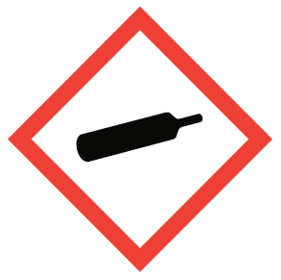  Gas Cylinder | 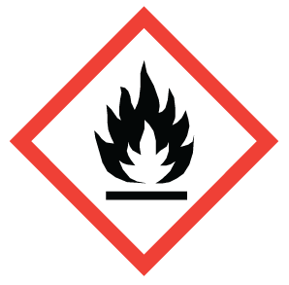  Flame | 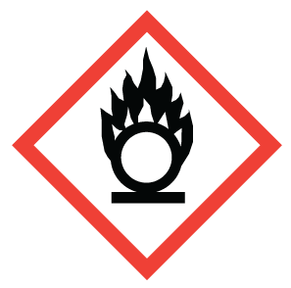  Flame over Circle | 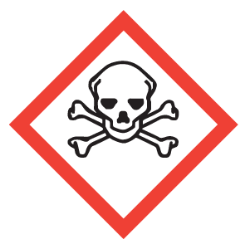  Skull and Crossbones
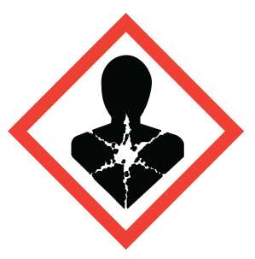  Health Hazard | 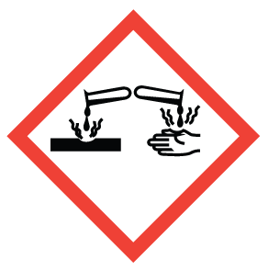Corrosion | 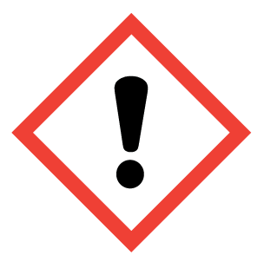Exclamation mark | 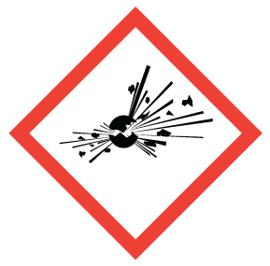Exploding Bomb
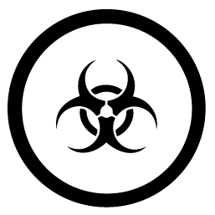  Biohazardous Infectious Material |  | 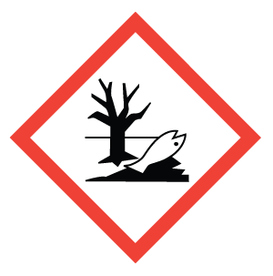  Environment (GHS)

PPE symbols (examples)
Eye protection
Safety glasses |  |  | Safety goggles |  |  | Face Shield
Hand protection
Gloves (disposable) |  |  |  |  | Gloves (thick, reusable, long cuffs)
Respiratory devices
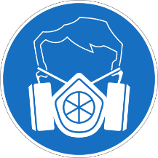  Half-face respirator |  | 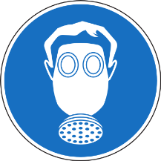  Full-face respirator |  |  | Disposable particulate respirator (e.g., N95) |  |  | Dust-mask
Protective clothing
Lab Coat |  |  | Disposable coverall |  |  | 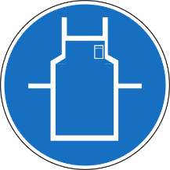  Apron
Other symbols
Closed shoes | Work/Safety shoes |  |  | Lab shoe covers |  |  | Wash Hands |  | Ventilation required

