Moodle Accessibility Checker (MAC)
Teacher Guide
Karen Holland
2020
Contents
Accessibility Review - Introduction 2
Add Accessibility+ Review block to your course 2
Using Accessibility Review block 3
PDF accessibility tips guides 3
Course content highlighting 4
Course Results 5
Download PDF of Course Results 5
Accessibility Toolkit - Introduction 6
Using the Accessibility Toolkit 6
The Accessibility Toolkit overview page 6
Report tools 8
Per Activity Results 8
Per Check Results 8
Per Checktype Results 8
Transcript 8
Advanced 8
Wizard tools 8
Errors 8
Fix Bold 8
Fix Image Alt Text 9
Fix Italics 9
Fix Link text 9
Fix Strike 9

Concordia’s Accessibility Checker for Moodle
  - Teacher Guide

Accessibility+ Review - Introduction
The accessibility+ review feature provides teachers the opportunity to assess their course against a set of technical standards for accessibility to get feedback on what the problem content is and where it is.
The block accessibility checker block in Moodle provides several features:
- Queue course for audit.
- Show results of audit.
- Provide downloaded printouts for tips on how to create content.
- Use a heatmap toggle (i.e. a graphical representation of data where values are depicted by color) to quickly see where errors are in the course.
- Access the main audit reports and remediation tools.

Add Accessibility+ Review block to your course
Go to your course where you have editing teacher permissions
Click on “Turn editing on”, either in the course actions menu, or the button (in version 3.9+).
Click on “Add a block”.
Click on the “Accessibility Review” block option to add this block to the course.
You should now see the block notification "This course has not been scheduled for analysis."
Click on the "Submit for analysis" button.
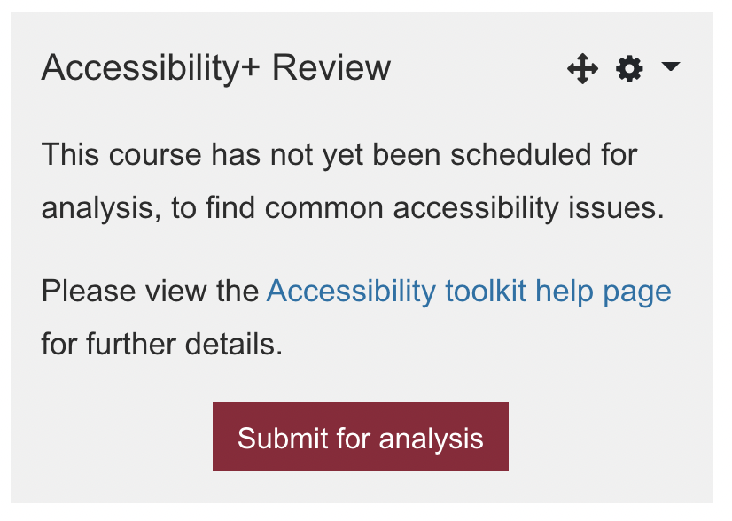
You should now see the block notification "This course has been scheduled for analysis."
Wait a period for the scheduled tasks to run. How long this needs to be depends on your Moodle course and task settings, but it should just be a matter of minutes.
Once the accessibility audit has been completed, the block should now show a table of Accessibility results and links.

Using Accessibility+ Review block
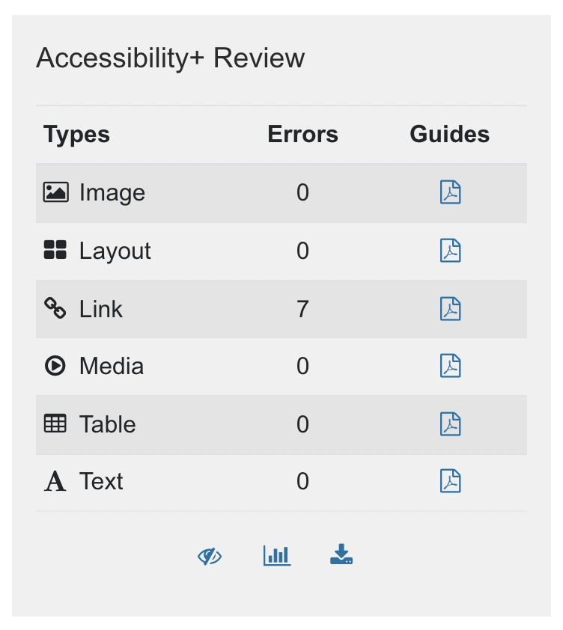
The main Accessibility+ Review block features are as follows:
- An error count for each type of Moodle HTML content (which MAC has designated as Image, Layout, Link, Media, Table, Text)
- Links to PDF accessibility tips guides, again for each type of HTML content
- Bottom links - Eye icon, to toggle on and off the course content highlighting (This should have a tooltip on hover of "Toggle Accessibility+ Heatmap")
- Bottom links - Bar-chart icon, to go directly to the Accessibility+ Report for your course (This should have a tooltip on hover of "View Accessibility+ Report")
- Bottom links - Download icon, to download a PDF transcript of your course’s current accessibility status (This should have a tooltip on hover of " Download Accessibility+ Report")

PDF accessibility tips guides
These provide concise, just-in-time, tips for accessibility best practice in the different types of HTML content where errors can occur within Moodle content.
You can click on each of the tips guide icons, which will then download the relevant PDF guide onto your desktop or device.
Here is an example of how the Images tips guide looks like:
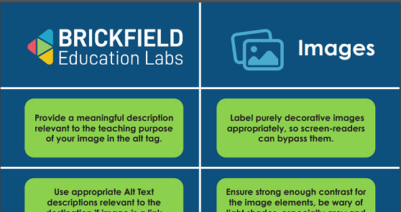

Course content highlighting
This Eye icon allows you to toggle on and off the content accessibility results display on the course page, which gives you a per activity, per resource and per course section accessibility status report.
The Eye icon is located at the bottom of the Accessibility+ Review block once the analysis has been requested and completed.
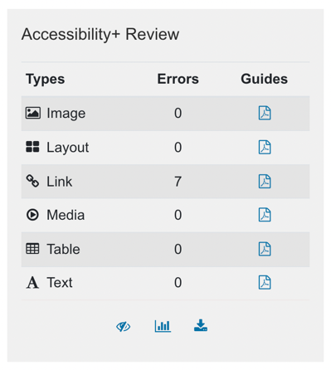
The course content highlighting, when toggled on, should look like this:
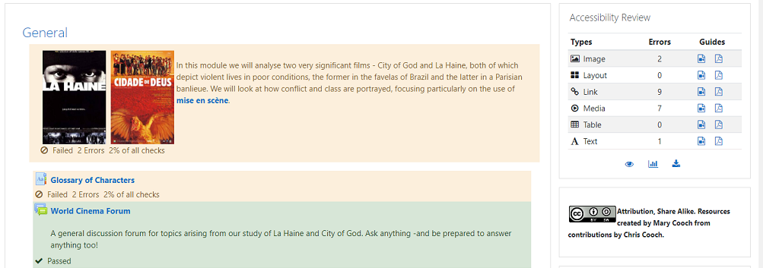

Course Results
The Bar-chart icon allows you to go directly to the Accessibility+ Report for your course, which gives you various accessibility status reports: overall, per activity, per error and per HTML content type and others.
The Bar-chart icon is located at the bottom of the Accessibility+ Review block once the analysis has been requested and completed.
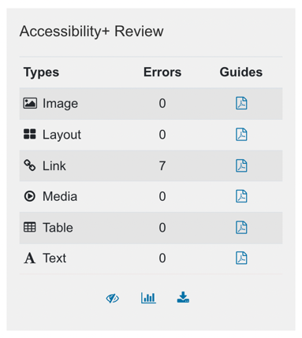
The report itself is dealt with in more detail in the Toolkit report section.

Download PDF of Course Results
The Download icon allows you to receive a PDF download of an Accessibility+ Report for your course, which gives you various accessibility status results: overall, per activity, per error and per HTML content type and others.
The Download icon is located at the bottom of the Accessibility+ Review block once the analysis has been requested and completed.
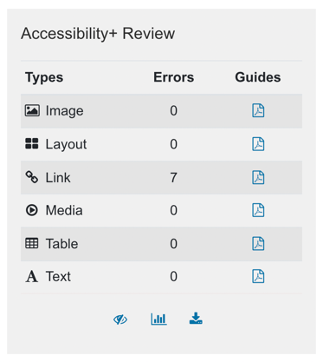
The information contained in the PDF itself is dealt with in more detail in the Toolkit report section.

Accessibility Toolkit - Introduction
The Accessibility toolkit is a collection of reports and content remediation wizards which enables the teacher to fix some of the most common content accessibility issues in their course.

Using the Accessibility Toolkit
You can navigate to the Accessibility toolkit, by using the Bar-chart icon link in the Accessibility Review+ block on your course. Alternatively, you can use the course’s Actions Menu (cog icon), clicking on the Accessibility Plus toolkit link.
This brings you to the Accessibility toolkit, where you should be able to see the initial Per Check page, which gives you a clear and concise page with your existing errors and how to deal with them. (The site administrator can configure the exact page which the toolkit defaults to, if required.)
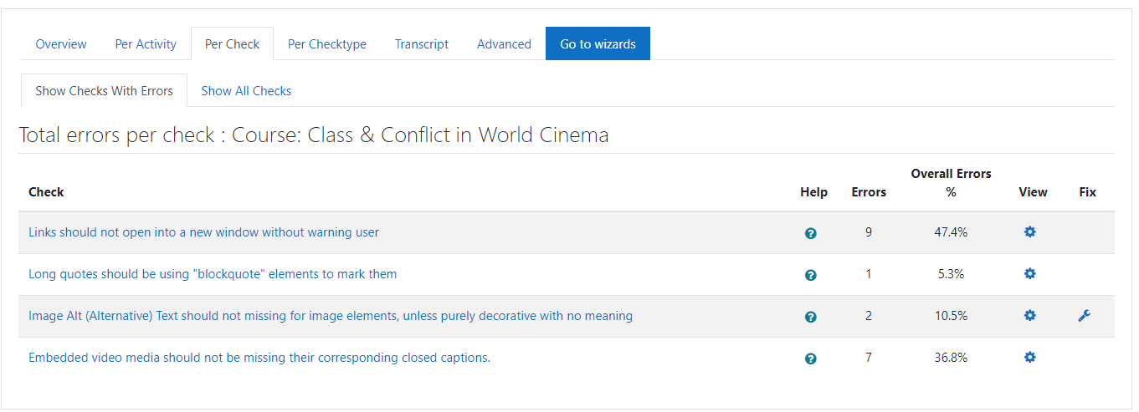
This page shows the various checks performed, and for which checks you have existing errors.
- Help – this provides a clickable popup text description of the check, and its impact on users if not followed.
- Errors – this provides a count of the errors for the check.
- Overall Errors – this displays the error amount as a percentage of the total errors for the course
- View – this links to the Errors page for the course, but just showing the errors relating to the relevant check
- Fix – if a wizard exists to fix the errors relating to the relevant check, it will be linked via the Fix icon in the Fix column

The Accessibility Toolkit overview page
You can navigate to the overview page, by clicking on the Overview tab, in the Reports tab bar. This is where you can see the various Report and Wizard Tools linked, as and when enabled by your site administrator, each with brief summaries. You should see the same “Go to reports” and “Go to wizards” as tabs in the tab bar for easy navigation.
You should also see the Summary and Error count tables with relevant information on your course, the same that is shown in the Accessibility Review block.
The full list of Tools, if all are enabled, is as follows:
- Overview (does not have link or brief description)
- Per Activity Results
- Advanced
- Per Check Results
- Per Checktype Results
- Transcript
- Errors
- Fix Bold
- Fix Image Alt Text
- Fix Italics
- Fix Link text
- Fix Strike
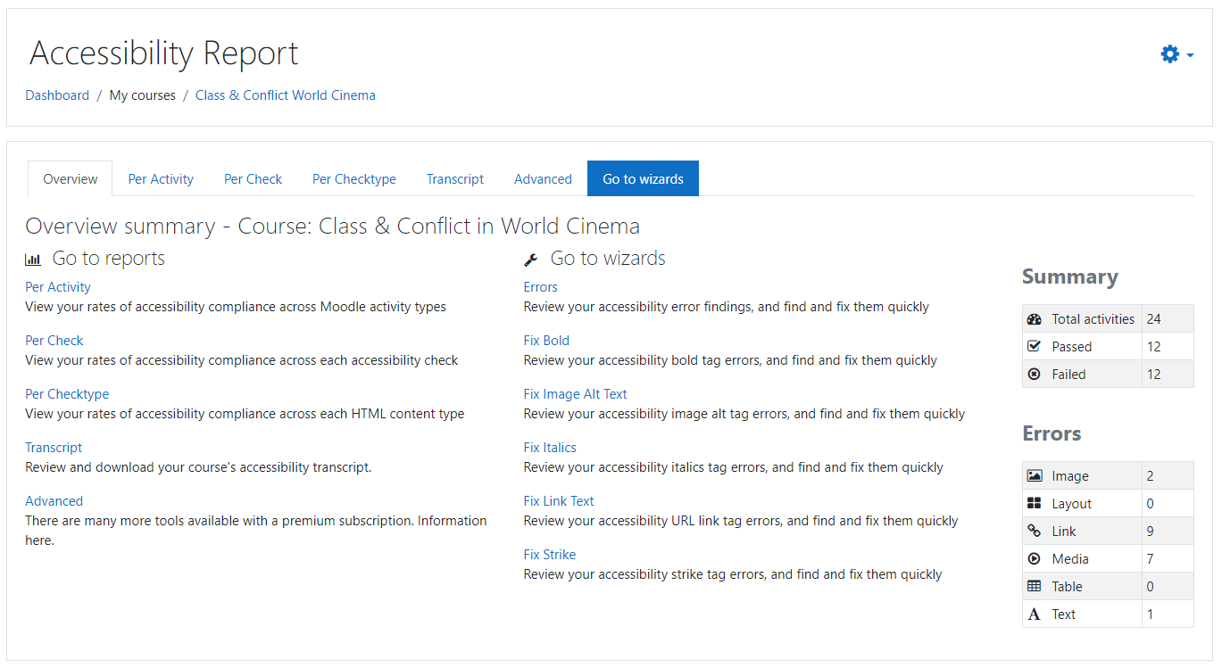

Report tools
The Report tools give you several different displays of your Accessibility results.

Per Activity Results
This gives you the results per activity, as both a ratio of passed to failed activities, and a total error count per activity.

Per Check Results
This gives you the results per check, as a total error count per check, either just checks with errors, or show all checks. It also gives you:
- each check’s percentage of the overall count of errors.
- A Help popup for each check, with further information on the check, its summary and impact.
- A View link for each check, which brings you to the Errors page for all the errors which relate to this check alone.
- Where relevant, some checks have corresponding Fix wizards, so you have a Fix link for each check where possible.

Per Checktype Results
This gives you the results for each type of Moodle HTML content (which MAC has designated as Image, Layout, Link, Media, Table, Text).
It gives you the results per checktype, as both a ratio of passed to failed instances (activities, course areas, questions etc.), and a total error count per checktype.

Transcript
This gives you a course transcript of the accessibility issues currently found. You also have a link called Download PDF, to download a PDF transcript of your course’s current accessibility status.
The course transcript is a summary of many of the Find tools listed above, as a handy one-pager.

Advanced
This gives you further details on the full suite of Accessibility features in the MAC.

Wizard tools

Errors
This allows you to review your accessibility error findings, and to find and fix them quickly. Each error has its own Edit link, which brings you directly to edit the original content in which the error occurs.

Fix Bold
This allows you to review your accessibility bold tag errors, and find and fix them quickly, in one or more pages, depending on how many bold tag errors there are.
The existing bold tag errors are listed with a “Submit Bulk Fixing” button, which will then fix all the errors on that current page. These edit changes are also logged for content change tracking.

Fix Image Alt Text
This allows you to review your accessibility image alt text errors, and find and fix them quickly, in one or more pages, depending on how many image alt text errors there are.
Please note that image alt changes need a degree of teacher oversight / engagement, hence they need to be manually typed into each image’s “Update to” input field, as plain text, which will then be used to update the image’s alt text in its content location.
There is also a help popup, with guidance on how to write good image alt descriptions.
The existing image alt text errors are listed with a “Submit Bulk Fixing” button, which will then update all the image alt errors on that current page. These edit changes are also logged for content change tracking.

Fix Italics
This allows you to review your accessibility italics tag errors, and find and fix them quickly, in one or more pages, depending on how many italics tag errors there are.
The existing italics tag errors are listed with a “Submit Bulk Fixing” button, which will then fix all the errors on that current page. These edit changes are also logged for content change tracking.

Fix Link text
This allows you to review your accessibility link text errors, and find and fix them quickly, in one or more pages, depending on how many link text errors there are.
Please note that link changes need a degree of teacher oversight / engagement. However, we do automated retrieval of the website’s own title, and provide it as a suggested text in the “Update to” input field. Hence the teacher needs to review and edit each link’s “Update to” input field, as plain text, which will then be used to update the link text in its content location.
The existing link text errors are listed with a “Submit Bulk Fixing” button, which will then update all the link text errors on that current page. These edit changes are also logged for content change tracking.

Fix Strike
This allows you to review your accessibility strike tag errors, and find and fix them quickly, in one or more pages, depending on how many strike tag errors there are.
The existing strike tag errors are listed with a “Submit Bulk Fixing” button, which will then fix all the errors on that current page. These edit changes are also logged for content change tracking.

