Accessible file format teacher guide
Contents
Introduction 2
MAC alternative file format plugin on your course 2
Requesting an alternative file format 2
Retrieving a newly processed alternative file format 4
File resource licensing 5

MAC Alternative File Format Plugin
  - Teacher Guide

Introduction
The Moodle Accessibility Checker (MAC) includes an alternative file format plugin that gives teachers the ability to provide their students with multiple alternate file formats of their existing file resources within their course.
It creates an easy-to-use integration with our conversion partner, SensusAccess, who receive and process all the conversion requests, returning the new files back to our Concordia’s alternative file format plugin, which then automatically adds these additional formats to the relevant file resource for download.
The plugin provides several conversion options, depending on the type of original file being converted, whether it is a word document, a PDF, a spreadsheet and so on.

MAC alternative file format plugin on your course
Once the MAC alternative file format plugin has been fully configured by your site’s system administrator, it will then automatically be available on your course main page.
It works by displaying a Request conversion icon beside each of your course file resources as follows:

Requesting an alternative file format
When you, or a student, clicks on the Request conversion icon, a popup screen appears, where you select the possible alternative format options you may have the file converted into.
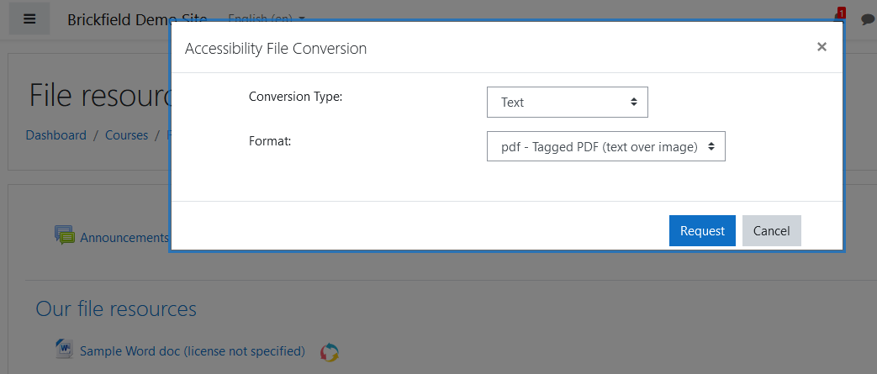

The “Conversion Type” dropdown shows you the initial available options for the file you are converting, so in this example case for a Word document, they are as follows:
- Text
- Audio
- Ebook
These main conversion types are then split into formats, depending again on the file you are converting, so in this example case for a Word document for a Text type, they are as follows:
- PDF – Tagged PDF
- TXT – Plain text
Once you have selected both the conversion type and format, click on the “Request” button, or click on the “Cancel” button to cancel your request and return to the course main page.
When you click on the “Request” button, the plugin checks if this particular type and format conversion has been previously requested and processed for this file resource.
If so, the alternative file will already be stored, and will be instantly produced as a file that can be downloaded. So, for instance, if you know in advance that one of your students will need audio conversions (and which speed format they prefer), you can request those conversions in advance, so that they will be ready for instant downloading whenever your student then wants them.
If the file has not been already converted to the specified conversion type and format, the alternative file will be requested, and you will see a confirmation message displayed. This means that your conversion request has been queued and you can safely return to the course main page. To exit out of the popup screen, you can either click on the “Close” button, or on the “X” icon in the top right corner of the popup, or else click anywhere on the screen outside the popup screen.
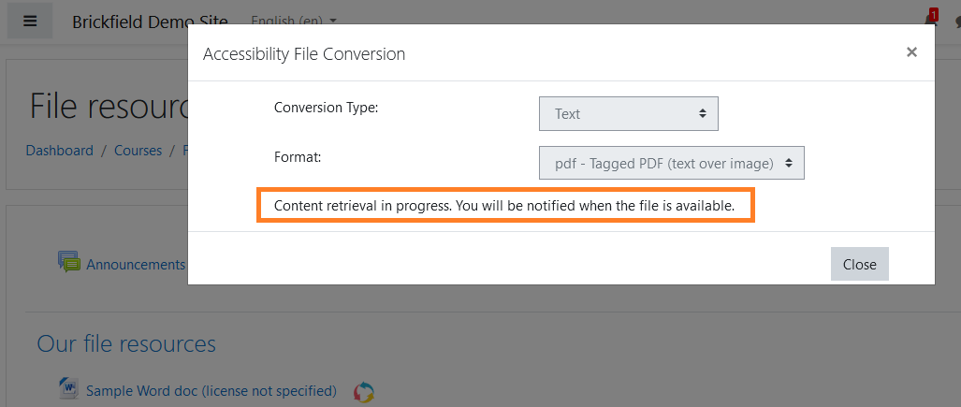

Retrieving a newly processed alternative file format
The file conversion can take between a few minutes and an hour usually, depending on the size of the file content being converted.
Once your alternative format file is ready, you will see a new notification alert.
When you click on this notification popup, click on the relevant “View full notification” link.
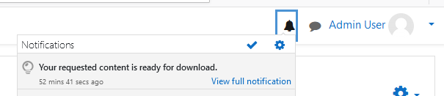
In your notifications page, you will see the full notification message, which contains the message link “<original_filename>.<newformat> is ready for downloading”. Click on this link to download your new file.
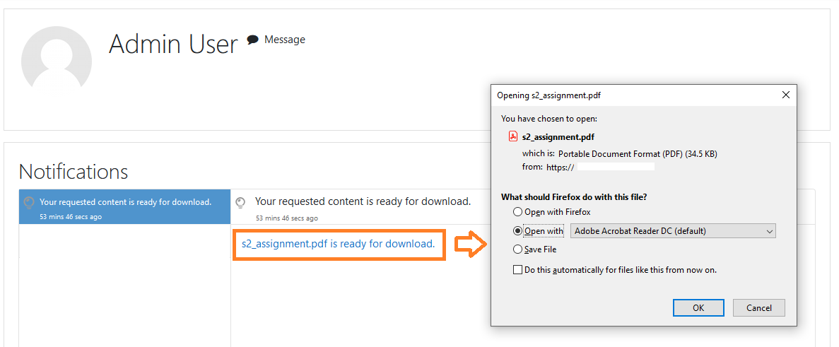
You now have access to your new file, in the conversion type and format which you requested! You can either open it directly or save it to your device for later viewing.

File resource licensing
There may be times when you want to restrict which files can be converted, and this would usually be due to copyright restrictions.
This is enabled by the MAC alternative file format plugin.
Your Moodle site’s system administrator would first configure a file license value. This defaults to “No license restrictions”, which means that all files are allowed to be converted by all users.
However, if the administrator changes this setting to a different value, such as “All rights reserved”, then the following filters are applied.
- If your course file resource’s own license setting is set to “All rights reserved”, then the file resource will NOT show the conversion icon next to it, unless the user themselves is designated to be allowed to request conversions for inclusion purposes
- If a file resource’s license setting is set to any other license value, then the file is deemed to be not restricted, and the file resource WILL show the conversion icon next to it for all users
- To check your course file resource’s license setting:
  - Click on the Edit settings page for the file resource
  - 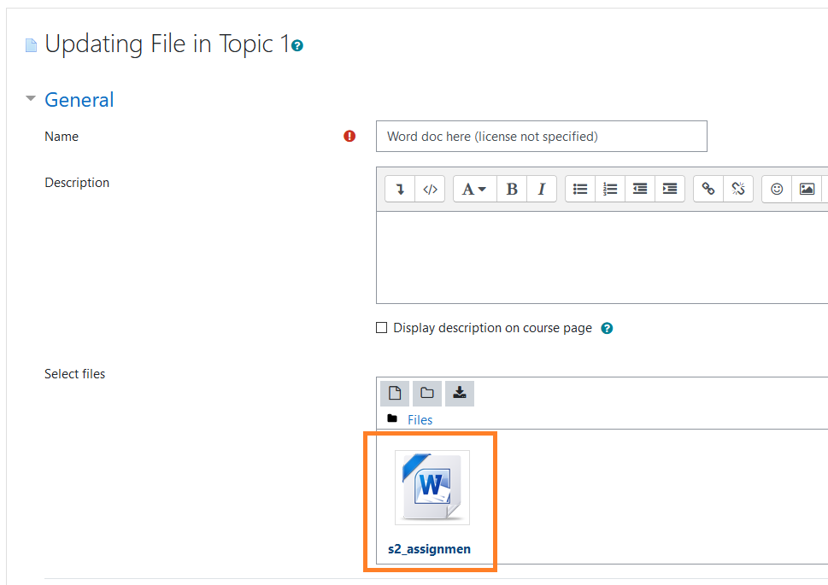
  - Go to the Select files, and click on the relevant file
  - This brings up a popup with the file details, including its current license setting
  - 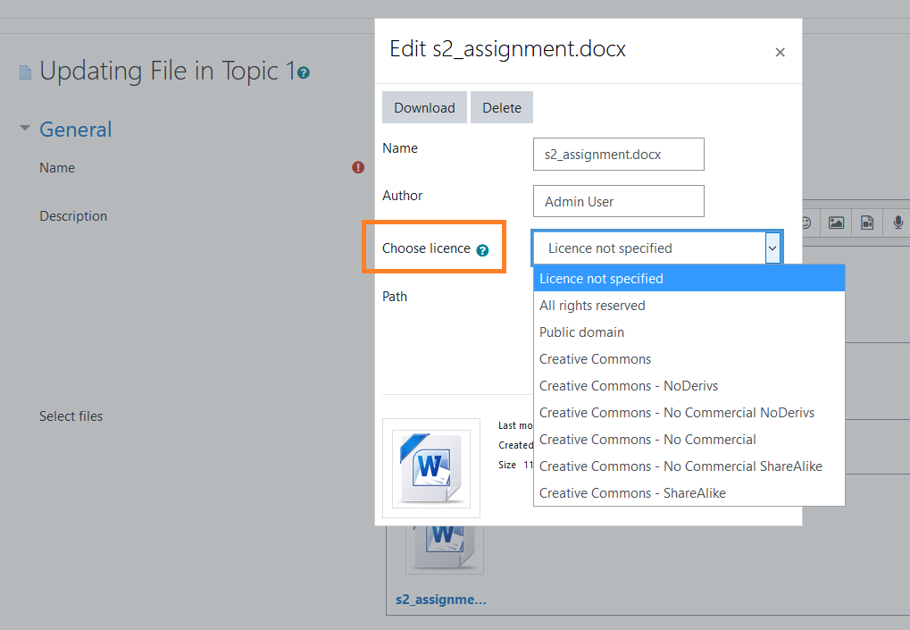
To illustrate this feature, we have an example screenshot below.
Here, this user is not designated to be allowed to request conversions for inclusion purposes. This user is allowed to convert files, using the conversion icon, with license values, such as “License not specified” and “CC license”, as described in the file resource name here for reference purposes.
They are not allowed to convert the Sample Word doc 3 as its license is “All rights reserved”.
The Sample Spreadsheet XML file also has no conversion icon, as the spreadsheet format is not converted at all. Spreadsheets themselves, when created correctly, are extremely accessible already.
