RELI 317 SUFISM

Library Workshop – handout
Resources

Getting started
Online resources to explore
- Developing Your Search Strategy by Concordia University Library, YouTube video, 7min22, https://youtu.be/6mLjkgkXWAc
- Search Smarter, Search Faster by the University of Sydney, YouTube video, 6min53, https://youtu.be/Oa66AxTbjxA

Accessing information

The Library offers multiple sources of information. If you have any difficulty finding or accessing a document, contact us. https://library.concordia.ca/help/questions/

Library website: https://library.concordia.ca/
Religions and Cultures Subject Guide: https://www.concordia.ca/library/guides/religion.html

Sofia Discovery tool: https://concordiauniversity.on.worldcat.org/advancedsearch?queryString=&databaseList=
Print books are organized in the Library by call numbers, an alphanumerical identification
- Searching: https://library.concordia.ca/help/using/sofia/searching.php
- Using a Call Number to Find a Book by the University Libraries at Virginia Tech, YouTube video, 2min24, https://youtu.be/duemCqRqMKA

Databases by subject: https://library.concordia.ca/find/databases/
Databases explored during the workshop: Academic Search Complete and Index Islamicus.

Google scholar: https://scholar.google.ca/
You can connect your Google Scholar account to the Concordia Library, via “Settings”. This will allow access to more full-text documents.

Relevant resources
- Oxford Reference (includes content previously available through Oxford Islamic Studies Online, now retired, and the Oxford Encyclopedia of the Islamic World: Digital Collection : https://concordiauniversity.on.worldcat.org/oclc/56044346
- Index Islamicus - https://lib-ezproxy.concordia.ca/login?url=https://search.ebscohost.com/login.aspx?authtype=ip,uid&profile=ehost&defaultdb=ich
- Academic Search Complete (multidisciplinary database) - https://lib-ezproxy.concordia.ca/login?url=https://search.ebscohost.com/login.aspx?authtype=ip,uid&profile=ehost&defaultdb=a9h
- ALTAFSIR.com (From the Royal Aal al-Bayt Institute for Islamic Thought (Jordan) - Qur’anic Commentary, Interpretation and Explanation (Arabic and English)
- ATLA Religion Database - https://lib-ezproxy.concordia.ca/login?url=https://search.ebscohost.com/login.aspx?authtype=ip,uid&profile=ehost&defaultdb=rfh
- ProQuest Dissertations & Theses Global - https://lib-ezproxy.concordia.ca/login?url=https://search.proquest.com/pqdtglobal/advanced?accountid=10246
- JSTOR (multidisciplinary database) - https://lib-ezproxy.concordia.ca/login?url=https://www.jstor.org/action/showAdvancedSearch
- The Quranic Arabic Corpus: https://corpus.quran.com/

Services
Courses reserve: https://reserves.concordia.ca/ares/
Interlibrary loans: https://library.concordia.ca/find/interlibrary-loans/
Article\ Chapter Scan & delivery: https://library.concordia.ca/find/delivery/login.php?target=articleForm.php

Guides
Finding: https://library.concordia.ca/help/guides.php?guid=finding
Evaluating: https://library.concordia.ca/help/guides.php?guid=evaluating
Citing: https://library.concordia.ca/help/citing/
Ask a Librarian: https://library.concordia.ca/help/questions/

On Generative Artificial Intelligence: https://library.concordia.ca/apps/things/thing.html?thingID=22032

Support for undergraduate students: https://library.concordia.ca/help/users/undergraduates/index.php

Interlibrary Loans service

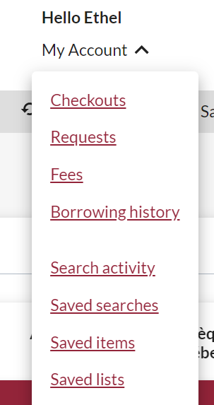
The Interlibrary loans service (ILL) is embedded within the Discovery tool Sofia.
ILL requests are made directly in the Sofia Discovery tool, using the “Request via Interlibrary Loan” button or using the form available under the “Requests” tab in your Sofia “My Account”.
If you visit another university library in Québec, your Concordia ID card will be your library card. (The BCI card is no longer required, nor supported.)
For more information on how to place ILL requests for books, articles and chapter scans, please visit the User guide for the Sofia Discovery tool.
This service is available to Concordia undergraduate and graduate students, faculty members and staff.

Go further
The Library also offers a selection of workshops that open to the Concordia community.
If you prefer a self-paced tutorial, the Library Research Skills tutorial is worth exploring.

Questions
The Ask a Librarian service (https://library.concordia.ca/help/questions/) will connect you via chat, phone and email to a reference assistant or librarian who can help you with most questions.

