Recover Deleted File on GCS Network Drive

GCS systems use incremental backups to preserve files stored on the network drives. This document provides instructions on how to restore deleted, missing, or corrupted files and folders.

Note: Always restore backed up files onto a network drive. Files saved to the desktop are not backed up and cannot be retrieved if deleted.

Restore Deleted File or Folder
- Navigate to the folder above where your deleted file or folder should be. In this document, the file I want to restore is located inside of “My Documents” on the G: drive.
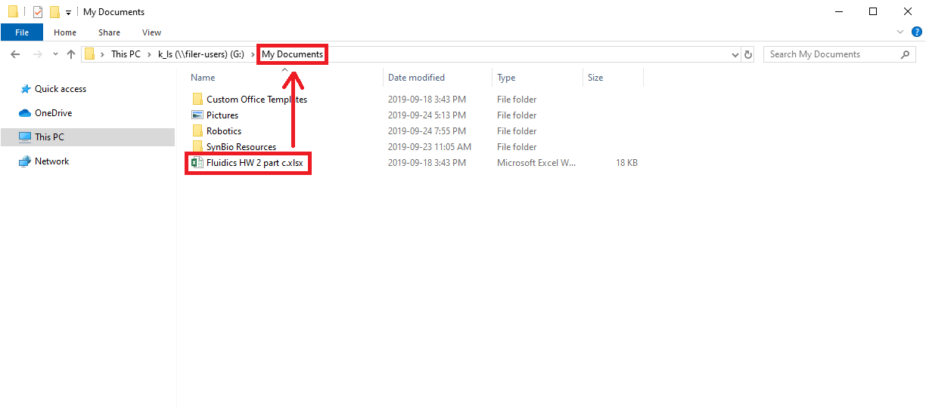
My deleted file was inside of “My Documents”.

- Right click the folder that contained the deleted file, then select “Restore previous versions”.
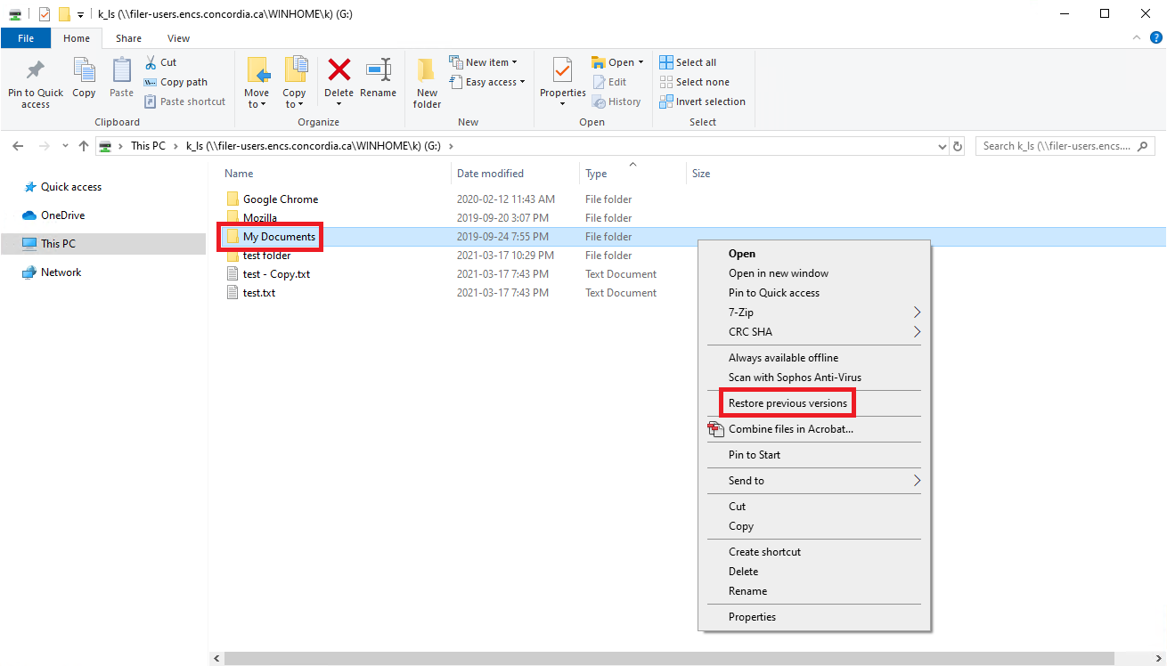
- If your file or folder is located in the root folder of your network drive, right click the network drive and select “Restore previous versions”.
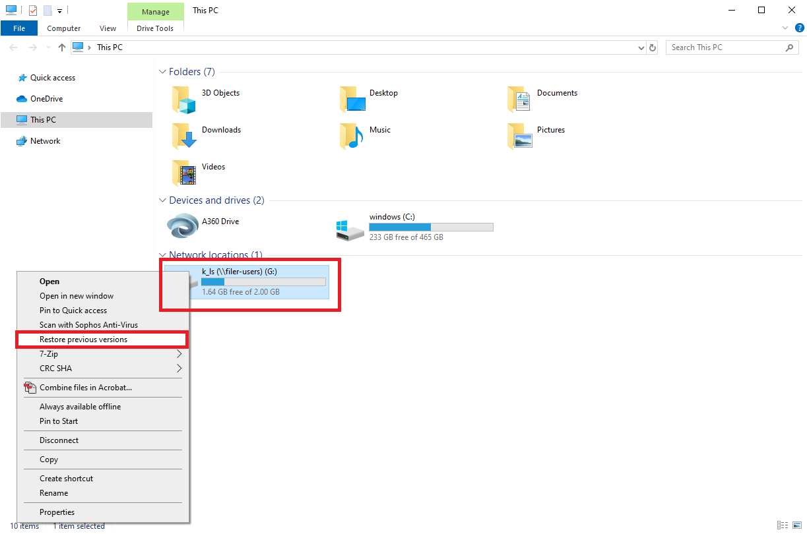
Restore previous version from the G: drive.
- If there are backups available, they will be listed here.
- The open button can be used to check the contents of the file or folder (see step 5).
- Warning: The restore button overwrites the current version on your drive with the backup selected. This is not reversible so it is not recommended.
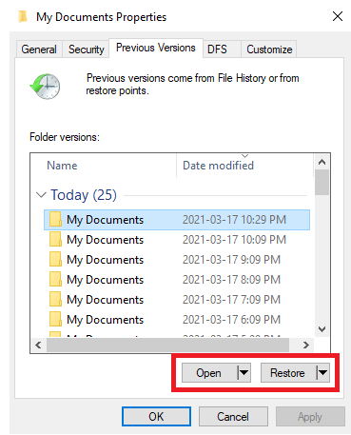
The timestamps indicate when the backup was made.

- Select the backup you want to view and press open (or double click the backup). This will open the backed up version of the folder. Files can be searched using the search bar.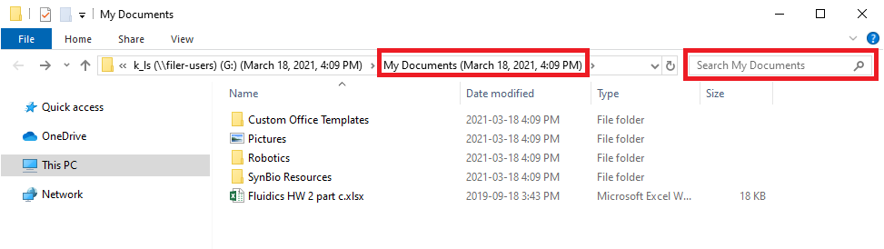
The folder name will show the date and time of when the backup was made.

- Inside the folder are the contents of the backup. Right click the file or folder you want to restore, select “Copy”, then paste it back onto your network drive.
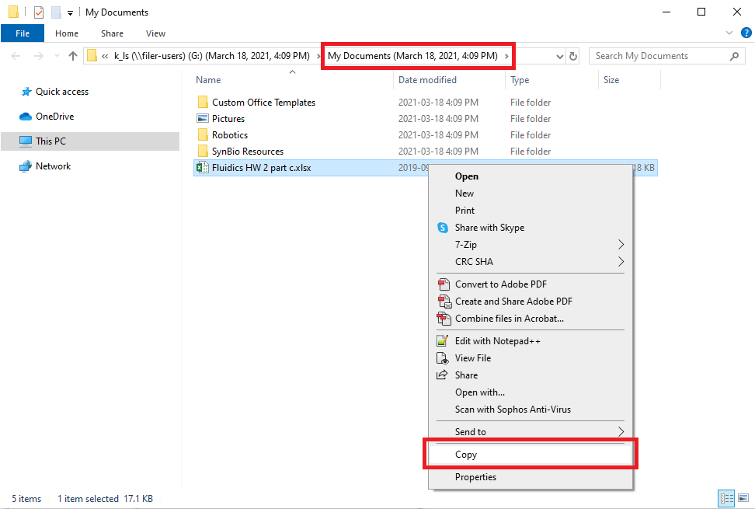
- If you know the name of the file, but you don’t know where it is located, use the search bar.
