Instructions for Supervisor

The new online forms are located at: http://nstp-pfsn.fluidreview.com/?l=en

When a student requests that you review and approve an NSTP form, an email will be sent to you whether you have an existing account or not.

The first time you receive such an email, you will be invited to create an NSTP account.

For all subsequent requests for approval, the system will automatically recognize you email and it will only ask for your password.

Approving the online forms consists of a few simple tasks

- Log-in:

- Access the .pdf of the form by doing the following steps. (Print screens of the steps are included on the next pages).

- Click on ‘Submission’
- Click on View/Edit
- Click on view (at this point the .pdf of the form will open)
- After you finish reviewing the form, close the form by clicking on blue ‘back to submission’ button.
- Click on Recommendations or Comments
- Click on Supervisor Comments or Supervisor recommendation
- Enter your comments or recommendations and submit.

Once all of these steps are done, an email will be submitted to the student letting them know that the form is ready to be submitted to the Chairperson.

* Please note that signed copies of the forms are not longer required. The .pdf version is for review purposes only.

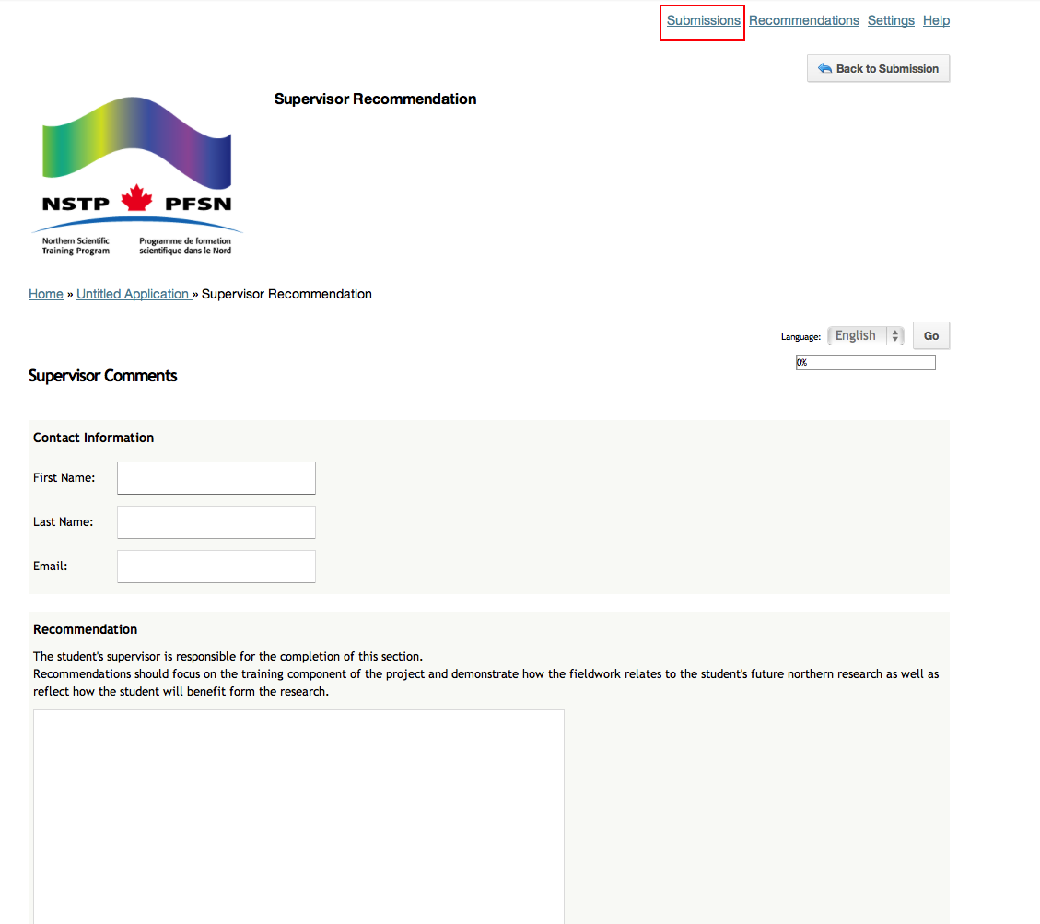
Step -1-

Step -2-

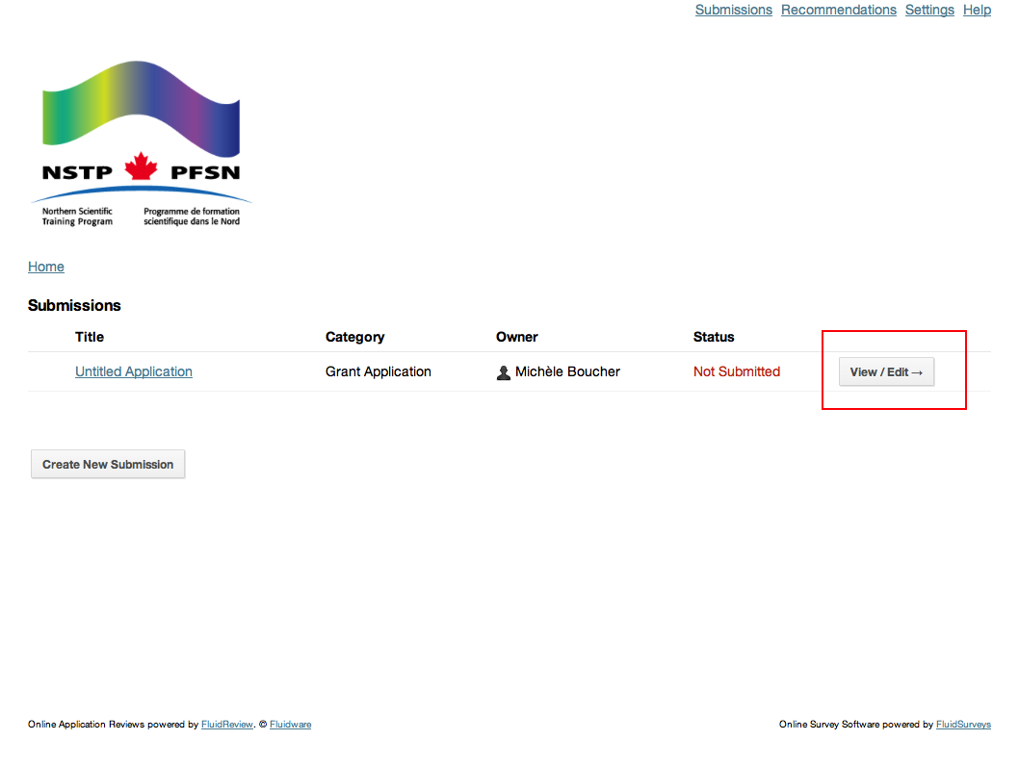

Step -3-

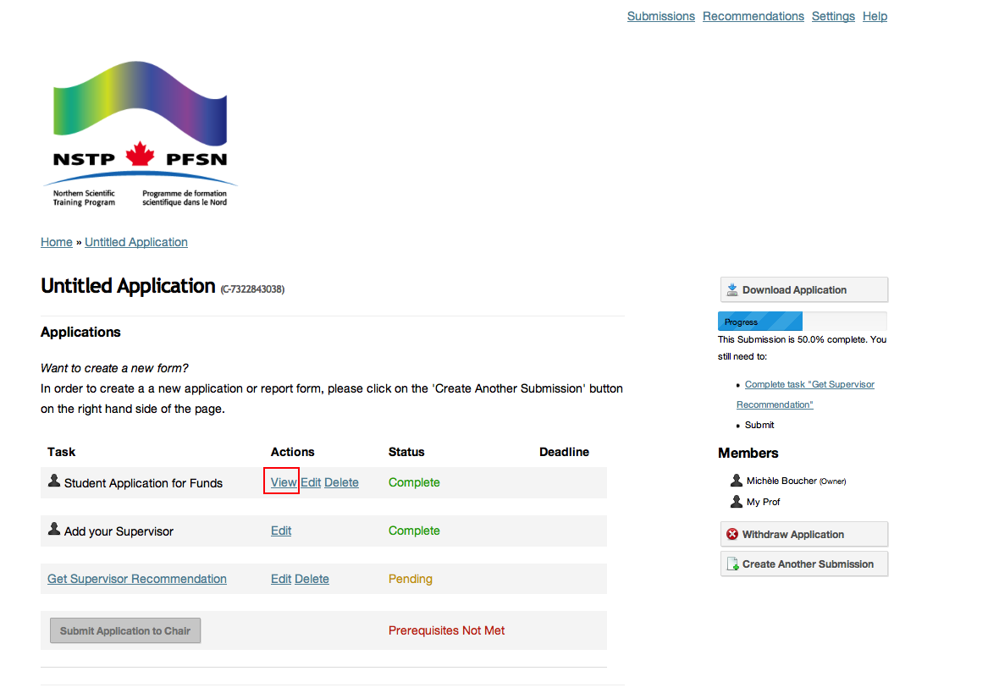

Step -4-
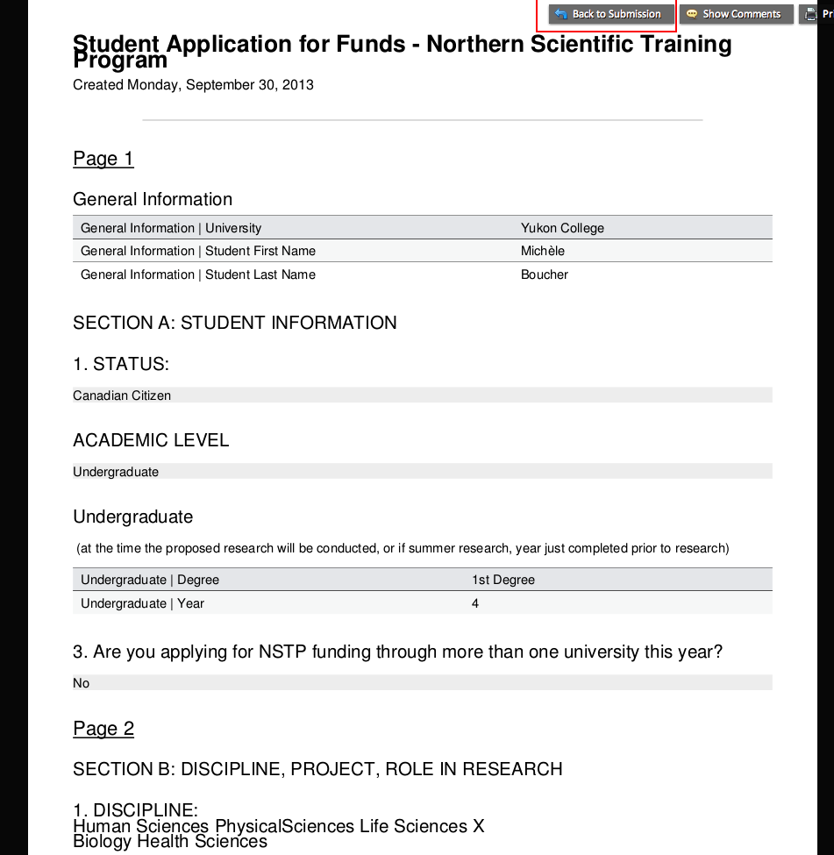

Step -5-
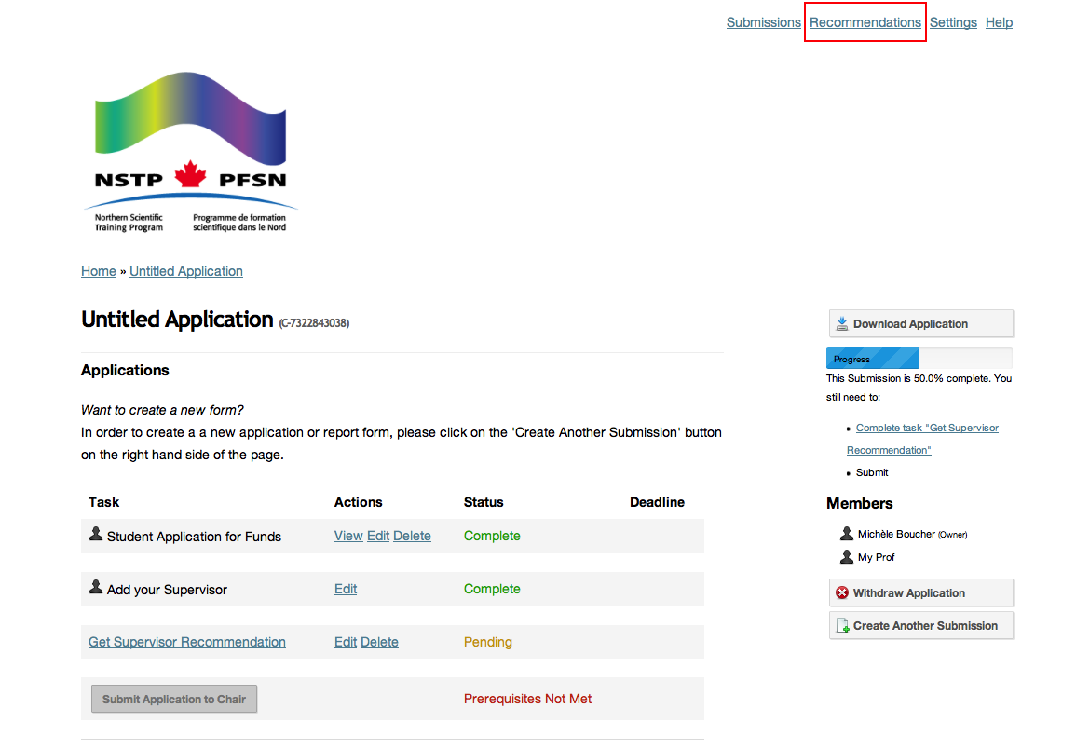

Step -6-
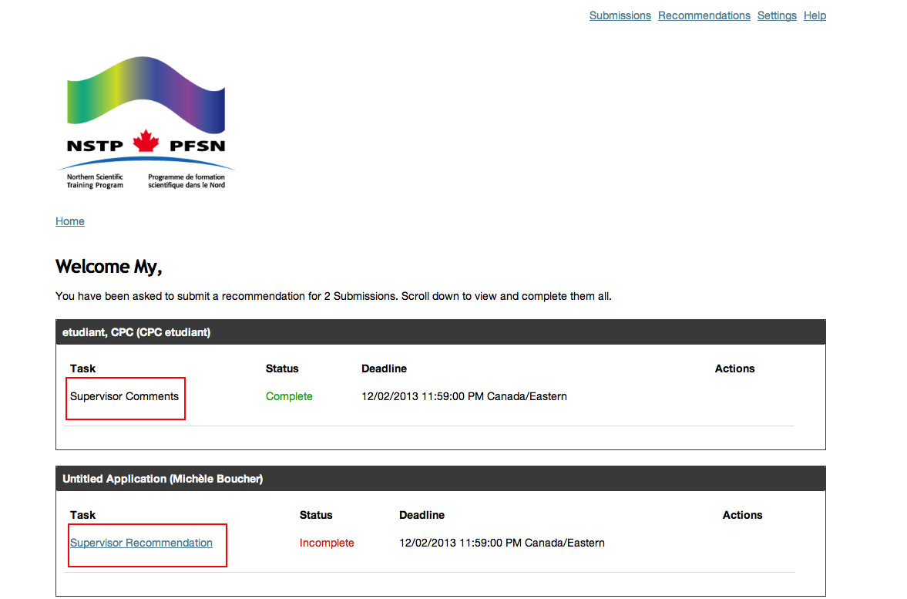

Step -7-


