How to Respond to Review Comments via ConRAD
- When your study has been reviewed, you will receive an e-mail with the file number, your last name and the status in the subject line, advising you of any issues that need to be addressed. Please copy these comments into a Word document, and under each one, explain how the issue has been addressed. For example
  - If you are asked to supply a revised document with changes highlighted, simply state “Revised as requested.”
  - If you are asked to supply additional documents, simply state “Uploaded as requested.”
  - If you are asked to answer an open ended question, please answer it in the Word Document
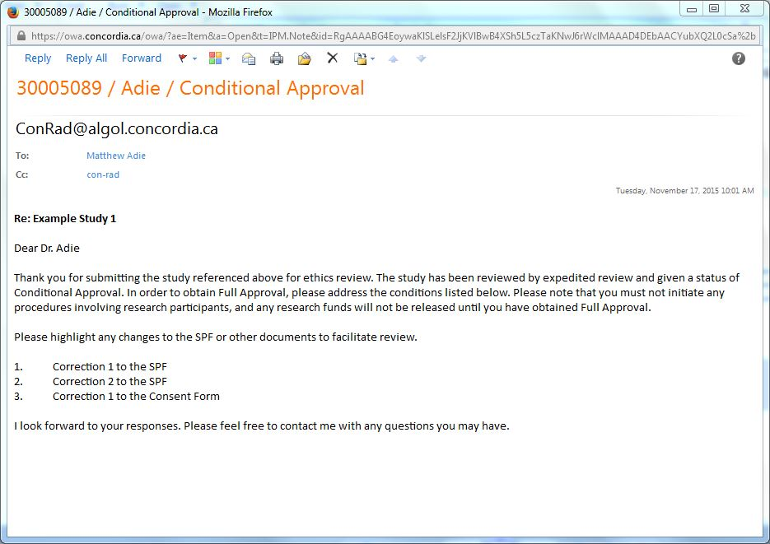

Please prepare the documents before logging into ConRAD and where you are preparing a revised document, give it a different filename from the one initially submitted. Please upload the responses in the Word document along with any new or revised documents as described below.
You will also receive a “system e-mail” prompting you to log into ConRAD.
- Once all documents are ready to upload, log into ConRAD the same way you did to submit the study initially. To view the application, click on “Applications (Submitted – Requiring my Attention)”

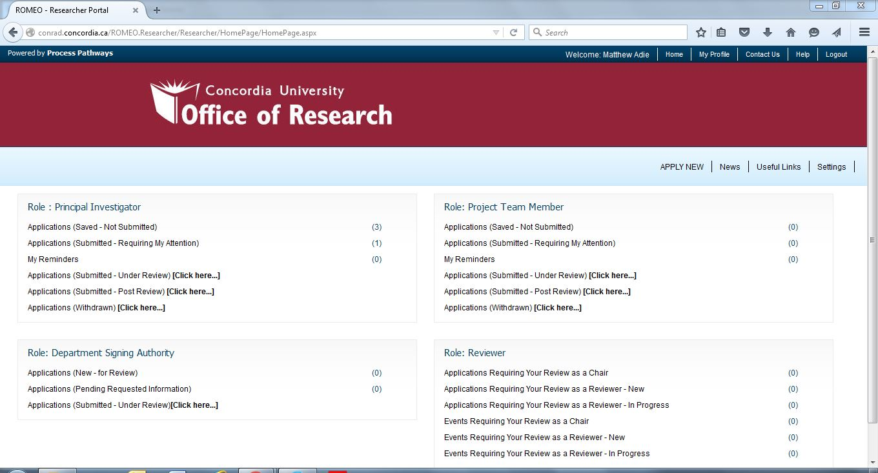
- Select the appropriate protocol and click “Edit”.

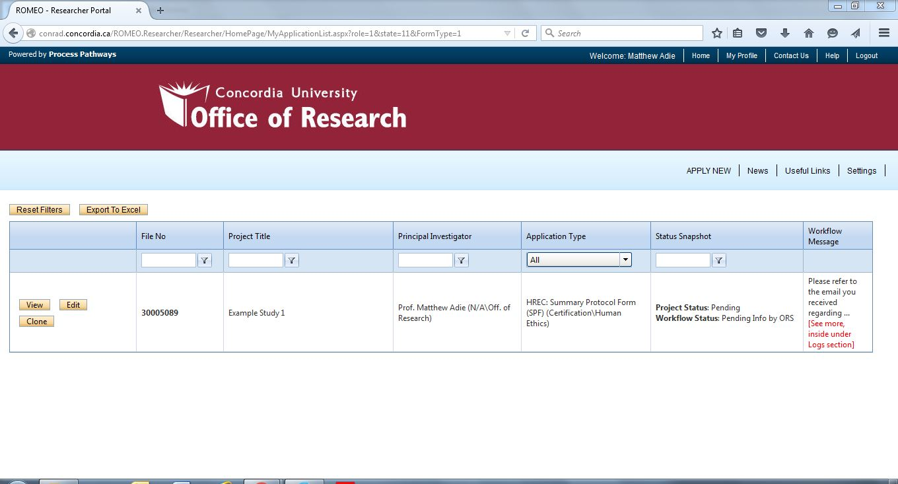
- Go to the Attachments tab and click “Add Attachment”. Click on the “Browse” button and select the document you wish to upload. Leave the “Version Field” blank unless the document has a version date other than today’s date. Select a “Doc/Agreement” type and click the “Add Attachment” button.
Please attach each document individually, i.e. do not merge documents together.

If the document has been assigned a version date, enter it here. Under “Doc / Agreement” select the appropriate document type. Click on “Add Attachment”. Repeat for any additional documents.
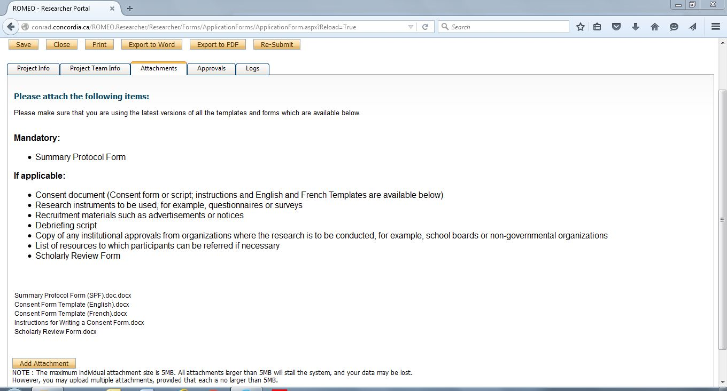

- When all documents have been uploaded, click “Re-Submit”.

