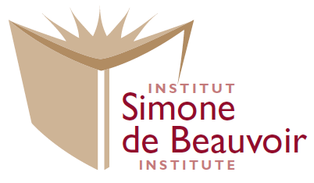

Request to Become a Research Associate

Research Associates (RA) are individuals who conduct research on feminist issues and who have an official link to the Simone de Beauvoir Institute. They are part-time teaching faculty, graduate students, independent scholars or professors from other universities interested in exchanging about research or conducting research in collaboration with SdBI members. (Temporary, visiting scholars who apply for affiliation to the Institute are not RAs.) Research Associates meet regularly to exchange ideas, notably in seminars or Feminist Café events. Criteria that will be taken into account, in considering applications from individuals wishing to be considered for RA status will include the following.

Please use the spaces below to write your answers – note that the spaces will stretch as you write or paste in your information.

Candidate Information
Name:
Current Institutional Affiliation (if any):
Current Home Address (location and ability to participate in local events):
Telephone No:
Current E-mail Address:
Mini---bio (please write a 200 to 300 words summary of who you are):

Research Information
Description of MAIN RESEARCH PROJECT (or any other activity related to activism or research) which will be carried out in the next year (200 to 300 words summary):

Reason for Affiliation
What length of term are you interested in as a Research Associate (3-year term in the norm)?
What are the reasons for your interest in becoming a SdBI Research Associate?

Are you comfortable with public positions taken by the Institute? http://www.concordia.ca/artsci/sdbi/about/positions.html Choose an item.
Renewal Information (For RAs seeking renewal, criteria will include the above as well as the following 3):
Have you participated in/helped with one SdBI activity or committee in the last three years ? Please provide details:

Have you participated in research events/meetings at the SdBI in the last three years? Please provide details:

Have you represented the SdBI at an activity internal or external to Concordia University or signed a
publication or a presentation acknowledging affiliation to the SdBI? Please provide details:

