Promoting Reflective Teaching

Practices using ePEARL: Final Report

Ministère de l’Éducation, du Loisir et du Sport Grant in “Programme de soutien à la formation continue du personnel scolaire”

Philip C. Abrami,

Centre for the Study of Learning and Performance

Concordia University

Eva M. Bures

Bishop’s University

C. Anne Wade, Larysa Lysenko, Ann-Louise Davidson

Centre for the Study of Learning and Performance

Concordia University

<<Draft Material: Please do not quote or disseminate without approval>>

September 30, 2011

Goals
As stated in the original proposal, Phase I of this professional development project aimed to introduce use of an electronic portfolio by pre-service and in-service Quebec teachers with the benefit of: (1) increasing attention to teacher’s own professional development and reflective practice, (2) adding more focus in PD activities by creating a professional portfolio that links to the twelve professional competencies, (3) improving pre-service teachers’ understanding of the competencies, and (4) developing a deeper understanding of Quebec Educational Programme.
The project unfolded over a two-year period. During year 1, participants used Level 3 (designed for secondary students) of ePEARL to provide input regarding the desired features for a professional development version (Level 4) of the software. Specific needs were identified by adult learners in regards to their professional growth and development. During year 2, the improved version of ePEARL Level 4 was used by the participants for professional learning.
Method
Participants: In year one, 89 pre-service students from Concordia University, Bishops’ University and Dawson College used Level 3 of ePEARL to help inform the development of Level 4 (for adult learners). In year two where the purpose was to pilot the newly designed ePEARL Level 4, teacher trainees from two partner institutions, Bishops’ University (n=19) and Dawson College (n=24), continued their participation in the project. Three in-service teachers and one CEGEP instructor volunteered their time to be trained with Level 4 ePEARL. One in-service teacher tested the software for her own professional development; her responses were not included into comparative data analysis.
Training: During years one and two, the participants were introduced to the ePEARL software through workshops to train them on how to use ePEARL to set goals, get feedback, and reflect on their own professional development and how to teach with ePEARL in their classrooms. Ongoing training and support were offered in the form of: follow-up workshops, support via phone and email, a moderated wiki for university students, teaching meetings, and individualized support as requested.
Description of ePEARL Level 4: An evidence-based, learner-centred digital portfolio is based on the cyclical, socio-cognitive model incorporating metacognitive and motivational elements (Zimmerman, 2000) and provides a life-long foundation for learning and skill development that is driven and sustained by the learner. The three phases of the self-regulation process forethought, volitional control and self-reflection are represented in ePEARL and are supported with relevant tasks. The screen shots in Appendix A on pages 14-16 show the three phases as represented in ePEARL Level 4 environment. They include features such as setting long-term and task goals, selecting strategies, evaluating personal motivation, creating and sharing work, providing meaningful feedback, reflecting on the performance and the outcome.
Many changes were made to ePEARL to accommodate adult learners. One important change was to allow the learners to associate teacher competencies with their artifacts. This makes it easier for pre- and in-service teachers to keep focused on core competencies. Another change is that ePEARL Level 4 compiles and displays certain information from individual work into cumulative visual graphs. This view provides a novel cross-section of the learning behaviors and inspires new insight into one’s own learning practice. For example, one graph represents the strategies learners have created. Another one displays each teacher competency and displays the number of works the learner has associated with that competency. Another graph shows the number of works that the learner has associated with each general ‘distal’ goal, allowing him/her to realize which goals are being met and which may be neglected.
A third change in level 4 relates to the cyclical nature of self-regulation. Constant monitoring, evaluation and adjustment of various aspects are necessary in Zimmerman’s self-regulation model. In ePEARL Level 4 we have tried to reinforce this through our interface design. While the main area of the screen is dedicated to working on the current task, a right-hand column constantly displays pertinent supporting information.
A fourth change reflects that for adult learners the tasks are expected to be more complex and to take longer to complete, and they are expected to have a greater autonomy regarding self-regulating their learning. Forcing learners to complete every part of an online interface, without regard for the task or the level of support needed by the learner, and without giving the learner any sense of agency or choice, will probably result in frustration and a loss of motivation. For this reason, the interface we developed for ePEARL Level 4 allows for a flexible interaction with the tool. It allows learners to focus on the aspects in which they feel that they need most assistance by choosing to drill-down for more support at that point in the process, or alternatively, to simply reply to a generic question if they feel uncomfortable with more precise inquiry. For example, the Self-Reflection phase in ePEARL Level 4 is comprised of a single general reflection question. However, there are also additional focused questions that may be accessed if a learner wants to tackle reflecting more deeply, or requests more scaffolding.
Idan, Abrami, Wade, and Meyer (2011) provide a detailed description of ePEARL Level 4 design.
Measurement of ePEARL Use:
ePEARL User Questionnaire: This questionnaire was distributed to trainees in the end of their course where ePEARL was integrated as part of the curriculum. The questionnaire intended to measure their ePEARL experiences including the use of ePEARL features as well as trainees’ perceptions of ePEARL and its helpfulness for professional learning.
Teacher Trainer Interview: Interview questions asked teacher trainers to share their experience, as well as their trainees’ experience with ePEARL as a tool for professional learning.
Pre-service Teacher Portfolios: Participants created portfolios in level 4 of ePEARL which can be used to analyze the use of ePEARL.
Results
CEGEP course Portfolios: Students in CEGEP a psychology course used ePEARL Level 4 to perform two tasks along the three phases of self-regulation process including planning, doing, reflecting. The first task was to design an observational activity to document how elementary students use their mathematics and language skills and strategies they use for memorization. In their portfolio, CEGEP students were expected to record their move through planning the activity, carrying it out and reflecting on whether they would do this activity again and how they might change it next time. The second task was to write an integrated paper using their observational data and concepts from the textbook. The students were not required to link their work to professional competencies. The course assessment scheme did not include the use of ePEARL.
Pre-service Teacher Portfolios: Students in the university course used their portfolios to document their development of teacher competencies during their 6-week practicum experience for credit in two three-credit university-courses. They focused especially on competencies 3, 4 and 5 as related to planning and implementing a Learning and Evaluation Situation (LES). Students were able to relate each piece of work directly to specific competencies. Twenty-five per cent of their course mark in effective teaching was based on the portfolio, and ten per cent in assessment. Students had to write at least two versions of both an effective teaching statement and also a statement synthesizing their strengths and weaknesses as a teacher. They also had to upload various artifacts to demonstrate their competencies as relates to their practicum experience.
To illustrate how pre-service teachers were able to use their portfolios to track their teacher competencies, we will look at the portfolios of a pre-service teacher, Molly (name is fictional). Appendix B on pages 17-18 presents a collection of screen shots (figures) extracted from Molly’s portfolio. She was able to identify general goals and strategies, and link her artifacts to her competencies. The visual graphs of Level 4 allowed her to track her learning in new ways. Figure 1 shows Molly’s original general goals. Figure 2 displays how often she linked those to specific tasks she was working on. Figure 3 shows the visual representation of the competencies that Molly associated with her artifacts. For example, she used competency 11, related to professional development, 13 times, competency number 5, related to assessment, 10 times, and competencies 3 and 6, related to planning and implementing a LES, 9 times each. At the end of the semester she wrote new goals drawing on her statement about her strengths and weaknesses as a teacher (Figure 4).
ePEARL Level 4 Experiences
Table 1 indicates that 40.5% of the respondents reported having developed a portfolio before starting to use ePEARL Level 4. A majority (n=13), were university students who had used a lower level of ePEARL (level 3). When asked to compare the two experiences, 26.9% of the respondents preferred their experience with ePEARL Level 4.
Table 1 ePEARL experience
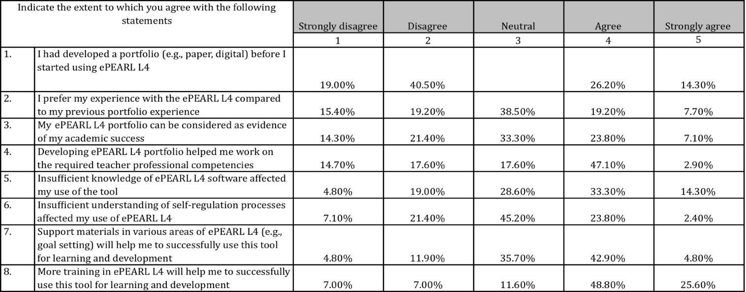
In their comments about what they liked in ePEARL, the respondents emphasized the tool’s capacity to structure and organize their work. However, CEGEP and university students’ statements seem to imply different meanings. CEGEP students focused more on scheduling as revealed by the following statements: “the calendar helped me organize class events”, “helped show the upcoming assignments or events in and out of school”, “that I can organize my schedule”, “good if you want to plan activities”. Conversely their university counterparts liked it because it was “a concise place to put learning” allowing to “organize work in a reflective way” and “reflect on development”. The ability to align their work to professional competencies and keep track of and reflect on their development was also appreciated by university trainees. Half of the respondents (84.2% of university students) stated that developing an ePEARL portfolio helped them work on the required professional competencies. However, only 30.9% considered their ePEARL portfolio as evidence of their academic success.
Commenting on their students’ ePEARL experiences, teacher trainers found that these experiences varied. “Stronger “, “more mature” students who have “stronger identity” and “do more critical thinking” benefited the most from using ePEARL as they used the tool more in-depth to support the stages of self-regulation, including goal-setting, planning, doing and reflection. Moreover, some of these students took the initiative and “did more stuff” than the trainer asked them to do; for instance, recording oneself practicing music and reflecting on the nuances, etc.
ePEARL Features: Use and Perceptions
Although ePEARL had been used by teacher educators with their pre-service students previously, Level 4 was a completely new endeavor to make a version of ePEARL for teachers rather than students. The new level of ePEARL aimed to address adult learners who are more able to organize their work. Key new features included: tagging, overview graphs, sidebar panel, etc.
Our survey collected some data regarding overall use of ePEARL features. As table 2 shows, the respondents tended to utilize some features more frequently than others. They reported general goals (m=2.31), task goals (m=1.86), navigation menu (m=1.86) and personalizing (m=1.86) as the most frequently used features. This indicates that the participants engaged in the self-regulation process of goal setting more often than in other processes; still the averages were lower than we would have hoped.
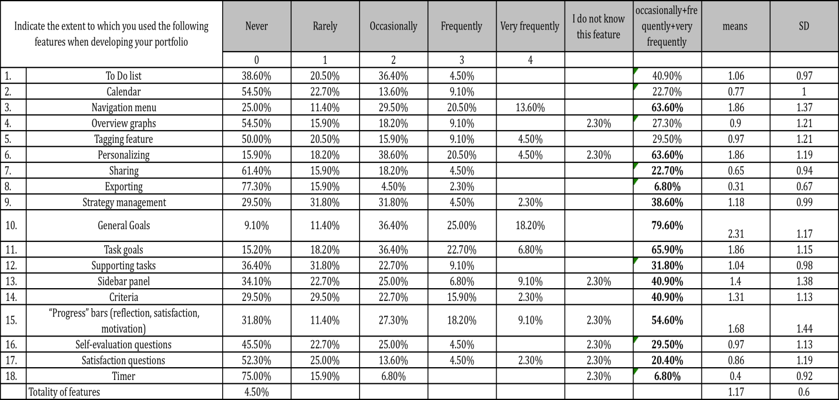
Table 2 Use of ePEARL features (all respondents)

The self-reports point to the existence of a significant difference between CEGEP (m=0.97) and university (m=1.42) students in the frequency of use of the ePEARL Level 4 features (see table 3). University students tended to use the totality of these features more frequently: t=2.69 ** (df=41). Specifically this difference is significant for the uses of tagging (t= 4.9**), overview graphs (t= 2.7*), navigation menu (t= 2.7*) and general goals (t= 2.4*). This probably reflects the instructional goals provided to students: for the university students they were told to write general goals, use the tagging feature to indicate which competencies each artifact linked to, and use the graphs to track their competencies.
Table 3 Use of ePEARL features (University and CEGEP students)
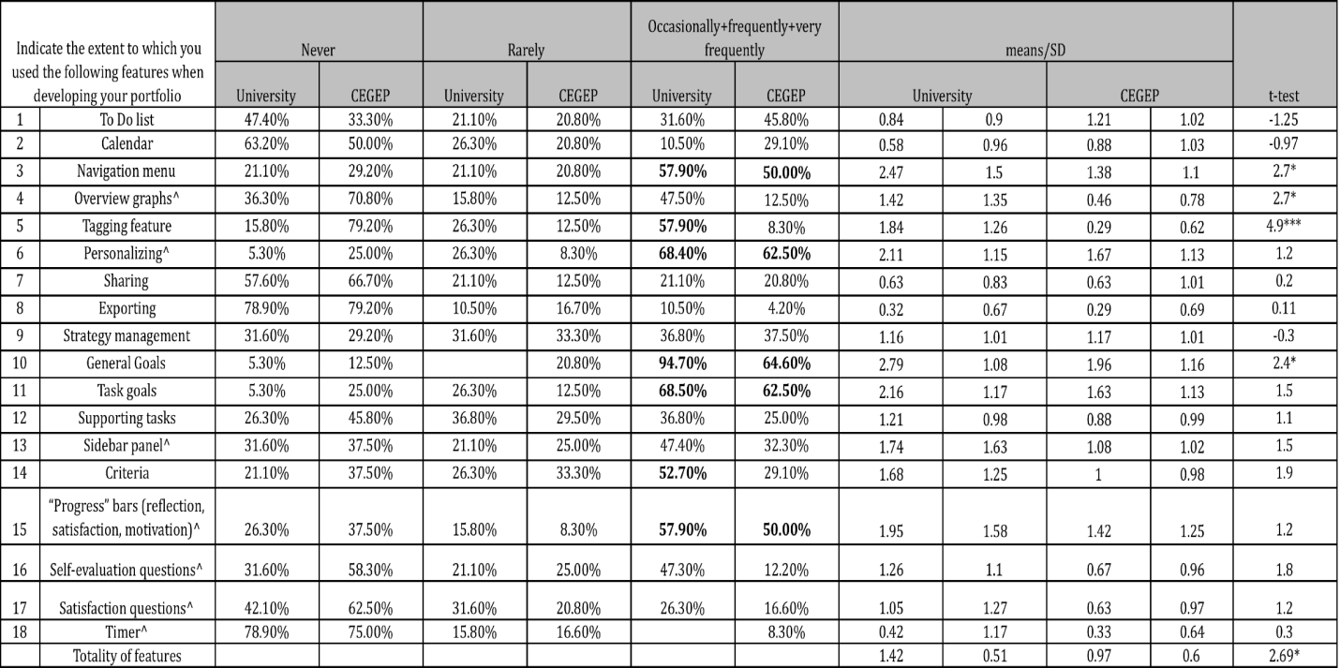
^ For the following items percentages do not add up to 100% as a few students from both groups responded that they do not know this feature.
*p<.05 **p<.01

The CEGEP instructor described her students’ use of ePEARL as medium overall. The students mainly used “planning” sections of the tool whereas reflections were used less. The СEGEP instructor noted that her students hardly used the capacity to connect professional competencies to the tasks they did in ePEARL. In contrast, quite a few university students engaged in self-reflection in terms of the development of their professional competencies during the process of creating ePEARL artifacts, as they related their work to the QEP standards. The university instructor commented that some of their students would include their lessons and then use the reflection section to comment on how their lesson went.
According to table 4, the trainees reported formulating general goals, reading instructor’s feedback and reflecting on their own work as the most helpful features for their professional development. Again CEGEP and university students differed in their perception of which features helped them learn. For instance, university students were significantly more positive about reading their instructor’s feedback (t= 2.61*). Conversely, CEGEP students were more optimistic about the helpfulness of creating a strategy bank (t=4.28***), scheduling events (t=2.98**), and breaking down task goals to supporting tasks (t=2.08*).

Table 4 Trainees’ perceptions of ePEARL features helpfulness
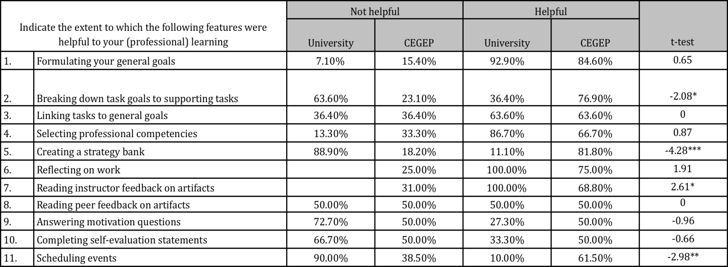
*p<.05 **p<.01 ***p<.000
Table 5 indicates modest and positive relationship between the frequency of use of some ePEARL features and values the respondents attach to these features. For instance, the more frequently they set general goals in ePEARL the more helpful they think this activity of formulating goals is for their learning (r=0.40**). Reciprocal association also exists between the use of strategy management and the helpfulness they view in creating strategy bank (r= 0.40**).
Table 5 Association between the use of ePEARL features and perceptions of their helpfulness (significant correlations (Pearson’s r) only have been shown)
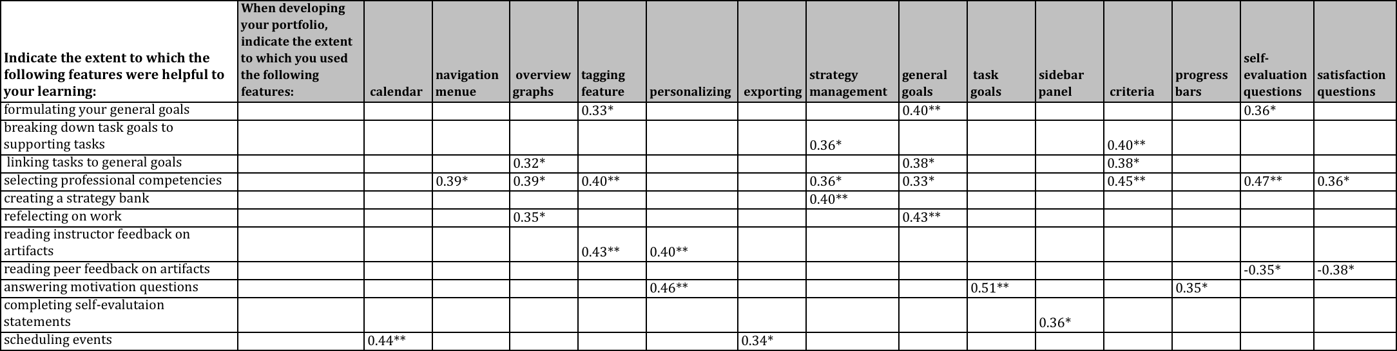
*p<.05 **p<.01
It is important to note that students’ perceptions of a certain ePEARL function is not only associated to the frequency of use of this very function but a whole range of related functions. For example, helpfulness of professional competencies is associated to the use of navigation menu (r=0.39*) and tagging feature (r=0.40**), as well as strategy management (r=0.36*), setting general goal (r=0.33*), evaluation criteria (r=0.45**), completing both self-evaluation (r=0.47**) and satisfaction statements (r=0.36*). We speculate that this link reflects the complex nature of the tool where the features complement each other to affect one aspect professional learning.
Interestingly, helpfulness of reading peer feedback is negatively linked to using self-evaluation (r=-0.35*) and satisfaction questions to reflect on one’s own ePEARL activity (r=-0.38*) and probably shows little value that more reflective trainees attach to what their colleagues’ think about their work.
Factors Affecting ePEARL Use
Many factors may have affected the use of ePEARL. First of all, whatever the instructor has set as the instructional goals has a big impact on how her students choose to use the software. The university instructor told them to set general goals, so they tended to do that more often than did the CEGEP instructor. The instructor should ideally focus on and make sure everyone understands how to use the features, which are critical for the assignments, and we should not be surprised when students do not make use of all the features available.
Another important factor is that this was a new version of ePEARL and the students and instructors were learning how to use it for the first time. Some of the trainees described their ePEARL experience as overwhelming given a perception that the tool was complex, and had “too many” features. In their surveys 47.7% percent of trainees reported an insufficient knowledge of the software.
Lack of understanding of self-regulation processes may have been yet another crucial factor that affected the use of the tool. According to the data, 26.2% of the trainees reported insufficient understanding of self-regulation processes (see table 1). When reviewing their comments, it became clear that some trainees both at the university and CEGEP levels expressed a misunderstanding of the purpose of a process portfolio.
The responses also indicate that training and support are critical for the successful implementation of the software. To use ePEARL successfully, 74.4% of the respondents reported needing more training, whereas 47.7% required additional support materials. They reported needing get trained in self-regulation processes including setting goal, linking them to task goals and professional competencies. In addition, they expressed the need for more training in the use of ePEARL features such as navigation and creating their “strategy bank”. According to the respondents, ePEARL help/support would have been useful. In particular, online multimedia tutorials demonstrating ePEARL features and modelling their use would have helped users of the portfolio.
Given the responses from students, the university instructor felt more time should have been devoted to training her students. Since they had used ePEARL level 3 in previous years it did not seem that important but the results suggested that some students did not feel competent at using the software.
Trainers pinpointed time as an important factor for ePEARL successful implementation, both for them and their students. Pre-service teachers would like more time to incorporate the tool organically into their course framework; that is to design appropriate evaluation and pedagogic activities and to make them an intrinsic part of the curriculum. According to them, time is also necessary for students to get comfortable with ePEARL to see that it helps them learn.
Finally, being a new version of the software, there were bound to be some changes that would need further refinements. Although technical problems were not the issue, the pre-service teachers made some noteworthy suggestions for refinements to the ePEARL Level 4 design relating to the software’s ease of use. These included: simplification and improvements to the interface, increased customizability of the tool such as ability to change the layout and select functions appropriate to the task, additional personalization features, and the opportunity to work off-line.
Challenges of Phase I
We had originally envisioned both pre-service and in-service teachers using ePEARL Level 4 to create professional portfolios but we had difficulties recruiting and retaining teacher participants so ended up focusing on the pre-service teachers. Teachers’ concerns about investing a considerable amount of their time for individual professional development were prevalent. We had also originally envisioned that the pre-service teachers would engage in a reverse training model where they would be expected to use eEPARL during field placements resulting in the in-servicing of their mentoring teachers. Novice trainees were concerned about “imposing” their knowledge on their mentors, whom they viewed as seasoned and, therefore more knowledgeable teachers. In the absence of cooperating in-service teachers as well as willingness of the trainees, the reverse mentoring model turned out to be impractical and to run counter to the pre-service student teacher- cooperating teacher model.
Implications
A first noteworthy implication of Phase I project roots in the fact that we were able to refine and test the ePEARL Level 4 software enabling teachers’ learning and development. As a knowledge tool it applies what is known of self-regulation learning and educational technology to advance the quality of learning in teacher education as it promises to facilitate the development of cognitive and meta-cognitive strategies necessary for life-long learning. Indeed, the tool provided focus in professional reflective practice by making explicit internal processes critical for learning including setting goals, identifying and selecting appropriate strategies, monitoring progress towards the goal, reflecting on the chosen means and achieved outcomes. ePEARL also allowed for tracing one’s own trajectory/evolution towards the provincial educational norms by linking portfolio activities to professional competencies, their features and Quebec Education Program.
However, self-regulation electronic portfolio ePEARL is much like any other software/intervention: it successfully worked for some trainees but did not work for the others. A number of steps can be taken to broaden the audience of successful users.
In the first place, it is important to bring students to better understanding of self-regulation processes not only in its theoretical aspect but also in its practical applicability to learning and self-development. We may note that there is work to be done to engrain the culture of professionalism at the source, i.e. to encourage authentic reflection “on and within the action, and […] transformation of the experience into knowledge” (Conseil supérior de l’éducation, 2004) rather than to convey ideologies and rhetoric speeches. Therefore, to expect the genuine use of ePEARL, self-regulation processes have to be made clear to pre-service teachers in the form of lived practice, that is as an integral feature continuously used in the their program of study. Naturally, such integration will require the same extent of planning, goal setting, monitoring and reflecting on the part trainers to ensure the effective and sustainable use by their trainees.
Secondly, for ePEARL to fully fulfill its promise of a self-directed professional development tool the issue of “ease of use” should be further addressed. The tool needs further refinement including the modification of the interface and the development of instructional help and support regarding self-regulation processes and related ePEARL features and functions. The improvement of the interface can be achieved through the simplification of the following aspects: ePEARL navigation to increase the accessibility of features and functions; customizability of the tool to meet the variety of needs (e.g. to accommodate teachers of different status). Since ePEARL is first and foremost the personal tool for professional development, the availability of help and support within the tool is crucial for its successful autonomous use. On the one hand, because of the importance for the users to understand the processes of self-regulation, tutorials and instructional videos providing insight to these processes should be integrated into ePEARL. On the other hand, ePEARL embedded help could facilitate ePEARL users in receiving assistance without leaving the portfolio environment. Pedagogical help should be developed to provide ideas to those who would be interested in integrating ePEARL into their course and program. Such help may include suggestions on pedagogical activities aligned with the specific professional competencies and appropriate evaluation activities.
The challenges that we faced in Phase 1 project to follow the planned research design urge us to do some critical reflection about how to encourage in-service teachers’ learning by their use of professional portfolios. We learned that pre-service teachers may be able to use portfolios themselves as a reflective tool, but this does not immediately translate to their use with their own students. Pre-service teachers are in a complicated situation during their practicum where they rely on their associate teachers for guidance and also for a successful evaluation: the reverse mentorship model does not account effectively for the reality student teachers face. So we question what the best ways are to encourage in-service teachers to take on the use of electronic portfolios to document their own teaching and /or with their students.
MELS normative document on teacher professional orientations and competencies declares among others the necessity for a teacher to engage in professional development individually and with others and to integrate information and communications technologies (ICT) in the preparation and delivery of teaching/learning activities and for instructional management and professional development purposes. A decade ago after its release, we are still struggling to engage in-service teachers were not ready to get involved into self-directed (self-regulation) model of professional development. The literature reports that sometimes teachers abstain from self-directed professional development because they are unwilling to assume the cost of their own professional formation or are exhibiting a simple desire to prevent one’s burnout or are lacking autonomy (infoDev report, 2005; Dionne & Potvin, 2007). Elsewhere (Abrami, 2009) we summarized will-related deficiency to persistent use of self-regulation strategies and knowledge tools. Potentially having pre-service teachers share their own portfolios with their associates would encourage the associate teachers in the use of ePEARL for their own professional practice. Associate teachers could write feedback into the student teacher portfolios as could the university supervisors, which could enhance the triadic associate teacher-supervisor-student teacher relationship. From there we might be able to support the associates in creating their own professional portfolios.
This project allowed us to develop a version of ePEARL for in-service and pre-service teachers aiming to accommodate their individual needs as adult learners. The results suggest that ePEARL can contribute to teachers’ professional growth as evidenced through the use of ePEARL to document teacher competencies during this project. Level 4 will be further refined to address the feedback provided by participants in this project including simplifying the interface design and incorporating more built-in ‘help’ specific to Level 4. We also learned that both trainers and students need support to understand how to use a portfolio effectively as a tool to promote self-regulatory learning and reflective practice.
References
Abrami, P.C. (2009). On the nature of support in computer-supported collaborative learning using gStudy. Computers in Human Behavior, 26, 835-839. doi: 10.1016/j.chb.2009.04.007
Conseil Supérieur de l’Éducation, (2004). Un nouveau souffle pour la profession
enseignante : avis au ministère de l’Éducation. Québec : Conseil Supérieur de
l’Éducation. Retrieved from http://www.cse.gouv.qc.ca/FR/PUBLICATIONS/index.html
Gaible, E., & Burns, M. (2005). Using Technology to Train Teachers: Appropriate Uses of ICT for Teacher Professional Development. Washington, DC: infoDev / World Bank. Retrieved from http://www.infodev.org/en/publication.13.html
Idan, E., Abrami, P. C., Wade, A., & Meyer, E. (2011, March). Designing for the development of self-regulation: A web-based electronic portfolio for adult learners. In the International Technology, Education and Development (INTED) conference proceedings (5th ed.). Valencia, Spain: INTED.
Ministère de l’éducation du Québec. (2001). Teacher training: Orientations, Professional Competencies – New Directions for Success. Québec: Publications Québec. Retrieved from http://www.mels.gouv.qc.ca/ftps/interieur/PDF/formation_ens.pdf
Potvin, P., & Dionne, E. (2007). Realities and challenges of educational reform in the province of Québec: Exploratory research on teaching science and technology. McGill Journal of Education, 42, 393‐410.
Zimmerman, B. J. (2000). Attaining self-regulation: a social cognitive perspective. In M. Boekaerts & P. R. Pintrich (Eds.). Handbook of self-regulation (pp. 13–39). New York: Academic Press.

Appendix A. Phases of self-regulation learning as reflected in ePEARL Level 4
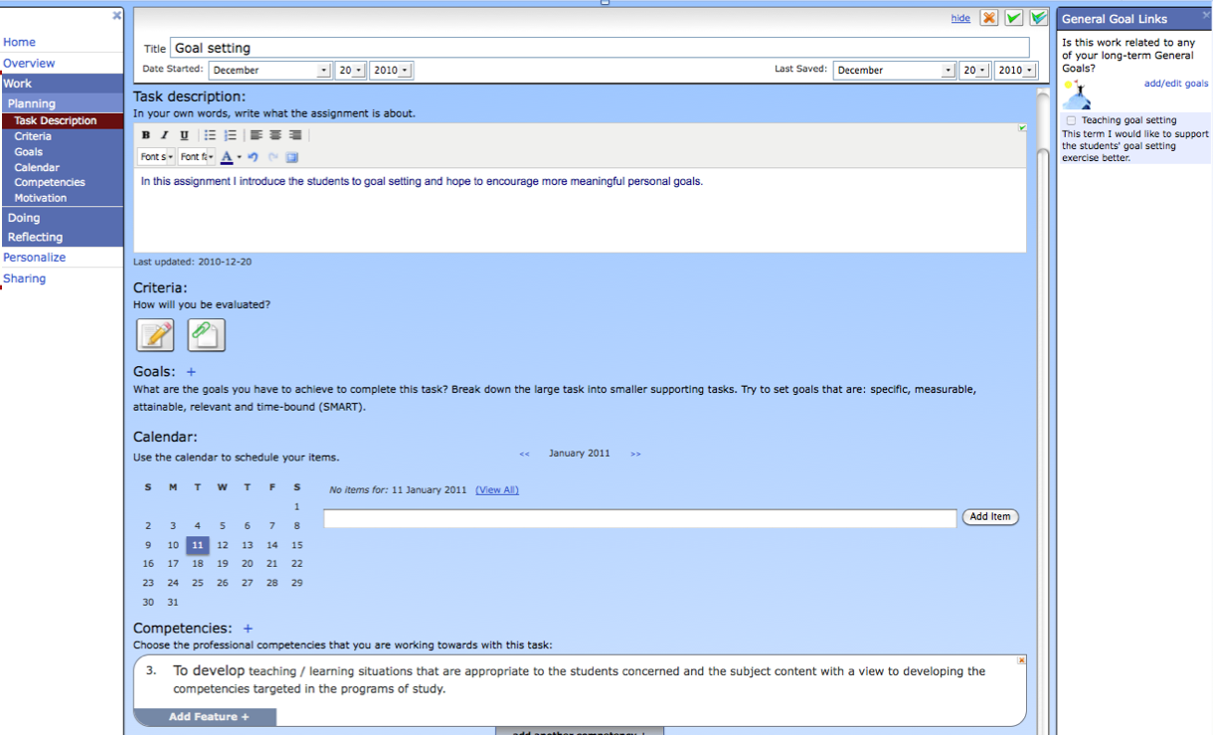
Figure 1 Planning
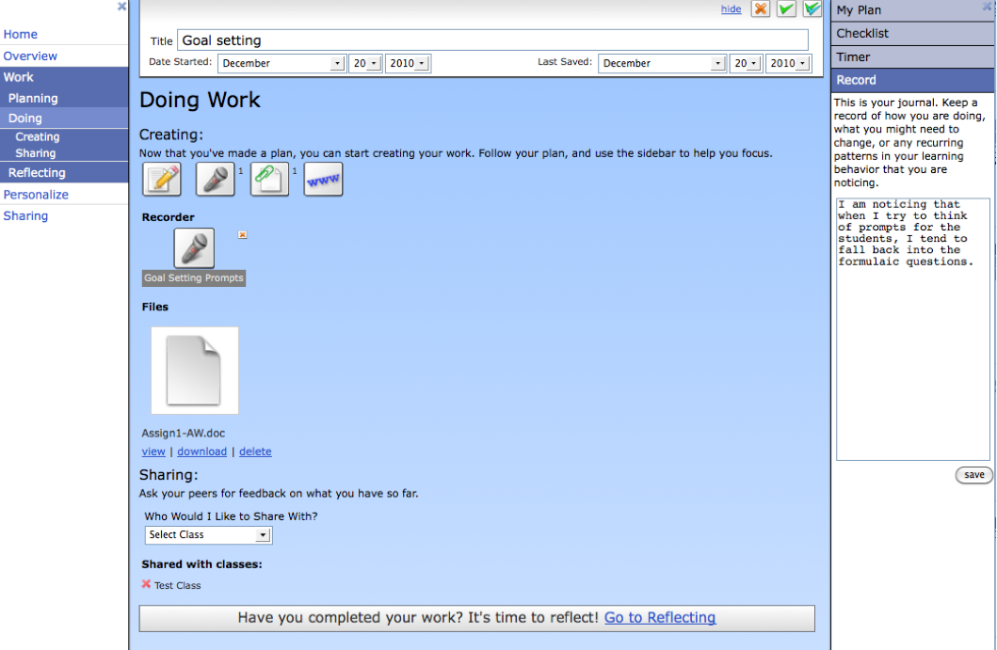
Figure 2 Doing
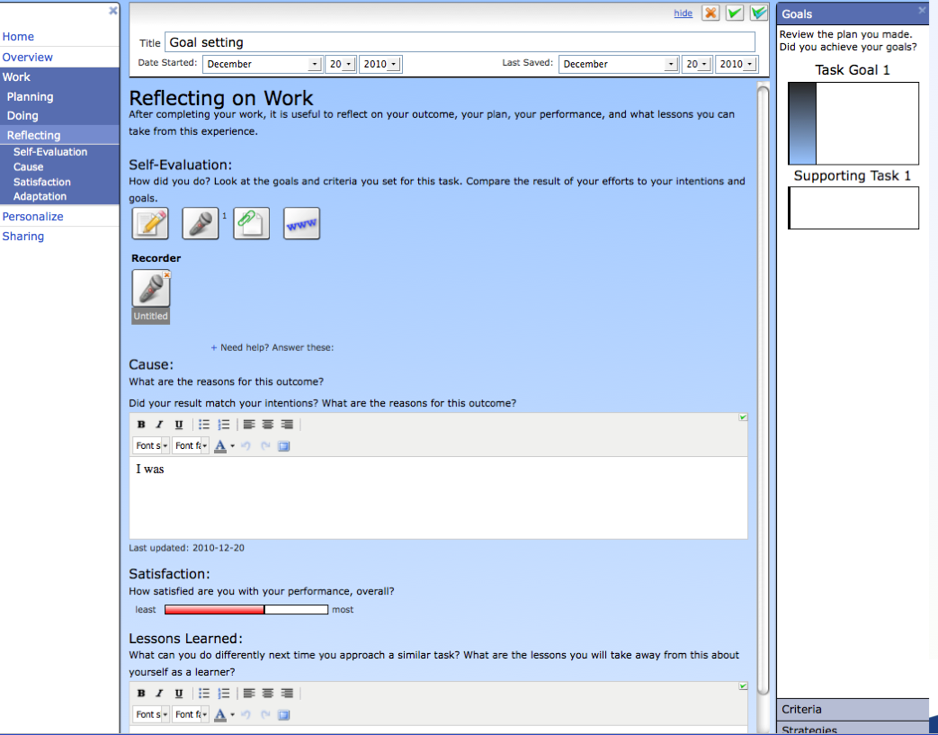

Figure 3 Reflecting
Appendix B. Molly’s portfolio (fragments)

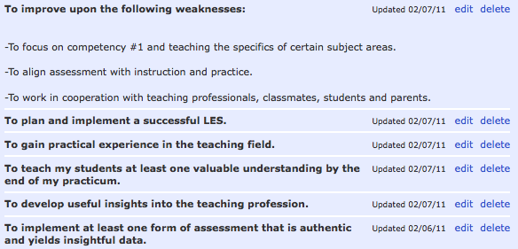
Figure 1 Molly’s goals before the practicum

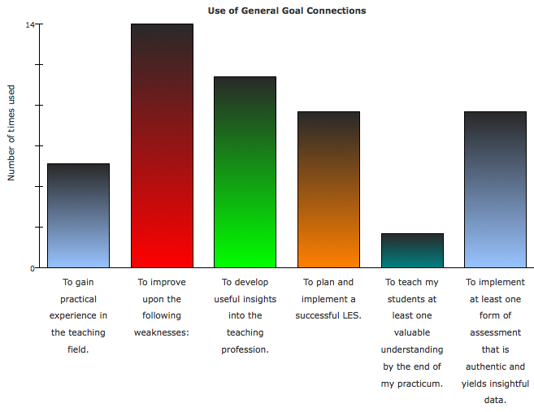
Figure 2 Molly’s use of general goal connections in ePEARL Level 4
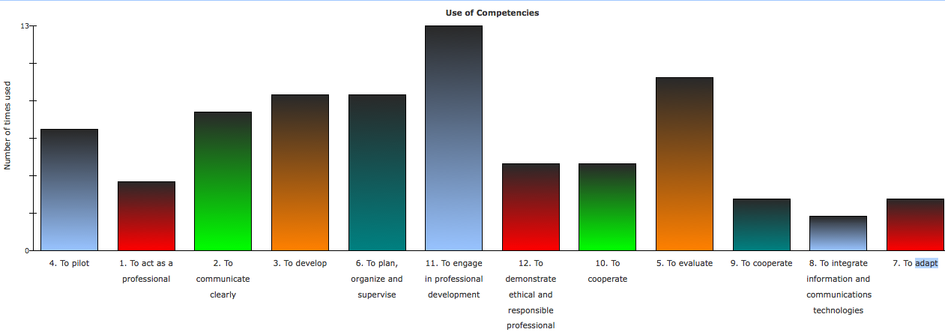
Figure 3 How Molly’s artifacts related to the teaching competencies

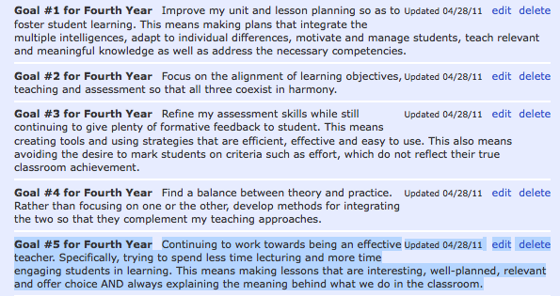
Figure 4 Molly’s revised goals for the following year

