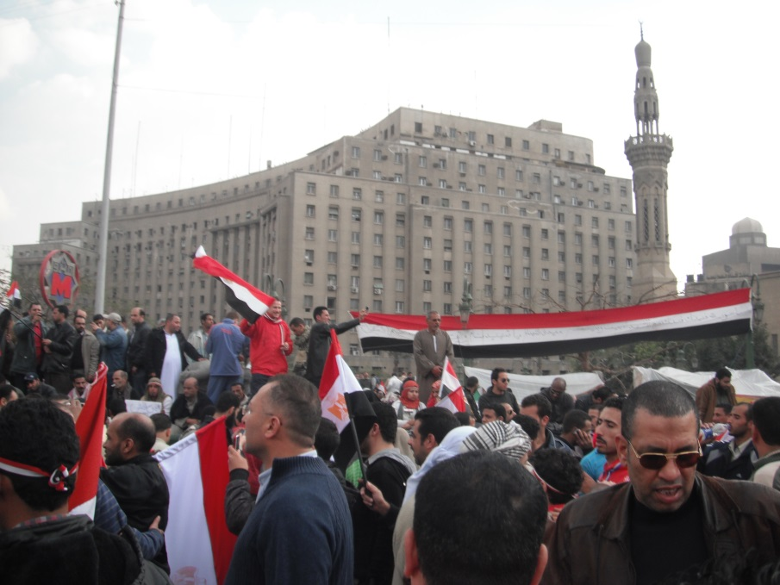
Photo taken by Carol Gray, February 11, 2011. Tahrir Square, Cairo.

Internship for Arabic/English Speakers
Are you fluent in English and Arabic? This internship is to transcribe and sometimes translate the Arabic portions of interviews which are part of an oral history project of one of Egypt’s leading human rights organizations. The interviews were conducted right after Egypt’s 2011 Revolution with a grant from the American University in Cairo. The internship will also include translating portions of the human rights organization’s website including legal documents posted on the website, as well as translating material on relevant blogs.
Requirements: No experience necessary in transcribing or translating but good typing skills and fluency in Arabic and English are needed. It would also be helpful to have access to a computer that can type and print in Arabic. Familiarity with Egyptian Arabic would be helpful, but is not required.
To Apply: Please email a letter explaining your interest to carolgray_2000@yahoo.com. Interns are sought as soon as possible, but may also be needed during the winter and spring semesters.
Contact:
Carol J. Gray, J.D., L.L.M.
Fulbright Visiting Research Chair
Concordia University - Loyola College for Diversity and Sustainability
7141 Sherbrooke Street West, AD-502
Montreal, Quebec, Canada H4B 1R6

Email: carolgray_2000@yahoo.com
Phone numbers: 514-419-8784; cell: 413-297-1075

